Enquiry question: Why does the population distribution vary between places?
Why: so that I can understand the reasons for uneven population distribution in 2 contrasting countries (China and the USA).

How:

- Use the 2 Infographics to collaboratively complete the Venn diagram to share the information collected

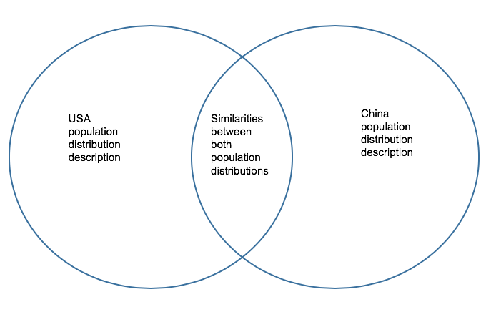

- Plan (and then write) an essay for the question : “Physical factors have the greatest impact on population distribution.” Discuss this statement. (10)

Interpreting the title: Look carefully at the essay title and carry out the following:

Underline the key words in the title.

Use the L.I.S.T. checklist below to ensure that you give it the essay title its broadest interpretation.

LOCATION (spatial context): poor/rich countries; rural/urban areas; tropical/temperate; land/air/sea; marine/terrestrial/atmospheric

ISSUES (factors): positive/negative, advantages/disadvantages, costs/benefits, human/physical, environmental, social, cultural, demographic, political, economic, geographic

SCALE: global, regional, international, national, sub-national, local

TIME: long-term/medium-term/short-term; past/present/future; contemporary/recent/current
Some of the items in the L.I.S.T. may not be relevant to the essay.

Planning: Planning ensures that:
- Ideas can be presented in a logical sequence
- New points can be added to the plan while writing the essay
- Responses are well structured and can access the highest markbands
- Content is relevant and the focus remains on the essay title

Structure

Introduction

The first sentence should make an impact
Define terms if necessary
Outline the general direction of the essay

Develop its subject clearly

Use clear English and write concisely

Make you paragraphs:

Statement

Expand
eXample
You need to make link to the question!!

Limit each sentence to one or two points
Have clear self-contained paragraphs (leave a line between paragraphs)
Have a recognizable connection between paragraphs

Come to an effective conclusion

Again try to finish with a sentence / sentences that make an impact
Provide an overview of the response which links back to the title
Do not introduce new ideas at this stage

Throughout the essay:

Use a wide vocabulary
Use appropriate geographic terminology
Write legibly in dark blue or black ink
Avoid note form and/or lists (bullet points)
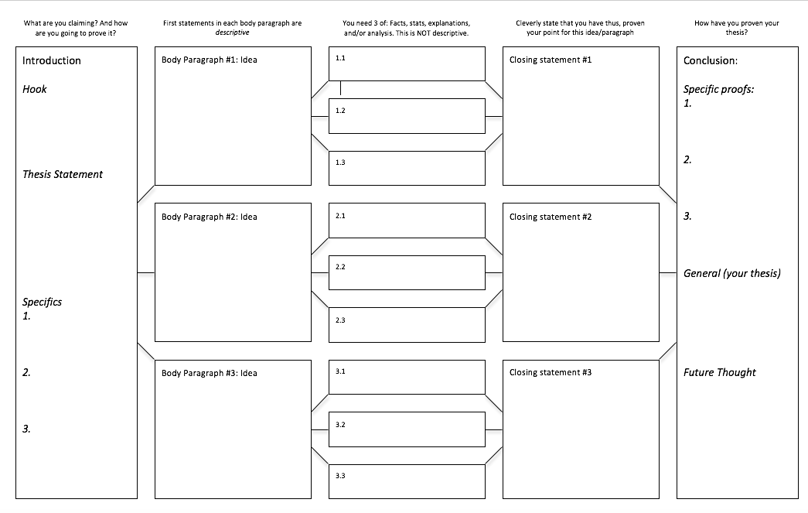
 | AO1: Knowledge and understanding of specified content  AO2: Application and analysis of knowledge and understanding | AO3: Synthesis and evaluation | AO4: Selection, use and application of a variety of appropriate skills and techniques
 | 0 The work does not reach a standard described by the descriptors below.
 | 1–2 The response is too brief, lists unconnected information, is not focused on the question and lacks structure.
 | - The response is very brief or descriptive, listing a series of unconnected comments or largely irrelevant information. The knowledge and understanding presented is very general with large gaps or errors in interpretation. Examples or case studies are not included or only listed.  - There is no evidence of analysis.  - Terminology is missing, not defined, irrelevant or used incorrectly. | • No evidence of evaluation or conclusion is expected at this level. | - Information presented is not grouped logically (in paragraphs or sections).  - Maps, graphs or diagrams are not included, are irrelevant or difficult to decipher (only if appropriate to the question).
3–4 The response is too general, lacks detail, is not focused on the question and is largely unstructured.
- The response is very general. The knowledge and understanding presented outlines examples, statistics, and facts that are both relevant and irrelevant. Links to the question are listed.  - The argument or analysis presented is not relevant to the question.  - Basic terminology is defined and used but with errors in understanding or used inconsistently. |  | - If appropriate to the question, the conclusion is irrelevant.  - There is no evidence of critical evaluation of evidence (examples, statistics and case studies). | - Most of the information is not grouped logically (in paragraphs or sections).  - Maps, graphs or diagrams included lack detail, are incorrectly or only partially interpreted without explicit connections to the question (only if appropriate to the question).
5-6 The response partially addresses the question, but with a narrow argument, an unsubstantiated conclusion, and limited evaluation.
- The response describes relevant supporting evidence (information, examples, case studies et cetera), outlining appropriate link(s) to the question.  - The argument or analysis partially addresses the question or elaborates one point repeatedly.  - Relevant terminology is defined and used with only minor errors in understanding or is used inconsistently. |  | - If appropriate to the question, the conclusions are general, not aligned with the evidence presented and/or based on an incorrect interpretation of the evidence.  - Other perspectives on evidence (examples, statistics and case studies) and/or strengths and weaknesses of evidence are listed. | - Logically related information is grouped together (in sections or paragraphs) but not consistently.  - Maps, graphs or diagrams included do not follow conventions, and include relevant and irrelevant interpretations in the text (only if appropriate to the question).
 | 7–8 - The response addresses the whole question, the analysis is evaluated and the conclusion is relevant but lacks balance.
 | - The response describes relevant supporting evidence correctly (information, examples and case studies) that covers all the main points of the question, describing appropriate links to the question.  - The argument or analysis is clear and relevant to the question but one-sided or unbalanced.  - Complex terminology is defined and used correctly but not consistently. | - If appropriate to the question, the conclusion is relevant to the question, aligned with the evidence but unbalanced.  - Other perspectives on evidence (examples, statistics and case studies) and/or strengths and weaknesses of evidence are described. | - Logically related information is grouped together (in sections) consistently.  - Maps, graphs or diagrams included contribute to/support the argument or analysis (only if appropriate to the question).
 | 9–10 - The response is in-depth and question-specific (topic and command term); analysis and conclusion are justified through well-developed evaluation of evidence and perspectives.
 | - The response explains correct and relevant examples, statistics and details that are integrated in the response, explaining the appropriate link to the question.  - The argument or analysis is balanced, presenting evidence that is discussed, explaining complexity, exceptions and comparisons.  - Complex and relevant terminology is used correctly throughout the response. | - If appropriate to the question, the conclusion is relevant to the question, balanced and aligned with the evidence.  - Evaluation includes a systematic and detailed presentation of ideas, cause and effect relations, other perspectives; strengths and weaknesses of evidence are discussed; (if appropriate) includes justification of the argument and conclusion. | - Response is logically structured with discussion (and if appropriate to the question, a conclusion) focusing on the argument or points made, making it easy to follow.  - Maps, graphs or diagrams are annotated following conventions and their relevance is explained and support the argument or analysis (only if appropriate to the question).

