Landscape evaluation

Katy mills
Positive Qualities | 3 | 2 | 1 | 0 | -1 | -2 | -3 | Negative Qualities
Attractiveness |  |  |  |  |  |  |  | Unattractive views
Clean (No Litter) |  |  |  |  |  |  |  | Dirty/Polluted
Colorful |  |  |  |  |  |  |  | Lacking colour
Evidence of Abundant Wildlife |  |  |  |  |  |  |  | No evidence of wildlife
Interesting Landscape |  |  |  |  |  |  |  | Uninteresting
Pleasant smells |  |  |  |  |  |  |  | Unpleasant smells
Quiet or pleasant noises |  |  |  |  |  |  |  | Load and Unpleasant noises
Sympathetic building development |  |  |  |  |  |  |  | Unsympathetic building development
Well Managed |  |  |  |  |  |  |  | Negligence/Unmanaged
Wide variety of vegetation |  |  |  |  |  |  |  | Lack of vegetation
Column Totals |  |  |  |  |  |  |  | Net Score; /30
Attractiveness- natural / man made

LaCenterra

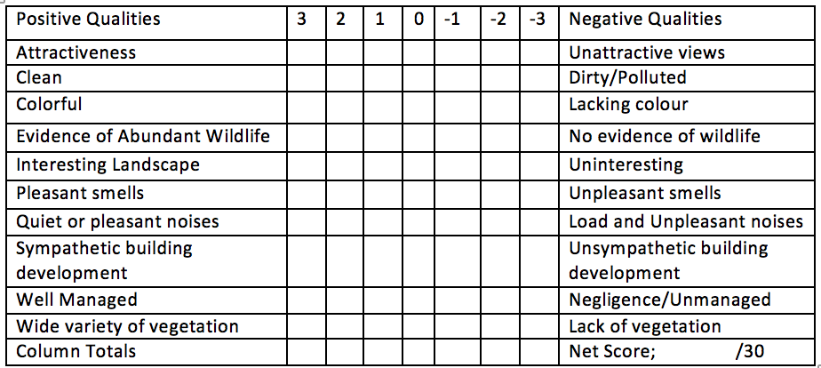
Attractiveness- natural / man made
Whole Foods

Attractiveness- natural / man made

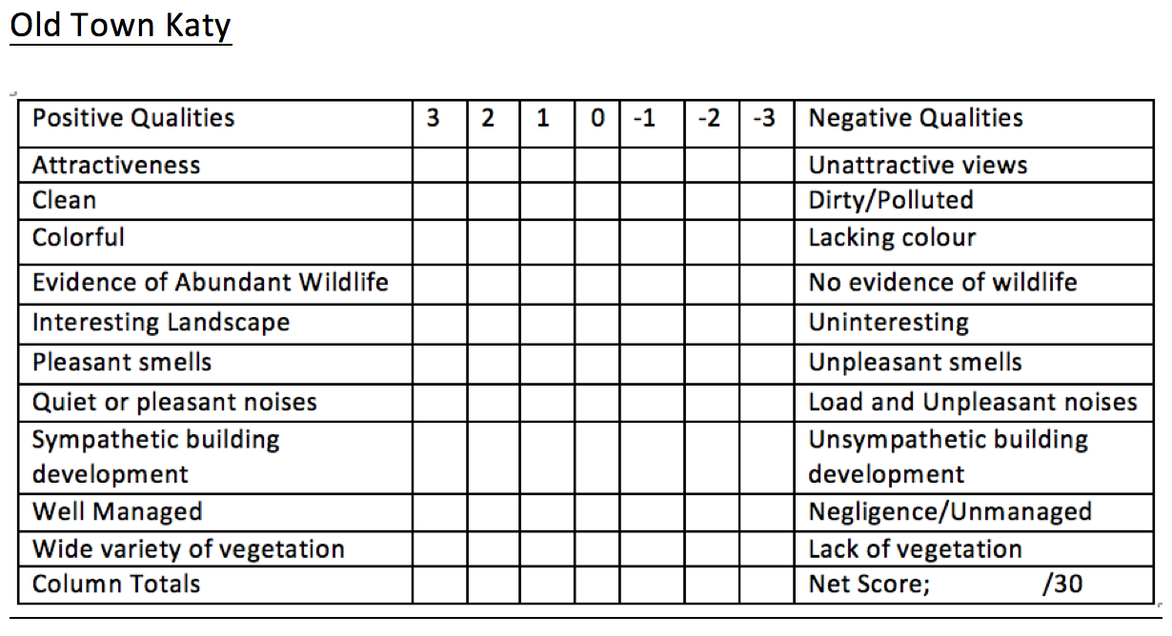

Attractiveness- natural / man made

