Global Interactions: Environmental Risks
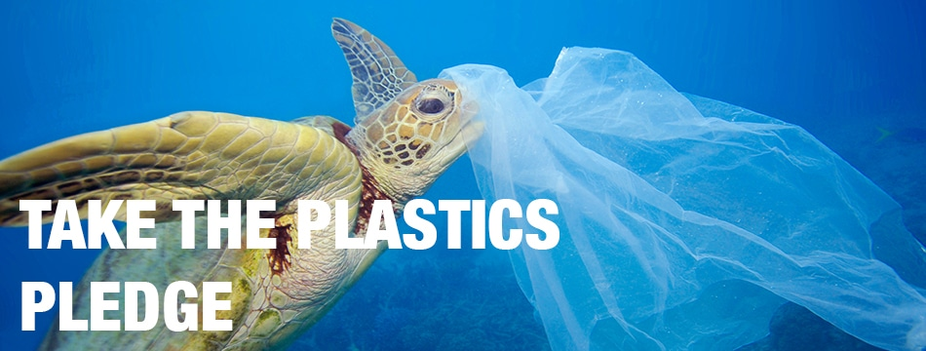

What: Environmental impacts of global flows at varying scales
Why: To understand the environmental risks that result from global interactions and how these risks can be mitigated (including civil society involvement, crowding funding etc)
How: investigate environmental risks and their management, such as the growth of plastic pollution in the ocean and its effects on local areas and the impact of pollution in shipping lanes.

Environmental risk 1: Pollution from shipping lanes:
- What are the impacts of shipping on the environment?
- How can it be managed?
Environmental risk 2: Plastic pollution in the ocean:
- What are the causes of increased plastic?
- Where is it impacting and why?
- What impacts?
What are the solutions to the issue of plastic pollution in the ocean?
- How are WWF encouraging people to reduce plastic pollution? (civil society action)
- How does the Ooho bottle work?
- How could this help with the plastics problem?
- How did the Ooho team attract investors through their crowdfunding?
- Can BoomyMcBoom face save the oceans?
- Corporate social responsibility – how are Starbucks and McDonalds trying to reduce plastic use?
- Government actions – how are the Rwandan government trying to reduce plastic use?
- Make notes on the 3 schemes described in the BBC article regarding different levels of control for plastic bags
- Complete Ban (reduce)
- Bag Tax (reduce)
- Long Life Bags - Pay particular attention to the interactive comparison section. (reuse)

Example exam question:

Examine how different kinds of global interactions can affect the physical environment. (16)

