Economic Integration

1. What is a **Trading Bloc?**

___________________________________________________________________________________________________________________________________________________________________________________________________

1. Why do countries form **Trading Blocs**?

* ______________________________________________
* ______________________________________________
* ______________________________________________
* ______________________________________________

1. Using the diagram below identify some of the different **Trading Blocs** that exist within the world.

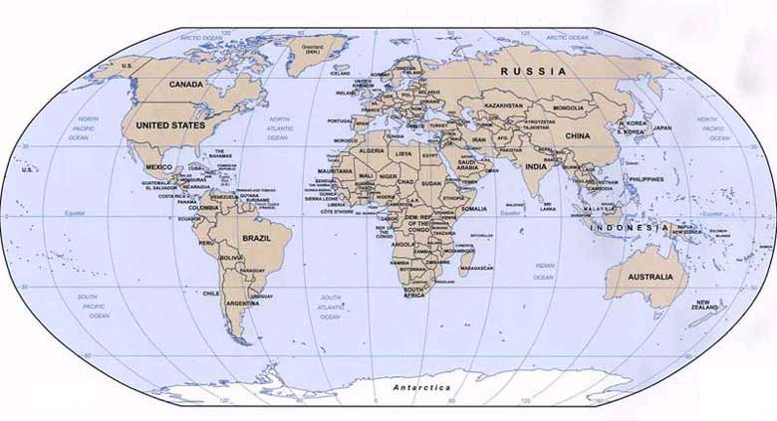

1. Explain how **Trading Blocs** are becoming increasingly important in world trade.

____________________________________________________________________________________________________________________________________________________________________________________________________________________________________________________________________

1. Identify the Trading Blocs and its members from the graphic on the next page.

|  |  |  |
| --- | --- | --- |
| Trading Bloc | Full Name | Members |
|  |  |  |
|  |  |  |
|  |  |  |
|  |  |  |
|  |  |  |
|  |  |  |
|  |  |  |
|  |  |  |
|  |  |  |

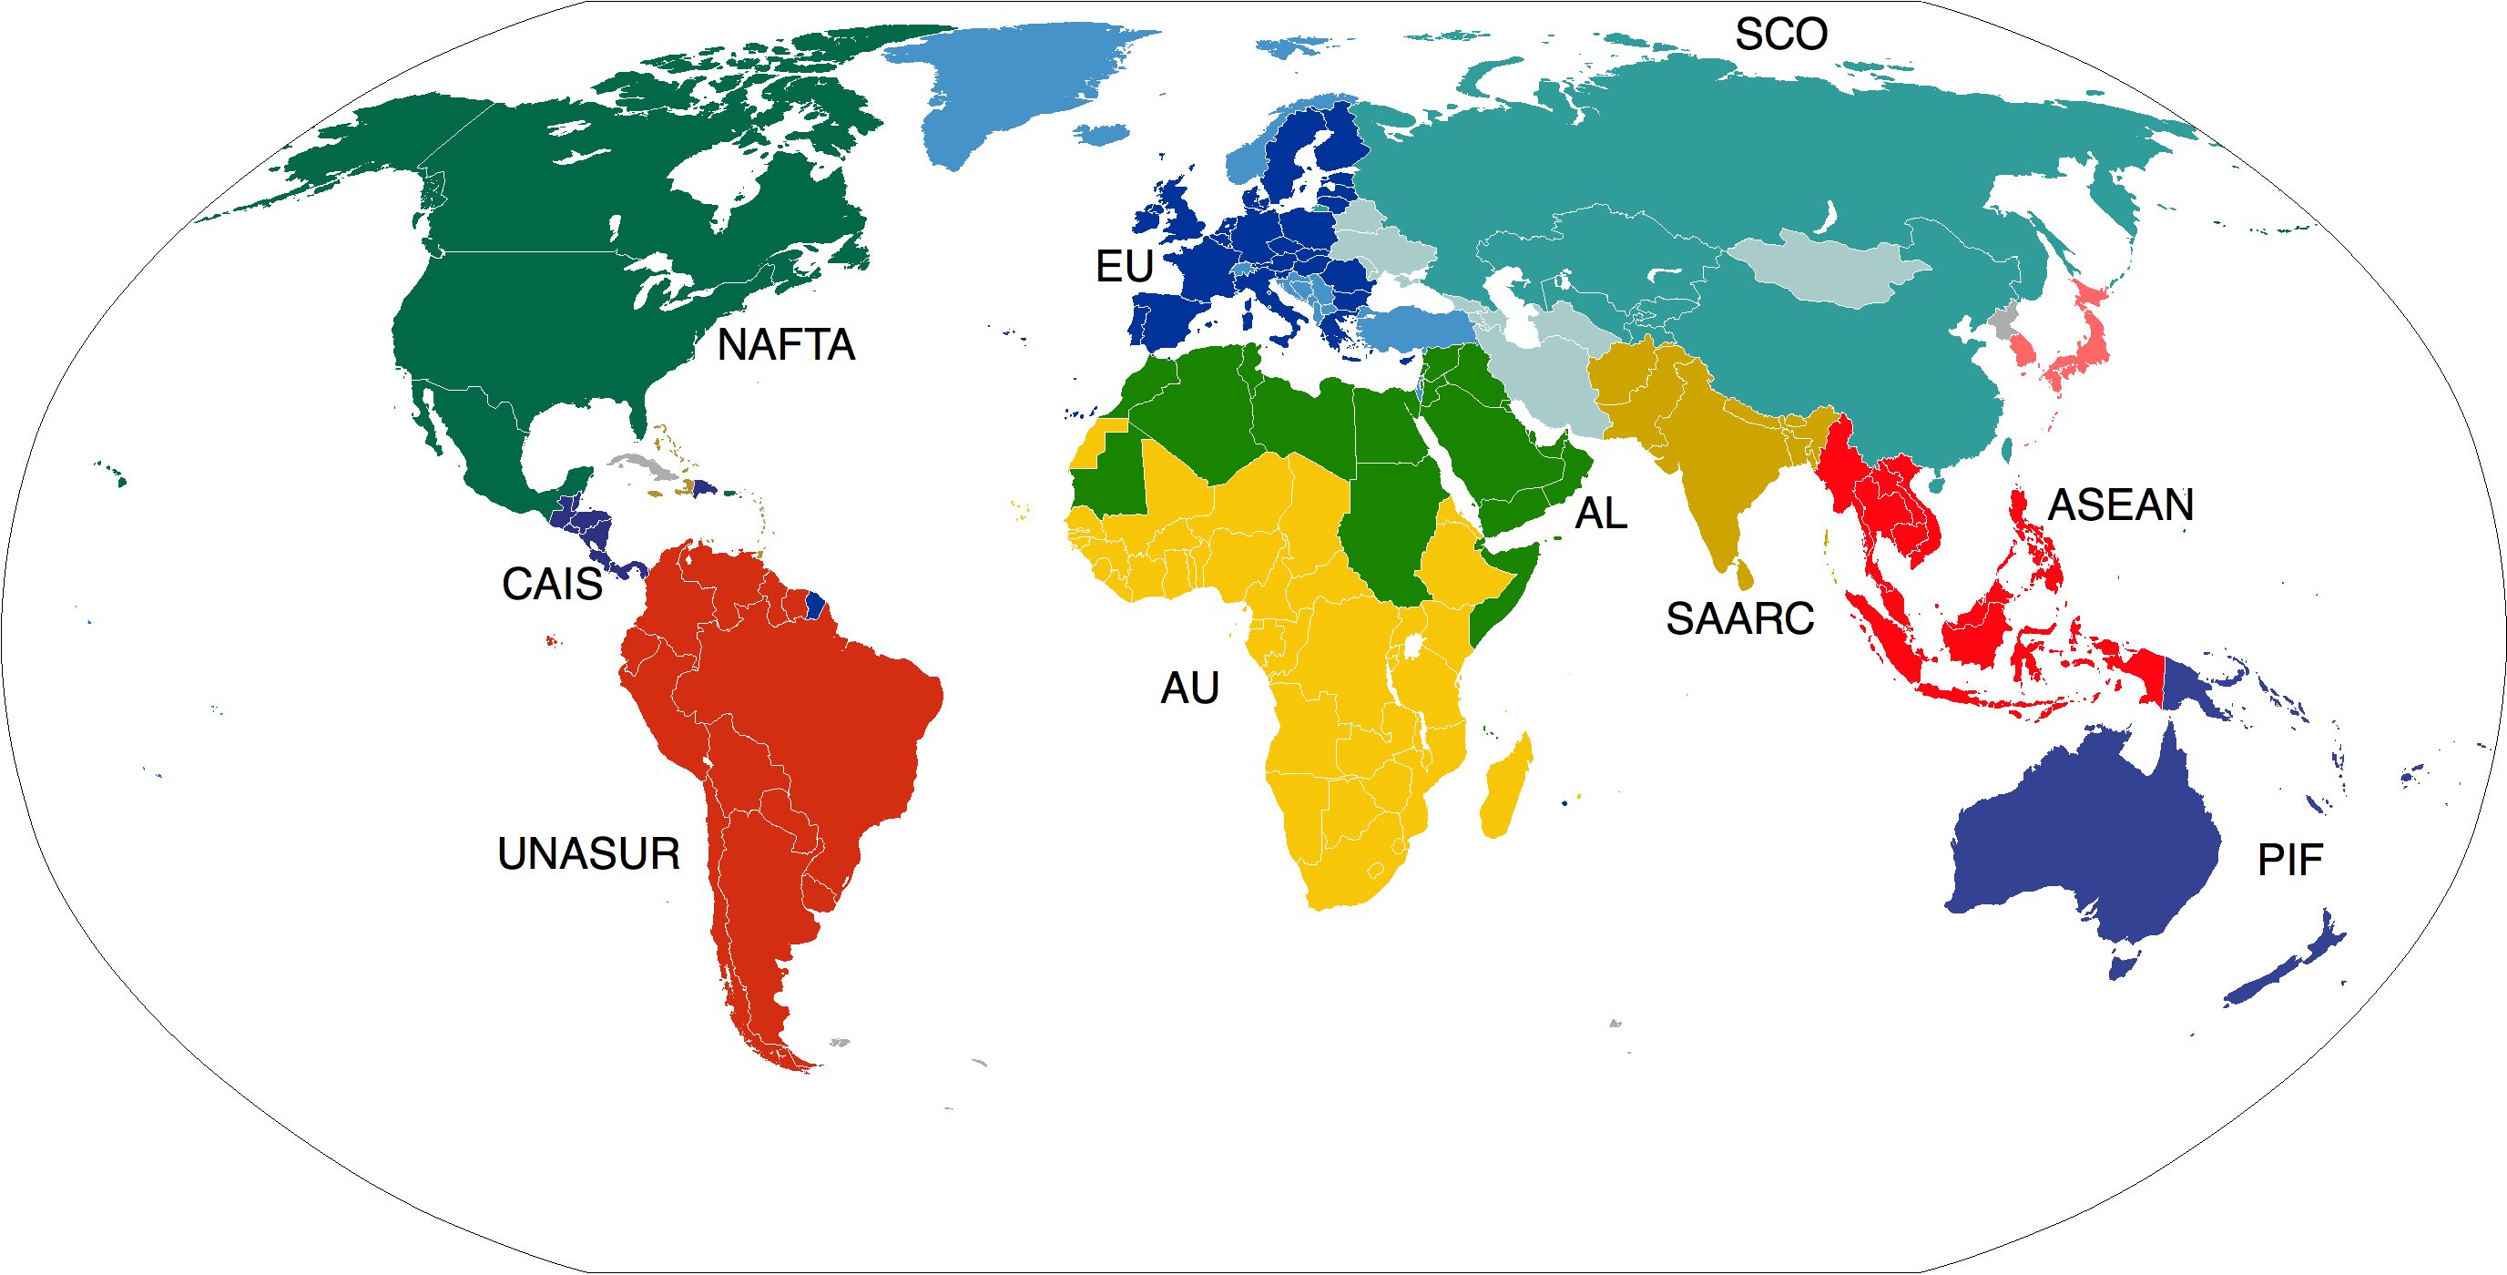

6. There are six stages of economic integration (**Balassa)**, or six forms that a trading bloc can take. These include:-

* ***Preferential Trading Area/Agreement***
* ***Free Trade Area***
* ***Customs Union***
* ***Common Market***
* ***Monetary Union***
* ***Complete Economic Integration***

7. Match the six stages to the descriptors below:-

|  |  |  |
| --- | --- | --- |
| Descriptor | Stage of Integration | Example |
| A customs union with common policies on product regulation. There is also free movement of goods, services, labour and capital |  |  |
| Nations trade freely amongst themselves, but can trade with other countries as they see fit. |  |  |
| An agreement between nations where countries trade freely and adopt a common external trade barrier against imports from outside of the trading area. |  |  |
| Final stage of economic integration with full monetary union and harmonized fiscal policies (tax and spending) |  |  |
| A trading bloc that gives preferential access to certain products from certain countries. This involves reducing or eliminating tariffs. |  |  |
| A common market with a common currency |  |  |

Common External Barriers

Customs Union

Free

Trade

**Country D**

**Country A**

**Country A**

**Country A**

***Free trade***

***Embargo***

***Imposes Tariffs***

**Country D**

***Free***

***Trade***

***Area***

**Country C**

**Country B**

**Country A**

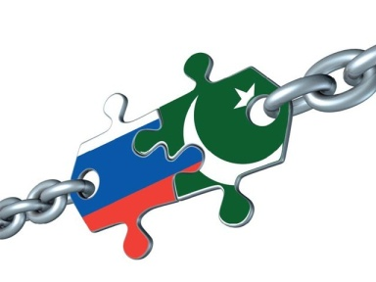8. – What is the difference between a bi-lateral and a multi-lateral free trade agreement?

**Bilateral** ________________________________________________________________________________________________________________________________________

**Multi-lateral**

________________________________________________________________________________________________________________________________________

**Monetary Union – Advantages and Disadvantages**

* There has been a big debate in some European Countries as to whether or not they should join the Euro.

1. What is a monetary union and can you give an example?

________________________________________________________________________________________________________________________________________

* Those in favour of the single currency usually quote the following reasons.

# Price Transparency

1. Why would it be easier to compare prices in different European Countries if a nation adopted the single currency?

________________________________________________________________________________________________________________________________________

Reduced exchange rate costs

1. Why do companies and individuals normally lose money when they convert one currency into another?

_________________________________________________________________________________________________________________________________________________________

1. Why would this be eliminated of we changed to the single currency?

________________________________________________________________________________________________________________________________________

Increased trade

1. Why might monetary union lead to increased trade between its members?

___________________________________________________________________________________________________________________________________________________________________________________________________

1. Complete the diagram below and explain why a firm might benefit from economies of scale as a result of the Euro.

**Long-run average cost**

## *Output*

____________________________________________________________________________________________________________________________________________________________________________________________________________



Inward Investment

1. Why might Japanese and U.S. firms wish to locate in the Eurozone?

____________________________________________________________________________________________________________________________________________________________________________________________________________

1. How might this increase in investment be beneficial for the U.K. if it joins the Euro?

____________________________________________________________________________________________________________________________________________________________________________________________________________

Macro-economic management

1. In the past macro-economic decisions have often been made according to what criteria?

____________________________________________________________________________________________________________________________________________________________________________________________________________

1. Who is responsible for monetary policy in the Euro-Zone?

_________________________________________________________________

1. Why might this be beneficial for the economies of Europe?

____________________________________________________________________________________________________________________________________________________________________________________________________________

**Disadvantages**

1. There are however several drawbacks to adopting a single currency. Consider the prices of four items in Swiss Francs.

|  |  |
| --- | --- |
| *Item* | *Price* |
|  |  |
|  |  |
|  |  |
|  |  |

13. Using the computers in the library find the exchange rate between the Swiss Franc and the Euro

_________________________________________________________________

14. Complete the table below where you identify the exact price in Euros (converted from Swiss Francs) and then the likely price that the cafeteria would charge.

|  |  |  |  |
| --- | --- | --- | --- |
| *Item* | *Price* | *Exact Euro*  *Price* | *Likely Euro Price* |
|  |  |  |  |
|  |  |  |  |
|  |  |  |  |
|  |  |  |  |

1. What is the likely to happen to the rate of inflation in many countries with a single currency?

____________________________________________________________________________________________________________________________________________________________________________________________________________

16. Why might shop-keepers be unhappy about the introduction of the Euro?

____________________________________________________________________________________________________________________________________________________________________________________________________________

1. Is the above disadvantage likely to be more short-term or long-term?

________________________________________________________________________________________________________________________________________

1. Find the following.

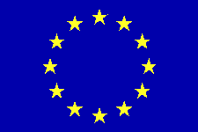

1. The rate of G.D.P. growth in a selection of Eurozone nations.
2. The rate of inflation
3. The rate of unemployment

|  |  |  |  |
| --- | --- | --- | --- |
| Country | Rate of Growth | Rate of Unemployment | Rate of Inflation |
|  |  |  |  |
|  |  |  |  |
|  |  |  |  |
|  |  |  |  |
|  |  |  |  |
|  |  |  |  |
|  |  |  |  |
|  |  |  |  |
|  |  |  |  |
|  |  |  |  |
|  |  |  |  |
|  |  |  |  |

1. Do all the members of the single currency have the same figures for growth, inflation, unemployment etc?

_____________________________________________________________________________________________________________________________________________________________________________________________

1. Choose three nations and put forward suggestions as to the best type of economic policy that could be adopted.

____________________________________________________________________________________________________________________________________________________________________________________________________________________________________________________________________

1. With the introduction of the Euro do individual nations have the opportunity to carry out whatever economic policy they wish?

___________________________________________________________________________________________________________________________________________________________________________________________________

1. Why might the common monetary policy lead to severe economic problems in some areas of the Eurozone?

___________________________________________________________________________________________________________________________________________________________________________________________________

1. How are such problems avoided in individual countries such as the U.K. or France?

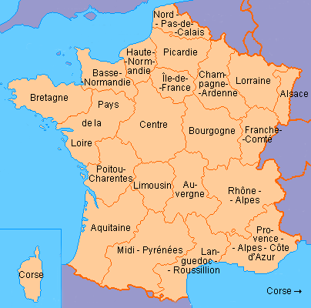

_________________________________________________________________________________________________________________________________________________________________________________________________________________________

1. Why can this not happen at present in the European Union ?

____________________________________________________________________________________________________________________________________________________________________________________________________________

1. Some argue that adopting the Euro will lead to a loss of political sovereignty. What exactly does this mean ?

**________________________________________________________________________________________________________________________________________________________________________________________________________________________________________________________________________________**

Trade Creation and Trade Diversion

**Trade Creation**.

* Consider the country below

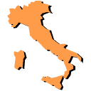

1. Imagine that Italy imposes a **20%** tariff on all car imports. What is **likely** to happen as a result of this?

______________________________________________________________________________________________________________________________

1. Now imagine that Italy joins a Common Market (The European Union)

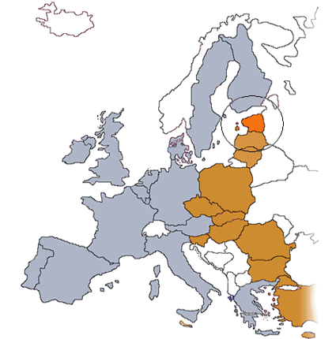

1. What is the difference in the way tariffs are imposed in the Common Market?

________________________________________________________________________________________________________________________________________

1. How might the Italian policy **change** with respect to buying cars?

________________________________________________________________________________________________________________________________________

1. Why would this be called **Trade Creation**?

____________________________________________________________________________________________________________________________________________________________________________________________________________

6. On the diagram below, illustrate the impact of trade creation.

**Price**

**Of Cars**

**Quantity of Cars bought and sold**

# Trade Diversion

Consider the country below



1. Before it joined the European Union France will have bought most of its goods and services from where?

______________________________________________________________________________________________________________________________

1. Once France joins the European Union what will occur?

______________________________________________________________________________________________________________________________

1. How might the French import policy change?

______________________________________________________________________________________________________________________________

1. Why is this an example of **Trade Diversion**?

_____________________________________________________________________________________________________________________________________________________________________________________________

1. Illustrate trade diversion on the diagram below

**Price**

**Of Cars**

**Quantity of Cars bought and sold**