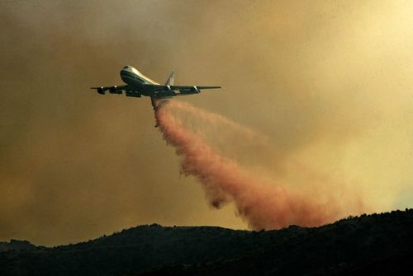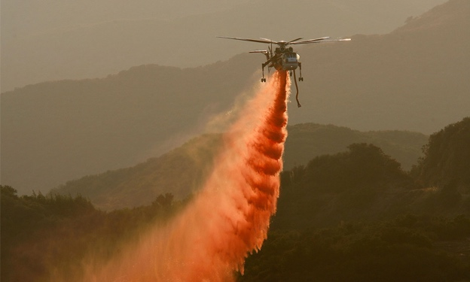

Direct or Indirect attack?

Technique: airplanes and helicopters are used for air drops where water and fire-retardant chemicals and water are released from the aircraft onto the wildfire.

Advantages

Disadvantages

-----------------------------------------------------------------------------------------------------------------

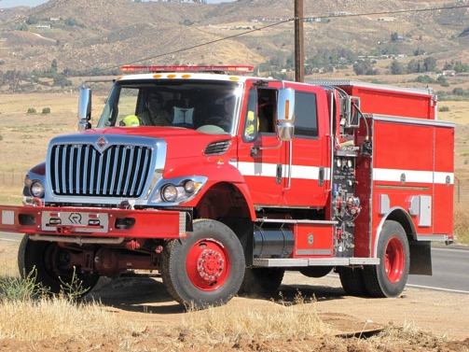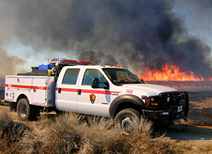

Direct or Indirect attack?

Technique: Wildland fire engines use special equipment to spray water, foam, and chemicals. The engines are able to carry up to 800 US gallons (3,000 L) of water. Many wildland fire engines are also equipped with four wheel drive and special equipment for off-road use

Advantages

Disadvantages

-----------------------------------------------------------------------------------------------------------------
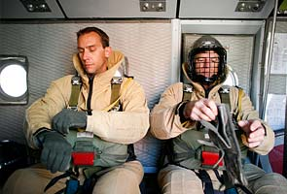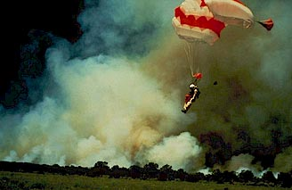

Direct or Indirect attack?

Technique: Smokejumpers parachute directly into the wildfire and carry axs and small amounts of fire retardant gel.

Advantages

Disadvantages

-----------------------------------------------------------------------------------------------------------------

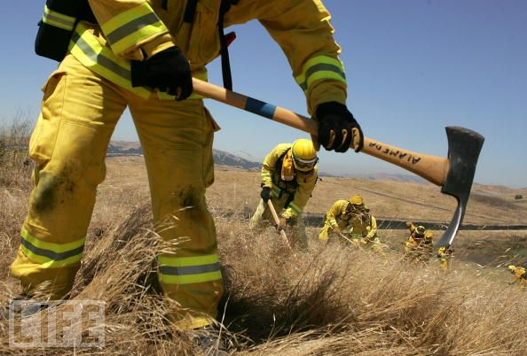

Direct or Indirect attack?

Technique: Control lines may be built to reduce the amount of fuel available for the fire. This is achieved by removing potential fuels and using natural barriers such as rivers and terrain breaks. This may be done by hand with tools called pulaskis or with bulldozers.
Advantages

Disadvantages

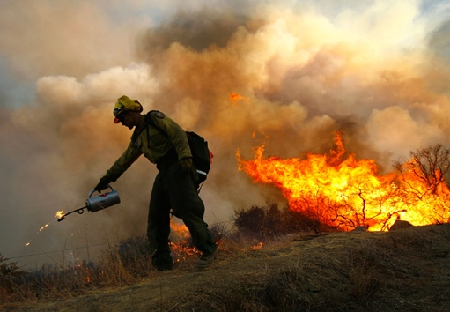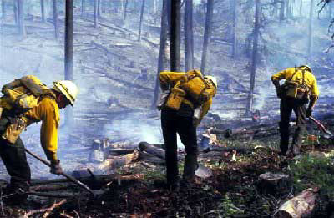

Direct or Indirect attack?
Technique: Backfiring is used to deliberatly burn areas of land ahead of the fire and use up the fuel. This is controlled by the firefighting services. Bulldozers may be used for large areas
Advantages

Disadvantages

-----------------------------------------------------------------------------------------------------------------
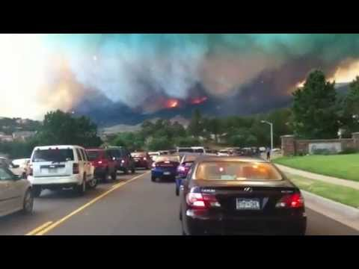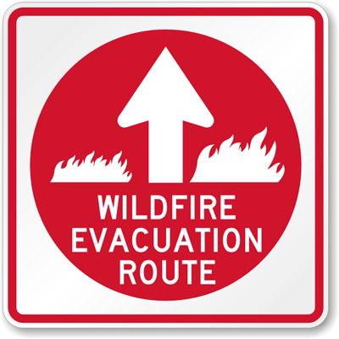

Direct or Indirect attack?

Technique: Mandatory evacuations are used when wildfires are becoming a risk to homes. People are moved to a safe area and sometimes the evacuations are enforced by law.
Advantages

Disadvantages

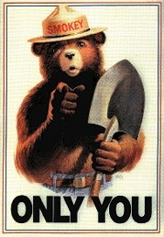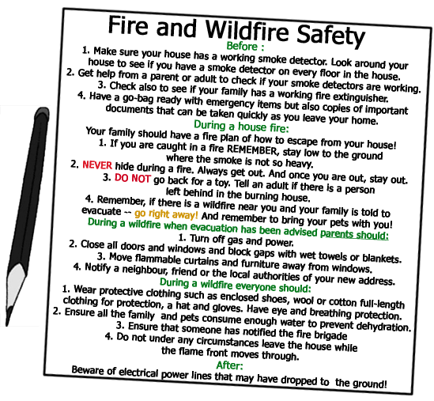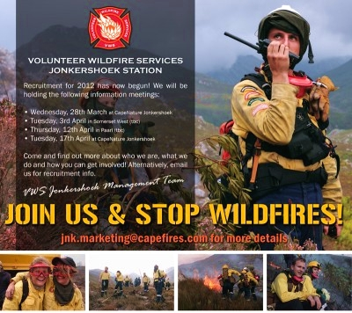

Direct or Indirect attack?
Technique: Volunteer groups help to remove dead leaves and branches from areas at risk. Park services also display advertising campaigns designed to increase awareness on how to prevent wildfires.
Advantages

Disadvantages
-------------------------------------------------------------------------------------------------------
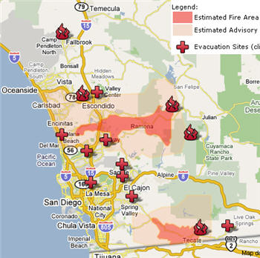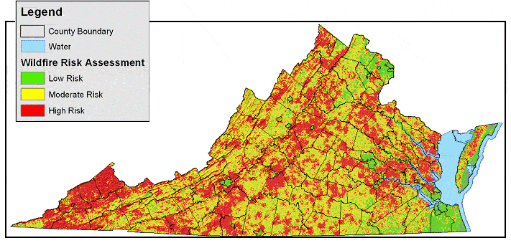
Direct or Indirect attack?
Technique: GIS (Geographical Information Systems) are being developed to show the extent of wildfire potential. They might show factors such as climate, drought potential and amount of fuel wood in a particular area and are used to forecast impending wildfires.
Advantages

Disadvantages

