Case Study A: Henry II and Thomas Becket
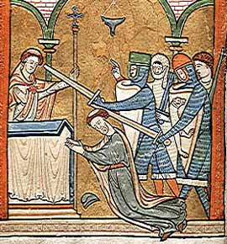
In Medieval England the Church was all powerful. The fear of going to Hell was very real and people were told that only the Catholic Church could save your soul so that you could go to Heaven. The head of the Catholic Church was the pope based in Rome. The most important position in the church in Medieval England was the Archbishop of Canterbury and both he and the king usually worked together. A king of England could not remove a pope from his position but popes claimed that they could remove a king by excommunicating him - this meant that the king’s soul was condemned to Hell and people then had the right to disobey the king.
For people in England, there was always the real problem - do you obey the king or the pope ? In fact, this was rarely a problem as both kings and popes tended to act together as both wanted to remain powerful. This is the story of one fall out that involved the Archbishop of Canterbury, Thomas Becket.
In 1162, Henry II, king of England, appointed Thomas Becket, as Archbishop of Canterbury. This was the most important religious position in England. No-one was surprised by Henry’s choice as both he and Thomas were very good friends. They enjoyed hunting, playing jokes and socialising together. Becket was known to be a lover of wine and a good horse rider. Henry II loved to ride as well but his personality was troubled by his fearsome temper. He tried to keep his temper under control by working very hard as it distracted him from things that might sparked off his temper.
Henry II also controlled a lot of France at this time. William the Conqueror had been his great-grandfather and he had inherited his French territories as a result of this. When Henry was in France sorting out problems there, he left Becket in charge of England - such was his trust in him. Becket became Henry’s chancellor - the most important position in England after the king. When the Archbishop of Canterbury died in 1162, Henry saw the chance to give his close friend even more power by appointing him Archbishop of Canterbury - the most important church position in England. Why would Henry do this?
In Henry’s reign, the Church had its own courts and any member of the Church could decide to be tried in a Church court rather than a royal court. Church courts usually gave out easier punishments to churchmen who had done wrong. Henry believed that this undermined his authority. As king, he was concerned that England was becoming too lawless - there was too much crime. He believed that Church courts did not set a good example as they were too soft on offenders. For example, a royal court would blind or cut off the hand of a thief; a Church court might send a thief on a pilgrimage.
Henry hoped that by appointing his good friend Becket, he might have more of a say in how the Church punished offenders. He hoped that Becket would do as he wished and toughen up the sentences passed out by Church courts. Becket did not want the job. As chancellor, he was as powerful as he wished to be. He also had an excellent relationship with Henry, and he did not want to spoil this. In fact, on being offered the post, Becket wrote to Henry that "our friendship will turn to hate." However, Henry persuaded Becket and he agreed in 1162 to the appointment. His letter was indeed to become prophetic (seen to predict the future).
The post of Archbishop changed Becket. He dropped his luxurious lifestyle; he ate bread and drank water, he had a luxury bed but preferred to sleep on the floor; he wore the rich clothes of an archbishop, but underneath the fine tunics he wore a horse hair shirt - very itchy and unpleasant to wear. He gave his expensive food to the poor.
In 1164, the first sign of a split between Henry and Thomas occurred. Henry passed a law which stated that any person found guilty in a Church court would be punished by a royal court. Becket refused to agree to this, and knowing of Henry’s temper, he fled abroad for his own safety. It took six years before Becket felt safe enough to return to England. However, they quickly fell out again when Becket asked the pope to excommunicate the Archbishop of York who had taken sides with the king. This was a very serious request and a very serious punishment for someone who could claim that he was only being loyal to the king. Henry was furious when he found out what Becket had done. He is said to have shouted out "will no-one rid me of this troublesome priest?" Four knights heard what Henry had shouted and took it to mean that the king wanted Becket dead. They rode to Canterbury to carry out the deed. The knights were Reginald FitzUrse, William de Tracey, Hugh de Morville and Richard le Breton. On December 29th 1170 they killed Becket in Canterbury Cathedral. After killing him, one of the knights said "Let us away. He will rise no more."
Where Becket died quickly became a place of pilgrimage. The pope quickly made him a saint. Henry II asked the pope for forgiveness and he walked bare foot to Canterbury to pray at the spot where Becket was killed. Monks whipped him while he prayed.

Case Study B: King John and Pope Innocent III

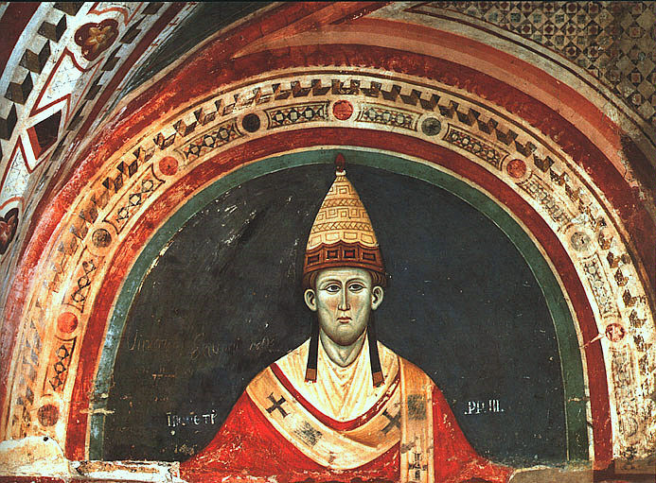
John succeeded in falling out with the pope in 1207. John quarrelled with the pope over who should be Archbishop of Canterbury. King John wanted it to be his choice John de Gray. Pope Innocent III, refused to accept John's choice of a new archbishop of Canterbury. No English king since the Conquest had failed to get an archbishop he wanted. Pope Innocent would not give way. In 1208, The pope excommunicated John and put England under a Church law that stated that no christening or marriage would be legal until the time the pope said that they would be. Church law said that only christened people could get to Heaven while children born out of marriage were doomed to Hell. This placed people in England under a terrible strain and they blamed one person for this – King John.
Not until 1213 did John give in and accept Langton. But monks, who wrote most of the chronicles, believed that a king who was excommunicated must be an evil monster. The pope never fully trusted John and in 1214, the pope proclaimed that anybody who tried to overthrow John would be legally entitled to do so. In the same year, John lost another battle to the French at Bouvines. This defeat resulted in England losing all her possessions in France. This was too much for the powerful barons in England. In 1214, they rebelled.

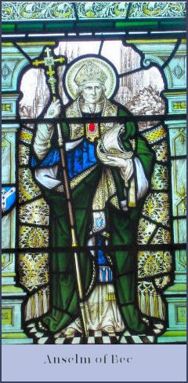
Case Study C: William II and Anselm
Unusual for his time, William II was not a devout son of the church but a sceptic in the matter of religion who held little respect for the church. William II drew the strong disapproval of the church through his practice of plundering bishoprics as soon as they fell vacant. He kept the see of Canterbury vacant for four years, while he took for himself its revenues. This made the Catholic Church angry. William II appointed the devout and learned Anselm of Bec, to be Archbishop of Canterbury. The pair soon fell into dispute on several issues.
A council was called at Rockingham in 1095 to deal with the matters of disagreement between Anselm and William II. Anselm appealed to the Pope, arguing that as Archbishop he could not lawfully be dealt with in a secular (non-church) court. The King proceeded to harass the Archbishop to the point where he could tolerate no more and in 1097 took ship for Europe, leaving William II to plunder his Archbishopric and profit further.

