Dealing with heavy content- geographical skill
Creating visual representations to encourage understanding and highlight key information. Graphics are visual elements often used to point readers and viewers to particular information. They are also used in an effort to aid readers in their understanding of a particular concept or maker the concept more clear or interesting.
Challenge
To include a range of specific case study detail figures/ place names) information about Hurricane Harvey relevant to the IGCSE geography course:
- Causes of hurricanes- physical development
- Wider causes- i.e. climate change and urbanisation in Houston
- Impacts of a specific hurricane on a coastal area (Rockport)
- Impacts of flooding (Houston)

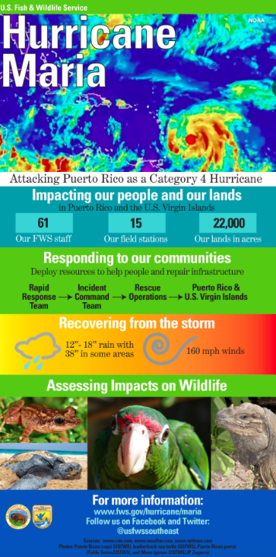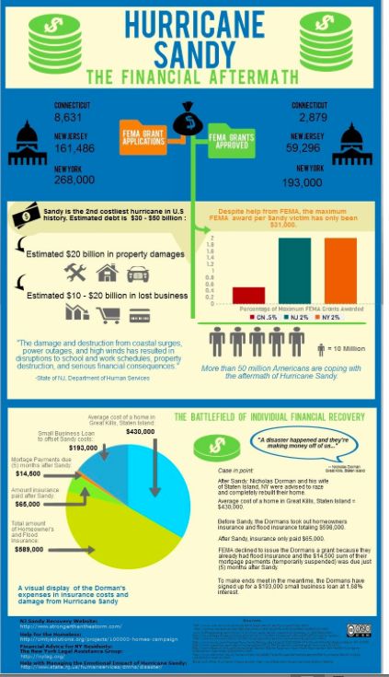
Resources:

http://www.bishoustonhumanities.net/hurricane-harvey.html
Textbook: 185- 191

Infographic making sites:

Picktochart:
bishoustonhistory@gmail.com
bishouston

Canva:
bishoustonhistory@gmail.com
bishouston

