Zaporizhzhia Power Plant - Enerhodar, south-eastern Ukraine
Zaporizhzhia is Europe's biggest nuclear power plant, which was set on fire on Friday, March 4, 2022, following intense fighting between Russian and Ukrainian troops.
Dramatic live stream video from the site - which is home to six reactors - in Enerhodar showed Vladimir Putin's troops blasting away at one of the buildings.
The Russians had been advancing on the plant throughout Thursday, March 3, 2022, and smoke was seen rising as the battle raged in the early hours.
Fire crews were reportedly unable to get near the blaze because they were being shot at by the Russians.
In a chilling warning, Ukraine's foreign minister Dmytro Kuleba said: "If it blows up, it will be 10 times larger than Chernobyl.
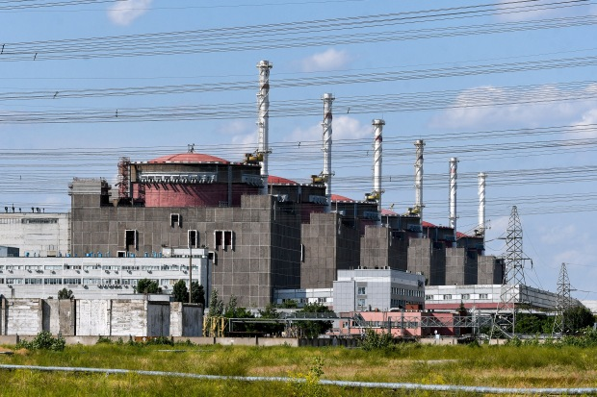

"Russians must immediately cease the fire, allow firefighters, establish a security zone."
Ukrainian citizens came out in force to block the troops from advancing.
However, on Friday, March 4, 2022, the State Nuclear Regulatory Inspectorate of Ukraine said: "The Zaporizhzhia NPP site has been seized by the military forces of the Russian Federation."
Only one of the plant's six nuclear reactors was working while the other five were either disconnected or being cooled.
Staff at the site 350 miles south of the capital Kyiv are working to inspect the damage and keep the site safe.

South Ukraine
According to the World Nuclear Association, there are three reactors located in a site called South Ukraine, which is near the Odesa coastline in southern Ukraine
The site is home to a Pressurised Water Reactor (PWR) and is run by the state-run firm, the National Nuclear Energy Generating Company, also known as Energoatom.
Construction started on the site on August 1, 1976, and the reactors went into commercial operation on December 2, 1983.

Khmelnytskyi Nuclear Power Plant - Netishyn, western Ukraine
The Khmelnytskyi Nuclear Power Plant houses two 950MWe reactors.
It started commercial operation on August 13, 1988, and it is located in the west of the country.

Rivne Nuclear Power Station - western Ukraine
This power plant in the country's north-western border with Poland has four nuclear reactors.

What happened in Chernobyl?
Chernobyl is the site of the world's world nuclear disaster.
The nuclear reactor exploded on April 26, 1986, and spewed toxic levels of radiation across Europe.
The Chernobyl nuclear power plant is situated near the now-abandoned town of Pripyat in Ukraine.
The initial explosion killed two people but radiation sickness quickly began to kill more plant workers and emergency services employees who were responding to the incident.
Authorities were slow to release information about the extent of the disaster to the outside world until radiation alarms began to go off at a nuclear plant in Sweden.
Trees surrounding the area absorbed so much radiation they died and turned red resulting in an area known as the "Red Forest".
Some 116,000 people were evacuated from the surrounding area in 1986 and there is now a 30km exclusion zone where it is illegal to live.

