Costs

- The meaning of economic costs, implicit and explicit costs
- Distinguish between the short-run and long run for businesses
- The difference between Fixed Costs and Variable Costs.
- How to calculate Total Costs (TC), Average Total Cost (ATC) and Marginal Costs (MC).

- What do we mean by economic costs?

________________________________________________________________________________________________________________________________________________________________________________________________________________________________________________

- What do we mean by implicit costs?
________________________________________________________________________________________________________________________________________________________________________________________________________________________________________________

- What do we mean by explicit costs?
________________________________________________________________________________________________________________________________________________________________________________________________________________________________________________

- How does the economist view costs differently to an accountant?

____________________________________________________________________________________________________________________________________________________________________________________________________________________________________________________________________________________________________________

- Give your own simplified example of the idea above. Make sure you use the ideas of implicit and explicit and economic costs.
____________________________________________________________________________________________________________________________________________________________________________________________________________________________________________________________________________________________________________

6.The Short-run costs involved with producing a product can be divided into two different types.

- Fixed Costs (FC) –

__________________________________________________________________________________________________________________

- Variable costs (VC) –

__________________________________________________________________________________________________________________

- On the diagram below identify the difference between fixed and variable costs.

Output
Output
Costs
Costs

Fixed

Variable

8) Using the table below classify the costs below as fixed or variable (Imagine the product is cuddly toys.

- Fabric | - Electronic parts | - Property taxes
- Salaried workers | - Rent | - Packaging
- (Water, Gas) | - Administration costs

Fixed | Variable

- How do you calculate the Total Costs of a firm?

________________________________________________________________________________________________________________________

- Complete the costs table below for the production of utility vehicles.

Total Product (Output 00’s) | TVC | TFC | TC | AFC | AVC | ATC | MC
0 | 0 | 3 | 3 | 3 | 0 | 3 | -
1 | 3 | 3 | 6 | 3 | 3 | 6 | -
2 | 5 | 3 | 8 | 1.5 | 2.5 | 4 | 2
3 | 6 | 3 | 9 | 1 | 2 | 3 | 1
4 | 7 | 3 | 10 | 0.75 | 1.75 | 2.5 | 1
5 | 7.5 | 3 | 10.5 | 0.6 | 1.5 | 2.1 | 0.5
6 | 9 | 3 | 12 | 0.5 | 1.5 | 2 | 1.5
7 | 11 | 3 | 14 | 0.42 | 1.57 | 2 | 2
8 | 14 | 3 | 17 | 0.375 | 1.75 | 2.125 | 3

- Plot the figures from the table onto the graph paper.
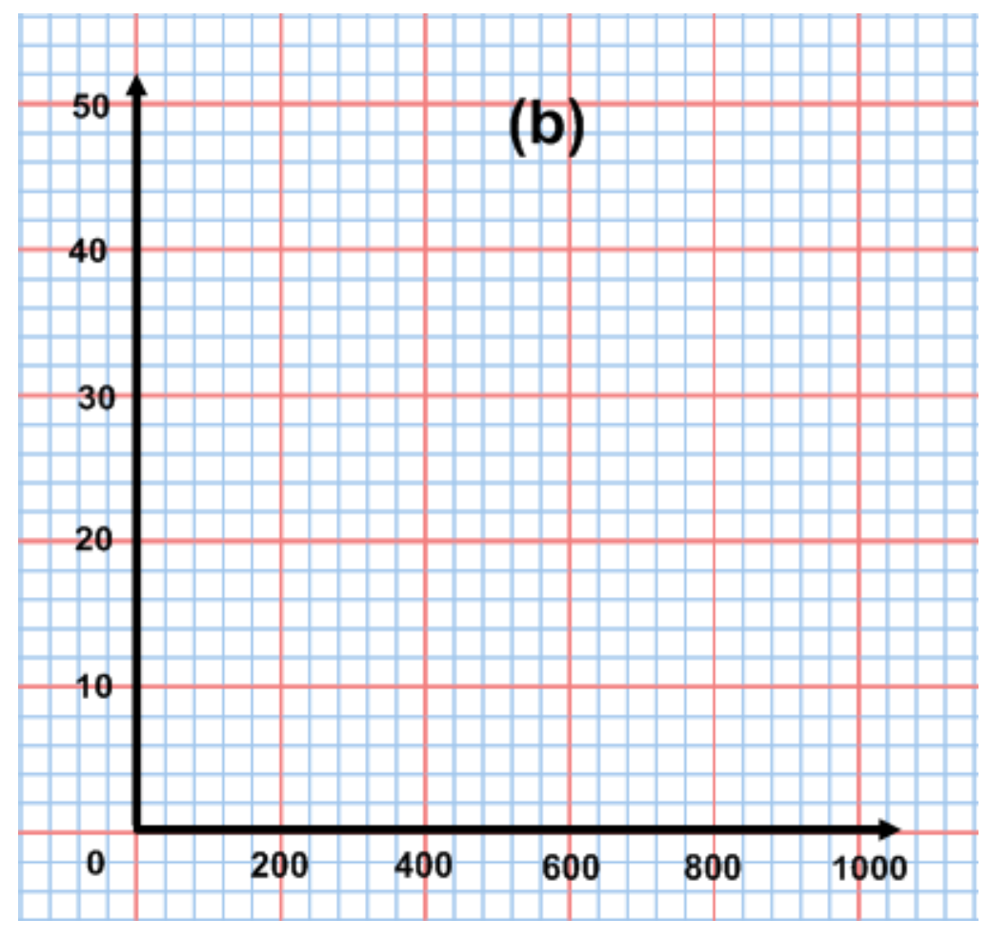
5
15
10
20

- What do you notice about the shape of the Total Cost curve?

____________________________________________________________________________________________________________________________________________________________________________________
- What do you notice about the shape of the Average Total Cost curve?

____________________________________________________________________________________________________________________________________________________________________________________
- What do you notice about the shape of the Marginal Cost curve?
___________________________________________________________________________________________________________________________________________________________________________

