Asymmetric Information

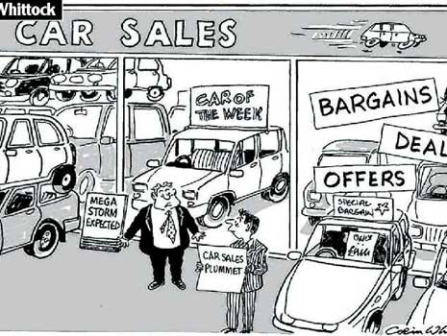
In a perfectly competitive, free market, one of the principal assumptions made is that there is perfect knowledge in the market. This means that the buyer and the seller each possess the sufficient information about market conditions and the product for sale.

This perfect knowledge means that firms must charge the market price, one which equals marginal cost.

In reality, given that nearly all real-world markets are imperfectly competitive, there is often asymmetric information in a product or factor market. Either the buyer or seller possesses more information than the other party. This asymmetric information leads to market failure.

- - Consider the following scenarios below. State which party, buyer or seller is the most informed.

Market | Most Informed Party
Second-hand cars

Life Assurance/Health Insurance

Job interview (labour market)

Restaurants in a tourist trap

Furnished flats for rent

- – Asymmetric information tends to lead to market failure due to a problem known as ‘adverse selection’

- The uninformed party gets exactly the wrong people trading with it. It gets an adverse selection of the informed parties.

- Using the same examples identify the adverse selection that occurs.

Market | Adverse Selection
Second-hand cars

Life Assurance/Health Insurance

Job interview (labour market)

Real Estate

Furnished flats for rent

- – Therefore we can now identify how the chosen markets fail in terms of price and output.

Market | Example of market failure
Second-hand cars

Life Assurance/Health Insurance

Job interview (labour market)

Restaurants in a tourist trap

Furnished flats for rent

- – The less informed party needs to find out more about the ‘hidden characteristics’ of a good, service or factor (worker or customer). Signals by the informed party can provide information to the uninformed party.

- For the same markets identify how the uninformed party might attempt to screen (ensure that they get a good deal from the offerings of the informed party)

Market | Signal/Screening
Second-hand cars

Life Assurance/Health Insurance

Job interview (labour market)

Restaurants in a tourist trap

Furnished flats for rent

- – How might the government deal with the above instances of market failure?

Market | Government Action
Second-hand cars

Life Assurance/Health Insurance

Job interview (labour market)

Restaurants in a tourist trap

Furnished flats for rent

- – Asymmetric information can lead to another type of market failure known as moral hazard. This phenomenon occurs when one party in a transaction can take actions that cannot be observed by the other party in the relationship (hidden actions).

- Another way of looking at ‘moral hazard’ is that if you reward people when bad things happen to them this will influence their behaviour in a negative fashion.

- In the table on the next page identify the instance of moral hazard that occur in different markets.

Market | Moral Hazard
Labour Market

Car Insurance

Unemployment benefit

- – In the case of adverse selection, goods or services have hidden characteristics. Therefore economic relationships have to be designed to transfer information from the informed party to the uninformed party. This transfer of information is the purpose of signals.

For instances of moral hazard the hidden actions of one party of the transaction cannot be observed by the other party. In this case, it is ‘incentives’ that are the problem. The uninformed party wants to ensure that the informed party has the right incentives to take an action.

- Identify the potential solutions to the problem of moral hazard.

Market | Solutions to the problem of Moral Hazard
Labour Markets (Employer/Employee)

Car Insurance

Unemployment benefit

