Convection currents

Take a copy of the cross section and then sort out the 8 statements below into the correct order underneath. Don't forget to add a title to your work.

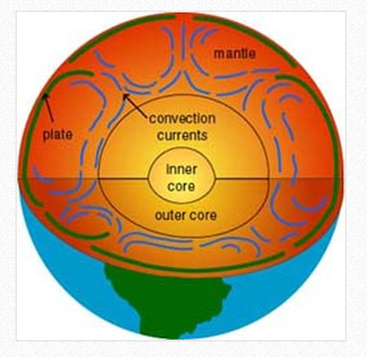

- The process is known as convection currents
- The rising and falling magma creates circular currents with the mantle
- The less dense magma then starts to rise towards the crust
- The cooling magma becomes denser and begins to sink
- As the magma warms it expands and becomes less dense.
- It are these currents that create friction with the crust above and causes it to move.
- Magma (semi-molten rock) near the outer core is heated.
- As the magma nears the crust it begins to cool.

