Social Surplus – Consumer and Producer Surplus

* Consumer surplus is defined as the difference between how much buyers are prepared to pay for a good and what they actually pay.
* Plot the demand curve given below.

|  |  |
| --- | --- |
| **Price of Uber rides ($)** | **Quantity bought** |
| 10 | 0 |
| 7.50 | 1000 |
| 5 | 2000 |
| 2.50 | 3000 |

* The above information represents the market demand curve for Uber rides.

**Quantity Demanded and Supplied**

### Price



* On the diagram above illustrate the **consumer surplus** at a price of **$5**.
* Why is there a consumer surplus on all goods and services consumed?

_______________________________________________________________________________________________________________________________________________________________________________________________________________

##### **Producer Surplus**

* 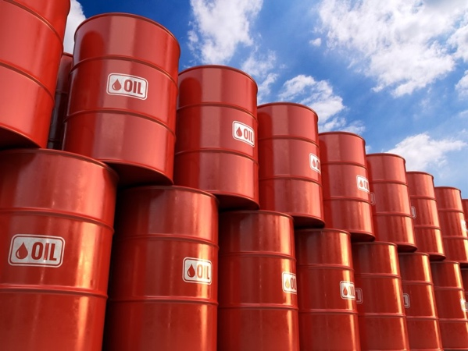When the **price of the product** exceeds the **marginal cost (supply curve**) the firm obtains a producer surplus. A producer surplus is the price of a good minus the opportunity cost of producing it.
* Plot the following information onto a supply curve. The supply of oil.

|  |  |
| --- | --- |
| Price per gallon | Quantity Supplied (M barrels) |
| 1 | 0 |
| 2 | 50 |
| 3 | 100 |
| 4 | 150 |

### Quantity Supplied

Price



* Mark on your diagram the cost to Exxon of producing the Oil.
* Illustrate the Producer surplus at a price of **$3**.

**Answer the following question.**

* Plot the demand and supply curves for the following figures. It is the market for video games.
* Find the equilibrium price.



|  |  |  |
| --- | --- | --- |
| Price (£) | Quantity Demanded (million units) | Quantity Supplied  (million units) |
| 100 | 0 | 60 |
| 80 | 5 | 50 |
| 60 | 10 | 40 |
| 40 | 15 | 30 |
| 30 | 20 | 20 |
| 20 | 25 | 10 |
| 10 | 30 | 0 |

**Quantity Demanded and Supplied**

### Price



* Mark on the above the diagram both the **consumer and the producer surplus**.
* Consumer surplus + producer surplus = _______________________________
* Use the term ______________________ to define allocative efficiency.

