Common Access Resources

In the previous lesson we looked at the difference between private goods and public goods. Private goods are excludable and rivalrous and public goods are non-excludable and non-rivalrous.

We will now consider goods and services that are either non-excludable or non rivalrous.

- – Use the images below to complete the table.
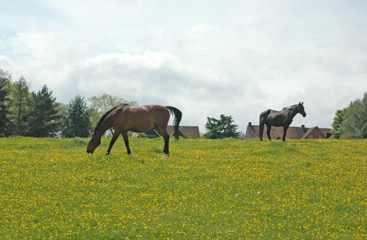

 | Excludable | Non-excludable
Rivalrous
Non-rivalrous

- – Write a definition for a ‘Common Access Resource’ using the terms non-excludable and rivalrous.

_________________________________________________________________________________________________________________________________________________________________________________________________________________________________

- – Give another example of a natural common access resource.

- – Give an example of a man-made common access resource.

- – Using the above approach (explain) how a road can fit into each of the four categories.

- Congested no-toll road
- Uncongested non-toll road
- Congested toll road
- Uncongested toll road

 | Excludable | Non-excludable
Rivalrous
Non-rivalrous

6. Complete the diagram below and explain why common access resources tend to be over-used.

Quantity Demanded/Supplied

Price

_________________________________________________________________________________________________________________________________________________________________________________________________________________________________

7. Why does over-use of common access resources represent market failure?

_________________________________________________________________________________________________________________________________________________________________________________________________________________________________

8. Why does the above situation pose a threat to the sustainable development of a nation (sustainability)?

____________________________________________________________________________________________________________________________________________________________________________________________________________________________________________________________________________________________________________

9. Using the table below, assess the possible solutions to the problem of market failure that arises from the over-consumption of common access resources.
Solution | Explanation | Potential Problem
- Introduce a price to ration the use of the common access resource

- Extend property rights to common access resources.

- Government quotas/legislation limiting access to resources.

