Colonization of the Americas

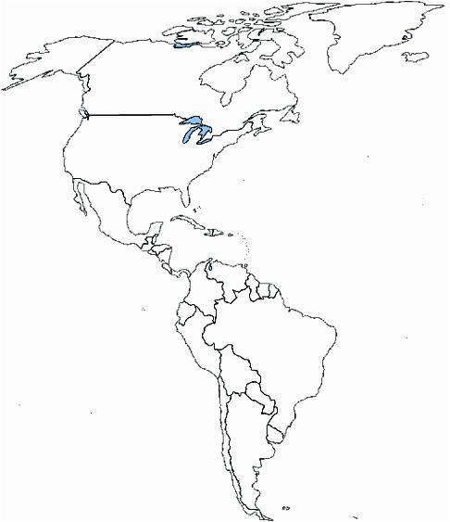
On the map of the Americas identify which countries were colonized by who and the date this occurred.

