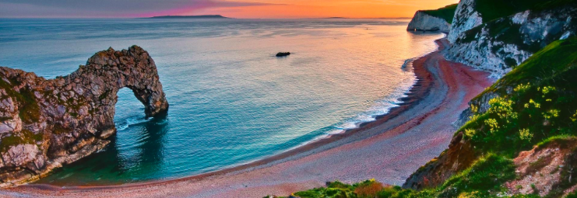

IGCSE Coasts revision

**How to use this booklet for learning.**

* Use your revision notes with this booklet
* Try answering questions in this booklet without your revision notes.
* Use the mind maps with a friend or parent. Give them detail to explain the mind map.
* Write model 7 mark answers
* Practice as many different types of questions as possible
* **Do a little often!!**

**Complete the boxes for all of these key words**

|  |  |  |
| --- | --- | --- |
| **Theme:**  **Coast** | **Explanation: what does this word mean to you?** | **Example: describe one example of this word or phrase. USE CASE STUDIES.** |
| Waves |  |  |
| Swash |  |  |
| Backwash |  |  |
| Fetch |  |  |
| Destructive waves |  |  |
| Constructive waves |  |  |
| Corrasion |  |  |
| Attrition |  |  |
| Corrosion |  |  |
| Cave |  |  |
| Wave-cut platform  Longshore drift |  |  |
| **Theme:**  **Coast** | **Explanation: what does this word mean to you?** | **Example: describe one example of this word or phrase. USE CASE STUDIES.** |
| Stack |  |  |
| Arch |  |  |
| Beach |  |  |

**Types of wave.**

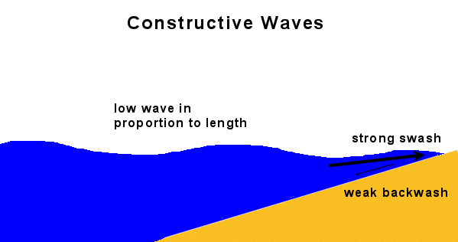**Constructive waves** build beaches. Each wave is low. As the wave breaks it carries material up the beach in its swash. The beach material will then be deposited as the backwash soaks into the sand or slowly drains away. These waves are most common in summer

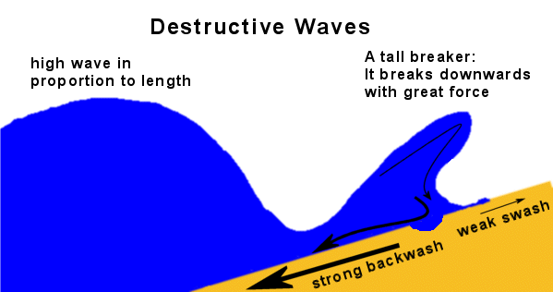**Destructive waves** destroy beaches. The waves are usually very high and very frequent. The back wash has less time to soak into the sand. As waves continue to hit the beach there is more running water to transport the material out to sea. These waves are most common in winter

**Complete the boxes for all of these key words**

|  |  |  |
| --- | --- | --- |
| **Theme:**  **TYPES OF WAVES** | **Explanation: what does this word mean to you?** | **Example: describe one coast example of this word or phrase. IF YOU CAN USE A CASE STUDY** |
| Constructive |  |  |
| Destructive |  |  |

**Processes of erosion:**

There are four main processes of erosion:

* **Hydraulic power (action):** This is the force of the water against the cliffs. Air gets trapped in the gaps and pressure builds up causing the gap to get bigger.
* **Attrition:** particles collide with one another and are broken into sand sized pieces.
* **Corrasion:** This is when sand and pebbles are thrown at the base of the cliff causing particles to be eroded away.
* **Corrosion:** This is chemical action on rocks where sea water contains a weak acid and wears away the rocks.

**Features of erosion**

**a) Headland and bay**

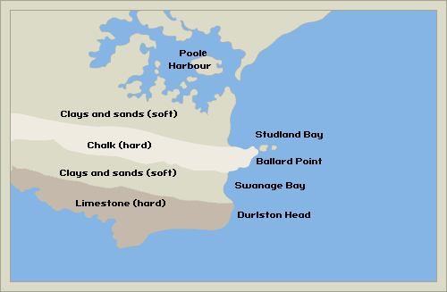Headlands and bays are usually found together on the same stretch of coastline. Headlands and bays form on [discordant coastlines](http://en.wikipedia.org/wiki/Discordant_coastline), where bands of rock of alternating [resistance](http://en.wikipedia.org/wiki/Resistance_%28geology%29) run perpendicular to the coast. Bays form where weak (less resistant) rocks (such as [sands](http://en.wikipedia.org/wiki/Sand) and [clays](http://en.wikipedia.org/wiki/Clay)) are eroded, leaving bands of stronger (more resistant) rocks (such as [chalk](http://en.wikipedia.org/wiki/Chalk), [limestone](http://en.wikipedia.org/wiki/Limestone), [granite](http://en.wikipedia.org/wiki/Granite)) forming a headland. An area of Britain where it is possible to see headlands and bays is Dorset. One of the most famous bays is Weymouth bay.

**b) Wave-cut platform** is the narrow flat area often seen at the base of a [sea cliff](http://en.wikipedia.org/wiki/Sea_cliff) caused by the action of the [waves](http://en.wikipedia.org/wiki/Wave). It forms after destructive waves hit against the cliff face, causing undercutting between the high and low water marks, mainly as a result of [corrasion](http://en.wikipedia.org/wiki/Corrasion) and [hydraulic power](http://en.wikipedia.org/wiki/Hydraulic_power), creating a wave-cut notch. This notch then enlarges into a cave. The waves undermine this portion until the roof of the cave cannot hold due to the pressure and freeze-thaw weathering acting on it, and collapses, resulting in the cliff retreating landward. Wave cut platforms are most common at low tides when they become more visible as huge areas of flat rock. One of the most famous wave-cut platforms is at Southerndown, South Wales.

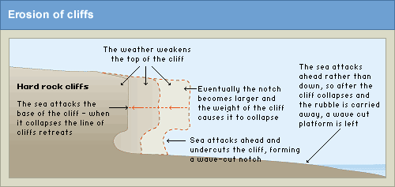

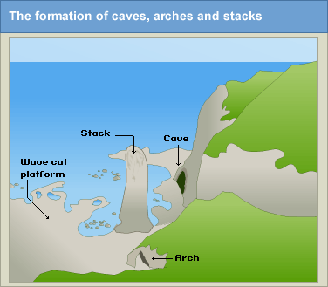**c) Arches and stacks**

This takes place is sedimentary rock where the waves begin to wear away at areas of weakness. These will get larger until caves are formed. This process will continue until the sea breaks through the headland until an arch is formed. The erosion will continue to take place until the roof of the arch will collapse and a stack is formed. The stack is then undercut leaving an arch,

**3. Draw and label how a stump may be formed?**

**Features of deposition**

**a) Beaches**

Beaches are [deposition](http://en.wikipedia.org/wiki/Deposition_%28sediment%29) [landforms](http://en.wikipedia.org/wiki/Landform), and are the result of wave action by which [waves](http://en.wikipedia.org/wiki/Wave) or [currents](http://en.wikipedia.org/wiki/Current_%28water%29) move sand or other loose [sediments](http://en.wikipedia.org/wiki/Sediment) of which the beach is made. Beach materials come from erosion of rocks offshore, as well as from headland [erosion](http://en.wikipedia.org/wiki/Erosion) and [slumping](http://en.wikipedia.org/wiki/Slumping) producing deposits of [scree](http://en.wikipedia.org/wiki/Scree). On sandy beaches, the backwash of the waves removes material forming a gently sloping beach. On shingle beaches the swash is dissipated because the large particle size allows percolation, so the backwash is not very powerful, and the beach remains steep.

**Transportation**

The 4 Processes of Transportation are -

* **Traction:** large boulders roll along the sea bed.
* **Saltation:** Smaller pebbles are bounced along the sea bed,
* **Suspension:** The finer sand and silt-sized particles are carried along in the flow of the waves
* **Solution**: Minerals, such as limestone and chalk are dissolved in the sea water and carried away, although they cannot be seen**.**

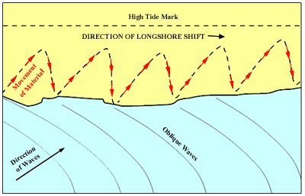

**Long shore drift**

Material is moved along the coast by a process called Longshore drift. This is a zig zag movement. It is pushed along by the dominant wind. The waves rush up the beach at an angle and return to the sea at right angles to the coast line

**Draw and label how Longshore drift works**

|  |
| --- |
|  |

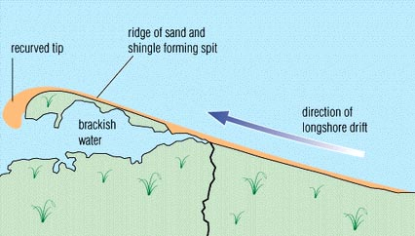**b) Spits**

A spit is a long beach made up of sand and shingle that extends out to sea. It is found:

* In areas of shallow water.
* On a bend in the coast line.

Eroded material is carried along the coast by long shore drift. This action continues until the prevailing wind and waves force the spit to start to curve. One example of a spit is Spurn head spit at Holderness.

**Explain the steps that will lead to (cause) the formation of a spit**

|  |
| --- |
|  |

**Dorset Coast, near Swanage, South East England**

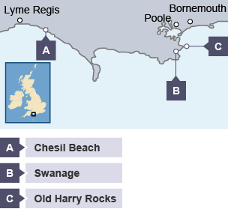Location

Dorset is in the south of England. Its coastline has examples of many erosional and depositional landforms.

For example:

* Swanage is an example of a headland and bay
* Old Harry Rocks is an example of caves, stacks and stumps
* at Chesil Beach there is a bar

Swanage Bay

The area around Swanage is made up of bands of hard and soft rock. The soft rock is made of clay and sands, and the hard rock is chalk and limestone. As erosion processes take place, the clay erodes away quicker than the limestone and chalk. This forms headlands and bays creating Swanage Bay and two headlands - Ballard Point and Durlston Head.

To the north of Swanage is Poole Harbour, one of the UK’s largest natural harbours. A great deal of deposition has taken place in this large sheltered bay. You can see two spits at the mouth of the harbour, one on the south side and one on the north.

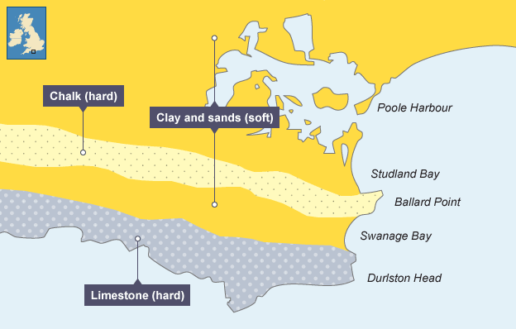

Old Harry Rocks

Old Harry Rocks are located on the headland between Swanage and Studland Bay. The headland is made from chalk, a hard rock. The headland juts out into the sea, so it is more vulnerable to high-energy waves. This caused the formation of Old Harry, a stack. Over time Old Harry will collapse to form a stump.

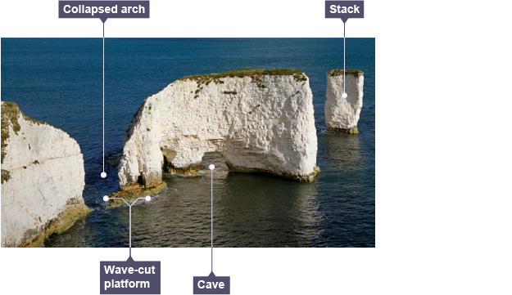

Chesil Beach

Chesil Beach is an example of a bar. Sediment has been deposited over time to form a spit. The spit has continued to join to the Isle of Portland. Behind the spit there is The Fleet, a lagoon.

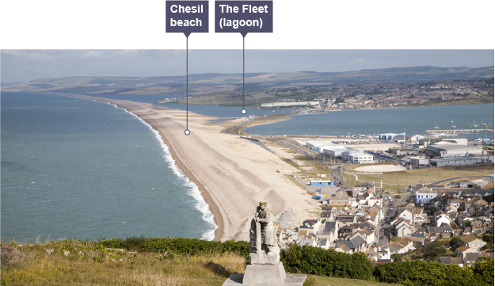



**Exam Practice**

|  |  |
| --- | --- |
| Explain how different landforms may be created by the transport and deposition of sediment along the coast.  [7 marks] | |
| Identity a landform created by transport and deposition. Explain how it is formed. | ____________________________________________________  ____________________________________________________  ____________________________________________________  ____________________________________________________  ____________________________________________________  ____________________________________________________  ____________________________________________________  ____________________________________________________ |
| Identify an additional landform created by transport and deposition. Explain formation | ____________________________________________________  ____________________________________________________  ____________________________________________________  ____________________________________________________  ____________________________________________________  ____________________________________________________  ____________________________________________________  ____________________________________________________ |

|  |  |
| --- | --- |
| With reference to an example of a section of coastline, describe the major coastal landforms of deposition.  [7 marks] | |
| Identity a landform created by deposition. Explain how it is formed. | ____________________________________________________  ____________________________________________________  ____________________________________________________  ____________________________________________________  ____________________________________________________  ____________________________________________________  ____________________________________________________  ____________________________________________________ |
| Identify an additional landform created by transport and deposition. Explain briefly explain the formation | ____________________________________________________  ____________________________________________________  ____________________________________________________  ____________________________________________________  ____________________________________________________  ____________________________________________________  ____________________________________________________  ____________________________________________________ |

**Coastal management schemes.**

**Soft engineering options**

Soft engineering options are often less expensive than hard engineering options. They are usually also more long-term and sustainable, with less impact on the environment. There are two main types of soft engineering.

**1. Beach nourishment**

* This replaces beach or cliff material that has been removed by erosion or longshore drift.
* The main advantage is that beaches are a natural defence against erosion and coastal flooding. Beaches also attract tourists.
* While it can be a relatively inexpensive option it requires constant maintenance to keep replacing the beach material as it is washed away.

**2. Managed retreat**

* This is where areas of the coast are allowed to erode and flood naturally. Usually this will be areas considered to be low value.
* The advantages are that it encourages the development of beaches (a natural defence) and salt marshes (important for the environment) and cost is low.
* While this is a cheap option, it will not be free as people will need to be compensated for loss of buildings and farmland.

**Hard engineering**

Hard engineering options tend to be expensive and short-term options. They may also have a high impact on the landscape or environment. The table shows the most common hard engineering solutions.

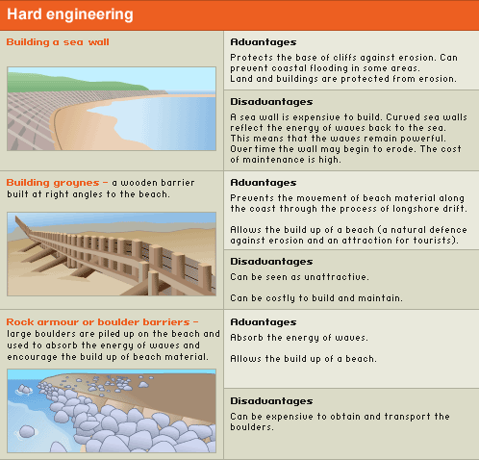

The management of coastlines is needed to protect our landuse such as settlements, tourism, roads and farming. The cost-benefit of any scheme must be balanced when deciding on the type of management for an area.

Coastlines can be used for recreation, settlement and industry. These activities will affect the coastline and can lead to visitor pressures, pollution, footpath erosion etc. The building of new houses and industries will also affect the coastline.

Conflicts may arise as different users have different uses for the coastline. For example, bird watchers and farmers, locals and hotel owners or rock climbers and the local authority. Different opinions and activities have to be balanced when managing the natural processes along a coastline.

**Coastal protection**

|  |  |  |  |
| --- | --- | --- | --- |
|  | **Explanation: what does this word mean to you?**  A coast where you can find one | Advantages | Disadvantages |
| Sea wall |  |  |  |
| Groynes |  |  |  |
| Gabions |  |  |  |
| Beach Rebuilding |  |  |  |

**Coastal example: Holderness coast.**

The Holderness coast is located in the north east of England. This is one of the most vulnerable coastlines in the world, retreating at a rate of one to two metres a year. There are two causes of the problem.

The Holderness coast is a 61km stretch of coast running from Flamborough Head in the north to Spurn Head (a spit) in the south. The Holderness coast is located in the NE of England. The Holderness coast is one of the fastest eroding coastlines in the world and the fastest eroding in Europe. On average the coast erodes at about 2 metres a year. This might not sound much, but if you multiply 2 metres by 1000 years, then that is 2 km of coastal erosion.

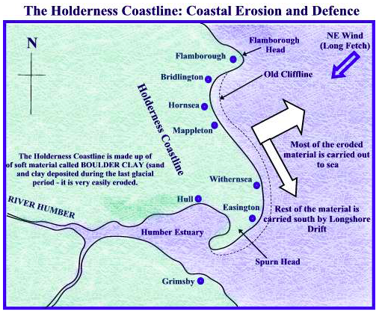

Main causes:

* Strong prevailing winds create a longshore drift that moves material southwards along the coast.
* The cliffs are made of soft clay, so they will erode quickly.   
  18,000 years ago the north of England was covered in ice (last ice age). As the ice melted it deposited huge amounts of glacial deposits. These glacial deposits actually extended the Holderness coast out into the sea. However, the glacial deposits (known as boulder clay) that make up the coast are extremely weak and vulnerable to erosion. Since Roman times, the coast has eroded by about 4km and around 30 villages have been washed into the sea, along with hundreds of square kilometres of farmland

Management on the Holderness Coast

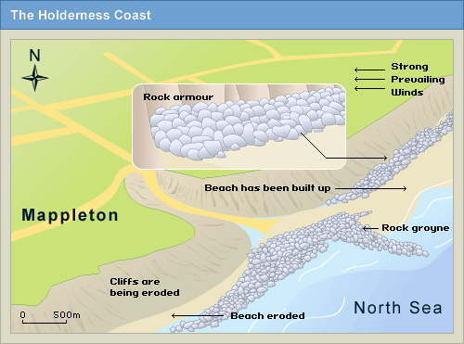

The village of Mappleton, perched on the cliff top, has approximately 50 properties. As the cliff is eroded away, the village is under threat.

In 1991, the decision was taken to protect the settlement of Mappleton, along the Holderness coast, south of Hornsea. A coastal management scheme costing £2 million was introduced. This involved two types of hard engineering: placing rock armour along the base of the cliff and building two rock groynes.

* The scheme has protected the settlement of Mappleton and the cliffs are no longer at great risk from erosion.
* The rock groynes have stopped beach material being moved south from Mappleton along the coast. This has increased erosion south of Mappleton.
* This shows that benefits in one area might have a negative effect on another area. This increases conflict between interest groups.

**Hornsea:** Hornsea is the main settlement on the Holderness coasts. It has a population of around 8,500 and is an important holiday destination. Because it generates a large income through tourism, it was decided to protect Hornsea. On the sea front a 3 metre high recurved sea wall was built to absorb and reflect wave energy. Groynes were also placed along the beach to try and prevent longshore drift and keep Hornsea's beach intact. On top of the sea wall, the cliff was also strengthened by building a concrete promenade. The promenade has a road on it, small cafes and shops and seating areas.  
  
  
**Withernsea:** Because Hornsea and Mappleton were protected it also became necessary to protect Withernsea further south. Withernsea has been protected with a sea wall, rip-rap and groynes.  
  
**Easington:** With Hornsea, Mappleton and Withernsea all protected, Easington is the next settlement along the coast. Because of defences north of it, its coastline is eroding an accelerating rate. Easington is home to a large natural gas terminal, so decisions on its defence will have to be made soon.

**Possible Conflict on the Holderness Coast**

Because coastlines are in demand, conflicts can often take place. For example the Holderness coast is used a holiday destination, it is used for walking, bird watching, farming, playing golf, living (private residences), transport, farming, fishing, refining oil/gas, Geography fieldtrips, etc. When you have so many groups of people wanting to use the coast, conflict is going to happen occasionally.

**7. Coastal Case study – Holderness**

|  |  |  |
| --- | --- | --- |
| Describe its Location – | What were the problems? | How did they manage the area? |



**Exam Practice**

|  |  |
| --- | --- |
| For a coastal landscape you have studied, outline the management strategy used.  **[7 marks]** | |
| Introduction:  What is your coastal landscape? | ____________________________________________________  ____________________________________________________  ____________________________________________________  ____________________________________________________ |
| Paragraph 1 –  Outline the management strategy and one way it has been successful.  What part of the coast was it used on?  Why was this decision made?  Use specific case stud detail  (target consider hard and soft engineering) | ____________________________________________________  ____________________________________________________  ____________________________________________________  ____________________________________________________  ____________________________________________________  ____________________________________________________  ____________________________________________________  ____________________________________________________  ____________________________________________________  ____________________________________________________  ____________________________________________________  ____________________________________________________ |
| Paragraph 2 –  Outline the management strategy and one way it has been successful.  What part of the coast was it used on?  Why was this decision made?  Use specific case stud detail  (target consider hard and soft engineering) | ____________________________________________________  ____________________________________________________  ____________________________________________________  ____________________________________________________  ____________________________________________________  ____________________________________________________  ____________________________________________________  ____________________________________________________  ____________________________________________________  ____________________________________________________  ____________________________________________________  ____________________________________________________ |
| Conclusion:  Your overall opinion linking back to the exam question. | ____________________________________________________  ____________________________________________________  ____________________________________________________  ____________________________________________________  ____________________________________________________  ____________________________________________________ |

|  |  |
| --- | --- |
| Name an example of a coastal management scheme.  ______________________________________________________  Assess whether the overall benefits outweigh any conflicts that are caused as a result of the scheme.  **[7 marks]** | |
| Introduction:  What is your coastal management scheme? | ____________________________________________________  ____________________________________________________  ____________________________________________________  ____________________________________________________ |
| Paragraph 1 –  Outline a way the scheme was successful.  Give evidence and examples. | ____________________________________________________  ____________________________________________________  ____________________________________________________  ____________________________________________________  ____________________________________________________  ____________________________________________________  ____________________________________________________  ____________________________________________________ |
| Counterargument –  Outline a way that the conflicts outweigh the benefits.  Give examples and evidence. | ____________________________________________________  ____________________________________________________  ____________________________________________________  ____________________________________________________  ____________________________________________________  ____________________________________________________  ____________________________________________________  ____________________________________________________ |
| Conclusion:  Your overall opinion linking back to the exam question. | ____________________________________________________  ____________________________________________________  ____________________________________________________  ____________________________________________________  ____________________________________________________  ____________________________________________________ |

|  |  |
| --- | --- |
| ‘Hard engineering strategies are effective in protecting the coastline.’ Do you agree with this statement? Explain your answer.  **[ 5 marks]** | |
| Introduction:  What is your coastal management scheme? What is hard and soft engineering? | ____________________________________________________  ____________________________________________________  ____________________________________________________  ____________________________________________________ |
| Paragraph 1 –  Hard engineering is more effective than soft engineering in managing the coastline.  Link to examples. | ____________________________________________________  ____________________________________________________  ____________________________________________________  ____________________________________________________  ____________________________________________________  ____________________________________________________  ____________________________________________________  ____________________________________________________ |
| Counterargument –  Soft engineering is more effective than hard engineering in managing the coastline.  Link to examples. | ____________________________________________________  ____________________________________________________  ____________________________________________________  ____________________________________________________  ____________________________________________________  ____________________________________________________  ____________________________________________________  ____________________________________________________ |
| Conclusion:  Your overall opinion linking back to the exam question. | ____________________________________________________  ____________________________________________________  ____________________________________________________  ____________________________________________________  ____________________________________________________  ____________________________________________________ |

## **Coral Reefs**

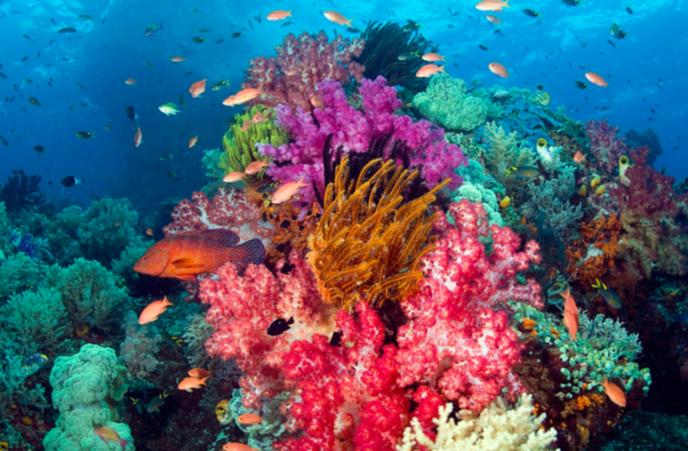  
A coral reef is a line of coral polyp found in warm shallow seas. Polyp are tiny carnivorous (meat eating) animals**.** Polyps live in groups called colonies. A polyp has a mouth at one end. The mouth is surrounded by a number of tentacles. These tentacles resemble feet, which is how they get their name ('polyp' is a Greek word meaning 'many feet'). Polyps cannot move from their limestone homes. They mostly feed at night.  
  
A polyp reproduces by dividing its own body to form two polyps, or by producing sperm and eggs. Each polyp builds a case of limestone around itself, using calcium from the water. It is like a house, with a floor and walls. This remains after it has died and forms a foundation for another polyp to build a house on, putting a floor on the roof of the old one. When these limestone formations increase, they are called a coral reefs.  
  
Coral reefs are very delicate and need the following conditions to form:

* Tropical sea conditions (between the two tropics)
* Warm waters (must be over 18 degrees centigrade year round)
* Clear water ( no sediment)
* No pollution
* Sunlight
* Water less than 60 metres deep

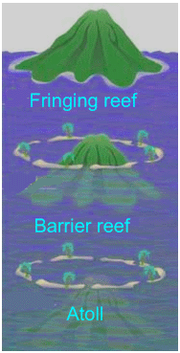**Fringing Reef:** Fringing reefs circle or fringe the coastline or islands. They are often protected by barrier reefs further out to sea, so the plants and animals that live in fringing reefs are suited to low wave energy environments.  
  
**Barrier Reef:** These occur further from the sea and are commonly separated from the mainland or island by a deep lagoon. Barrier reefs are normally older and wider than fringing reefs. The Great Barrier reef in Eastern Australia is a barrier reef and stretches for 1600km.  
  
**Atoll:** They rise from submerged volcanoes. They are similar to barrier reefs in terms of biodiversity and form. However, they are confined to submerged oceanic islands, unlike barrier islands which can follow continental coastlines e.g. Great Barrier Reef.

|  |  |
| --- | --- |
| BENEFITS OF CORAL REEFS | HOW CORAL REEFS ARE BEING DAMAGED |
| * They support 25% of marine species (about 1 million species of plants and animals) * They protect coastlines from erosion * They form as a natural barrier against tropical storms and even tsunamis (they can absorb energy). * Act as natural recycling agent for carbon dioxide from sea and atmosphere * They contribute material to the formation of beaches (eroded coral reef) * They are source of raw material (coral for jewelery and ornaments) * Many species are being found to contain compounds useful in medicine. * They benefit the tourism industry because many people like to dive and snorkel over coral reefs * They provide important fishing grounds * The global value of coral reefs in terms of coastal protection, fishing and tourism has been estimated at $375 billion. | * Rising sea levels mean that the depth of water above coral reefs is increasing. This means that in the future many coral reefs will not receive enough sunlight to survive. * Increases in the global climate means that many corals are being bleached. Coral reefs are extremely sensitive to changes in temperature and can bleach (die and turn white) even with only small increases. * Hurricanes. Although coral reefs act as a natural defence against tropical storms, they can be severely damaged during tropical storms. * Fishing techniques like dynamite, cyanide and trawling can damage corals. Corals are sensitive and take hundreds and thousands of years to grow.Damaging fishing techniques therefore can cause long term damage. * Deforestation. As areas of land are deforested, especially in the tropics (Indonesia, Thailand, Philippines) there is greater surface run-off and more sediment enters the rivers and is ultimately discharged into the sea. The increased sediment reduces visibility and means less sunlight reaches the coral. * Overfishing. Not only do damaging fishing techniques damage the coral but also overfishing. Coral reefs have very delicate food webs and if you remove elements of the food web, it can upset the balance of the reefs. * Pollution. The growth of urban settlements and tourist developments, as well as increased coastal traffic can also cause pollution to reefs. * Tourism. Tourism can damage reefs in many ways. Anchors from tourist boats can damage reefs. Motor boat engines can kill animals. Divers can touch and damage coral and tourist developments can release pollution. * Marine trade. There are many products, like coral, turtle shells, star fish and sea shells that get removed from corals and sold. This removal of coral and animals damage the reefs. |

## 

## **Coral Reef Management**

* Damaging fishing practices like dynamiting can be banned. It is important that this is enforced or the practices will carry on.
* Conservation zones where tourists aren’t allowed or there numbers are restricted can be created.
* Areas where coral reef cannot be farmed can be created
* Fish stocks can be enhanced and quotas imposed on amount being caught
* Sewage outlets can be moved downstream of coral reefs
* Banning the dropping of anchors on coral reef.
* Reduce the use of fertilisers near coral reefs
* Finally one of the most important is educating people about why coral reefs are important and how we can protect them.

Case Study: The Great Barrier Reef, Australia

The Great Barrier Reef is the world’s largest coral reef system composed of over 2,900 individual reefs and 900 islands stretching for over 2,300 kilometres. The reef is located in the Coral Sea, off the coast of Queensland, Australia.

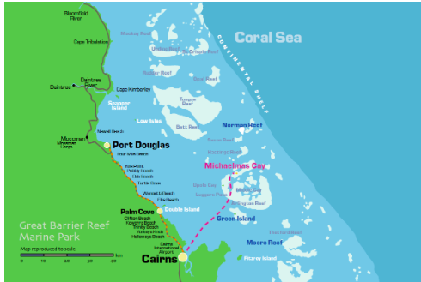The Great Barrier Reef can be seen from outer space and is the world’s biggest single structure made by living organisms. This reef structure is composed of and built by billions of tiny organisms, known as coral polyps. It supports a wide diversity of life and was selected as a World Heritage Site in 1981. CNN labelled it one of the seven natural wonders of the world. The Queensland National Trust named it a state icon of Queensland.

A large part of the reef is protected by the Great Barrier Reef Marine Park, which helps to limit the impact of human use, such as fishing and tourism. Other environmental pressures on the reef and its ecosystem include runoff, climate change accompanied by mass coral bleaching, and cyclic population outbreaks of the crown-of-thorns starfish. According to a study published in October 2012 by the Proceedings of the National Academy of Sciences, the reef has lost more than half its coral cover since 1985.

The Great Barrier Reef has long been known to and used by the Aboriginal Australian and Torres Strait Islander peoples, and is an important part of local groups’ cultures and spirituality. The reef is a very popular destination for tourists, especially in the Whitsunday Islands and Cairns regions. Tourism is an important economic activity for the region, generating over $3 billion per yea

|  |  |
| --- | --- |
| For a named area of coral reef which you have studied, describe the conditions which led to its formation. [7] | |
| What is a coral reef?  Include a named example of an area with Coral reefs | ____________________________________________________  ____________________________________________________  ____________________________________________________  ____________________________________________________ |
| Point 1 –Theory  How are barrier reefs formed? | ____________________________________________________  ____________________________________________________  ____________________________________________________  ____________________________________________________  ____________________________________________________  ____________________________________________________  ____________________________________________________  ____________________________________________________ |
| Point 2 –  What are the conditions in the area that have allowed the reef to develop? | ____________________________________________________  ____________________________________________________  ____________________________________________________  ____________________________________________________  ____________________________________________________  ____________________________________________________  ____________________________________________________  ____________________________________________________ |

**Mangroves**

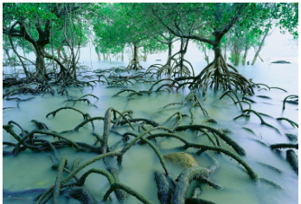Mangroves are a tree or shrub which grows in tidal, chiefly tropical, coastal swamps, having numerous tangled roots that grow above ground and form dense thickets. It is thought that originate from South-east Asia and then spread across the globe. Because they grow in the intertidal zone, they live in a constantly changing environment.

Distribution is controlled by the following factors of growth:

* **Temperatures** – Most mangroves grow only 30 degrees latitude of the equator.
* **Salinity** – The water around mangroves has to be of a certain salt content if not the mangrove will suffer, so if fresh water is added to salty water this would be harmful.
* **Exposer to Air** – Air is too rich in oxygen will harm to mangrove if the mangrove is exposed for too long.

Value

* **Contain Natural Resources** – Charcoal, firewood, fish, medicines and other substances can be extracted form mangroves.
* **Foraging and Living Place for Wildlife** – Without mangroves there would be no habitat for animals so there would be no animals.
* **Reducing Water Pollution** – The root systems of mangrove species absorb inorganic substances and reduce water pollution.
* **Protecting the Coastline** – Because the roots of a mangroves act  can stabilise the coastlines of the river shores and river mouths. They also protect the coastline from wave erosion.
* **Flood Prevention** – Mangroves can stabilise water capacity of the substratum and on the soil surface, hence steady and retain water to prevent flooding.
* **Ornamental Value** – A mangrove forest is a beautiful environment with a diversity of life that in some peoples eyes is with saving.

Threats

* **Clearing** – Mangrove forests have often been seen as unproductive and smelly, and so cleared to make room for agricultural land, human settlements and infrastructure, and industrial areas.
* **Overharvesting** – While harvesting has taken place for centuries, harvesting of mangroves become unsustainable and threaten their future.
* **River Changes** – Dams and irrigation reduce the amount of water reaching mangrove forests, changing the salinity of water in the forest.
* **Overfishing** – The global overfishing crisis facing the world’s oceans has effects far beyond the directly overfished population. The ecological balance of food chains and mangrove fish communities can also be affected.
* **Destruction of Coral Reefs** – Coral reefs provide the first barrier against currents and strong waves. When they are destroyed, the stronger-than-normal waves and currents reaching the coast can undermine the fine sediment in which the mangroves grow. This can prevent seedlings from taking root and wash away nutrients essential.
* **Pollution** – Fertilizers, pesticides, and other toxic man-made chemicals carried by river systems from sources upstream can kill animals living in mangrove forests.
* **Climate Change** – Mangrove forests require stable sea levels for long-term survival.

Case Study: Bangladesh, Sundarbans

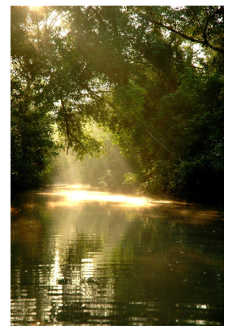The Sundarban forest lies in the vast delta on the Bay of Bengal formed by the super confluence of the Ganges, Padma, Brahmaputra and Meghna rivers across southern Bangladesh. The seasonally flooded Sundarbans freshwater swamp forests lie inland from the mangrove forests on the coastal fringe. The forest covers 10,000 square kilometres (3,900 sq mi) of which about 6,000 square kilometres (2,300 sq mi) are in Bangladesh. It became inscribed as a UNESCO world heritage site in 1997. The Indian part of Sundarbans is estimated to be about 4,110 square kilometres (1,590 sq mi), of which about 1,700 square kilometres (660 sq mi) is occupied by waterbodies in the forms of river, canals and creeks of width varying from a few meters to several kilometres.

The Sundarbans is intersected by a complex network of tidal waterways, mudflats and small islands of salt-tolerant mangrove forests. The interconnected network of waterways makes almost every corner of the forest accessible by boat. The area is known for the eponymous Royal Bengal tiger (Panthera tigris tigris), as well as numerous fauna including species of birds, spotted deer, crocodiles and snakes. The fertile soils of the delta have been subject to intensive human use for centuries, and the Eco-region has been mostly converted to intensive agriculture, with few enclaves of forest remaining. The remaining forests, taken together with the Sundarbans mangroves, are important habitat for the endangered tiger. Additionally, the Sundarbans serves a crucial function as a protective barrier for the millions of inhabitants in and around Khulna and Mongla against the floods that result from the cyclones. The Sundarbans has also been enlisted among the finalists in the New 7 Wonders of Nature.

**Sand dunes**

Sand dunes are large heaps of sand that form on the dry backshore of a sandy beach.

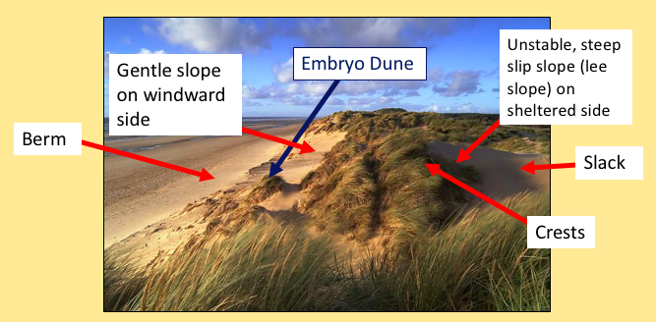

For a sand dune to form, it needs:

•A large flat beach,

•A large supply of sand,

•A large tidal range, so there is time for the sand to dry,

•An onshore wind to move sand to the back of the beach,

•An obstacle such as drift wood for the due to form against.

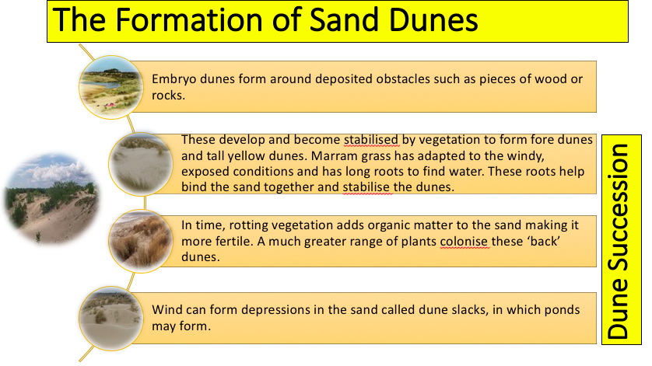

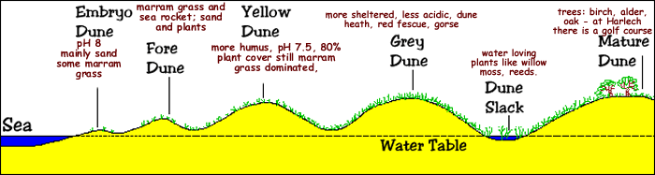

**The benefits and threats of living near the coast**

Benefits:

* Tourism- in Galveston 6.4 million tourists per year- particular attractions are holidays such as a cruise where visitors can sail to the Caribbean and Mexico
* Fishing
* Resources- such as oil- Gulf of Mexico on of the major sources of oil in the US and so many rigs and refineries are located in the area
* Home to unique ecosystems- Galveston bay home to the largest and most biologically productive ecosystem in Texas- home to migratory birds and turtles etc. Other coastal parts of the world are home to coral reefs and mangroves etc.- can be used for tourism
* Transportation hubs
* Unique geological landforms

Threats:

* Coastal erosion
* Coastal flooding- threat increasing due to climate change
* Need for expensive management
* Tropical storms

**Case study: Hurricane Harvey, 2017**

# **How hurricanes form**

* When this warm and wet air rises, it condenses to form towering clouds, heavy rainfall. It also creates a low pressure zone near the surface of the water.
* Rising warm air causes the pressure to decrease at higher altitudes. Warm air is under a higher pressure than cold air, so moves towards the ‘space’ occupied by the colder, lower pressure, air. So the low pressure ‘sucks in’ air from the warm surroundings, which then also rises. A continuous upflow of warm and wet air continues to create clouds and rain.
* Air that surrounds the low pressure zone at the centre flows in a spiral at very high speeds - anti-clockwise in the northern hemisphere - at speeds of around 120 km/h (75 mph).
* Air is ejected at the top of the storm – which can be 15km high – and falls to the outside of the storm, out and over the top, away from the eye of the storm. As this happens, it reduces the mass of air over the ‘eye of the storm’ - causing the wind speed to increase further. Some ejected air also cools and dries, and sinks through the eye of the storm, adding to the low pressure at the centre.
* The faster the winds blow, the lower the air pressure in the centre, and so the cycle continues. The hurricane grows stronger and stronger.
* Seen from above, hurricanes are huge circular bodies of thick cloud around 450 km (300 miles) wide. The cloud brings heavy rain, thunder and lightning.
* In the centre is the **eye of the hurricane**, about 45 km across (30 miles) across. Often there will be no clouds in the eye. Seen from below it will seem calmer, with a circle of blue sky above. The eye is formed because this is the only part of the hurricane where cold air is descending.
* In the northern hemisphere, the prevailing easterly tropical winds tend to steer hurricanes toward land - although their course is unpredictable. As hurricanes move inshore, their power gradually reduces because their energy comes from sucking up moist sea air.

**Effects**

* The most expensive in U.S. history at over $190 billion, surpassing Hurricane Katrina.
* Harvey has also swamped one-third of oil refining capacity of the US. It could be weeks before refineries return to full operation. This has caused huge concerns about fuel supplies. Prices for refined products like gasoline have jumped.
* Death toll more than 60
* 1 million  cars lost
* 50,000 homes destroyed
* 150,000 homes damaged
* Schools and other services closed for approx. 2 weeks

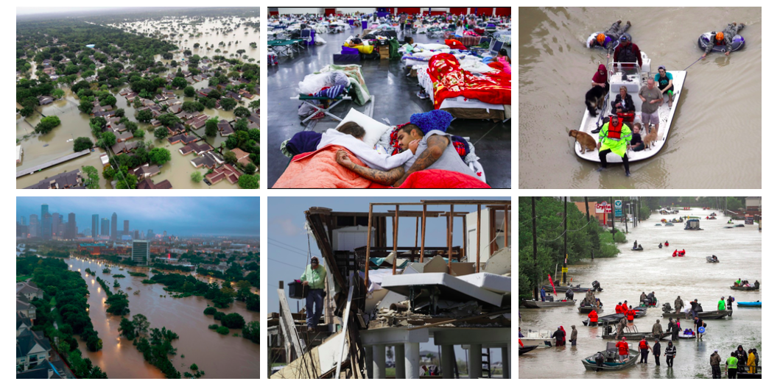

7-mark coasts questions

2007: In many parts of the world the natural environment presents hazards to people. Choose an example of a tropical storm. For a named area, describe the short-term and long-term effects of the example which you have chosen on people living in the area. [7]

2009: Explain how and why coastal sand dunes have formed in a named area which you have studied. You may use a labelled diagram or diagrams in your answer. [7]

2009: Name an area which you have studied where a coral reef has formed. Describe the conditions which have led to its formation. [7]

2010: Tropical storms are another type of natural hazard. Explain why the effects of tropical storms of the same strength are likely to be greater in an LEDC than an MEDC. Refer to examples which you have studied. [7]

2010: For an area you have studied, describe the benefits and problems of living near the coast. [7]

2011: Name an area which you have studied where tropical storms occur. Describe the problems which they cause for people living in your chosen area. [7]

2012: For a named area of coral reef which you have studied, describe the conditions which led to its formation. [7]

2013: For a named area which you have studied, describe the impacts of a tropical storm. [7]]

2013: Describe the ways in which a coastal area can provide opportunities for the people who live there.  [7]

2017: Explain why people live along a named area of coastline you have studied. (7)

Example questions with model answers

Outline the characteristic features of a destructive wave (4)

You could include in your answer:

- high frequency (10-14 / minute)

- short wave length (<1m)

- backwash greater than swash - therefore beaches are eroded

- high energy waves formed due to greater fetch

Explain the formation of cliffs and wave-cut platforms (4)

Maximum erosion occurs at the base of a cliff where wave-cut notches are formed by erosion processes such as hydraulic action and abrasion. As the wave-cut notch gets bigger it creates an overhang. Weakening of the cliff face due to lack of support and weathering of the cliff face causes it to collapse. As it retreats it leaves behind a gently sloping rocky platform known as a wave-cut platform which often has loose rocks on top it from cliff fall.

You could be asked to include a labelled or annotated diagram for this type of question so make sure you learn one!

Explain the formation of Headlands and Bays (4)

Headlands and bays form where there are layers of hard and soft rock outcropping at 90o to the coastline (a discordant coastline). They form due to differential erosion. Harder rock (e.g. chalk) will form headlands (sticking out into the sea) as it erodes slowly. Softer rock such as shale and clay will erode quickly by processes such as abrasion and hydraulic action and will erode back to form a bay. Once formed the headland will be most exposed and can be eroded itself forming features such as stacks.

You could be asked to include a labelled or annotated diagram for this type of question so make sure you learn one!

Explain the formation of a stack (4)

Stacks begin as part of an eroding headland. As waves attack a headland, joints in the rock are attacked by abrasion and hydraulic action, eventually forming a cave. The cave will eventually erode through the headland to form an arch. Weakening of the roof of the arch by weathering and weakening at its base by waves will eventually cause the arch to collapse leaving a stack e.g. Old Harry (Dorset Coast).

You could be asked to include a labelled or annotated diagram for this type of question so make sure you learn one!

Explain the factors which affect the rate of coastal recession (4)

More resistant rock (e.g. chalk) will erode less quickly than weak rocks such as clay and shale which are easily attached by waves. In areas where there is a large fetch (distance over which wind has blown), waves will have greater energy and will cause greater rates of erosion. Erosion rates will be lower in places where coastal management is in place. For example, sea walls will protect cliffs from wave energy, reducing erosion.

Suggest how wave fetch can cause different rates of coastal recession (3)

The fetch is the distance over which wind blows to form waves. A greater fetch means waves have more energy as the wind can build bigger waves. This will result in greater rates of erosion. In areas where there is a small fetch, waves will have less energy and there will be slower rates of recession.

Compare the characteristics of constructive and destructive waves (4)

Destructive waves have a greater backwash than swash this is in contract to constructive waves which have a stronger swash than backwash. Whereas constructive waves will build up beaches, destructive waves will therefore erode beaches. Constructive waves have a lower frequency than destructive waves. Destructive waves however are higher (>1m) than constructive waves (<1m)

When answering this question - look carefully at the command word - make sure you are directly comparing - and not just stating the characteristics of a destructive wave and then those of a constructive - look again at the answer above - look for the comparative terms used.

Explain the formation of a spit (4)

Beach material moves along a coast due to longshore drift. Where there is a change in direction of the coastline and a loss of energy material will begin to build up. Overtime a spit is formed as sediment is deposited offshore. The end of the spit may become hooked due to a change in dominant wind direction (creating a recurved lateral).

(You could also mention the formation of salt marshes behind a spit as it become a

low energy zone protected from wave action).

You could be asked to include a labelled or annotated diagram for this type of question so make sure you learn one!

Explain the advantages and disadvantages of offshore reefs as a method of coastal defence (4)

**Advantages:**

They do not take up space on the coastline (1) therefore do not directly affect developments (exp) (1)

They break waves before they reach coast (1) Therefore reducing wave energy before it reaches the coast (exp) (1) meaning less need for onshore protection (1)

Visually unobtrusive (1)

Long lasting therefore provide value for money over time (1).

**Disadvantages:**

Local residents may be upset during construction (1) The cost of set up is high / maintain (1)

They are not always effective in intense storms (1) therefore may need secondary support on the coast (exp) (1)

There may be environmental concerns / damage habitats / ecosystems (1)

(need BOTH Advantages and Disadvantages explained for full marks)

Soft engineering is a way of managing the coastline. Outline the advantages and disadvantages of soft engineering techniques (4)

Advantages – cheaper than hard engineering (1). More sustainable to environment (1), and does not require quarrying of rock (1). Less visually obtrusive (1). Doesn’t require as much maintenance.

Disadvantages – less effective than hard engineering (1) as it does not always stop erosion from occurring (1), cost of maintenance could be high in the long term (1) with repeated outlays due to annual upkeep (1)

Explain how groynes protect cliffs from erosion (3)

Groynes prevent Longshore Drift(1) therefore trapping sediment and resulting in the building up of a beach (1) This beach will absorb the wave energy and therefore reduce erosion (1)

Describe the advantages of groynes as a hard engineering technique (3)

Hard engineering is stronger (1) and more durable (1). Groynes, which can be wooden or stone can help build beaches which absorb the energy of the waves (1). They are cost effective in the long term (1).

Explain how the following methods of hard engineering help to reduce erosion: (could be a single question - with particular method stated..)

GROYNES - The groynes help build beaches (1). They achieve this through preventing longshore drift (1). The bigger beaches then absorb energy from breaking waves (1) This reduces recession as less waves reach the area behind the beach(1).

SEA WALLS - the sea wall is strong and durable (1) this means it will be able to withstand the impacts of waves for a prolonged period. Sea wall deflects the energy of waves (1) which means energy is not focused on the coast (1)

RIP-RAP - helps break the waves (1) and this causes the energy of the waves to be absorbed (1). The rocks used are durable/ a long-term solution (1) resulting in less maintenance or replacing (1).

For a named area of coral reef which you have studied, describe the conditions which led to its formation. [7]

The Great Barrier Reef in Australia is largest living structure on the planet stretching 2300 kilometres

the Great Barrier Reef is incredibly rich and diverse. The Great barrier reef runs parallel to the Queensland coast. It is a barrier reef so separated from the mainland by a large lagoon. The temperature ranges of 18-30 c. Off the coast of Queensland there is little annual variation in sea temperature. The salinity is at favorable level. This is important as freshwater kills the coral. The water off the coast of Queensland is very clear. The outer ring of the barrier reef protects the inland reef allowing for calmer and clearer water. The depth of the water in the inner reef is very shallow- 35 meters. This allows the sun’s rays to penetrate so that photosynthesis can happen.