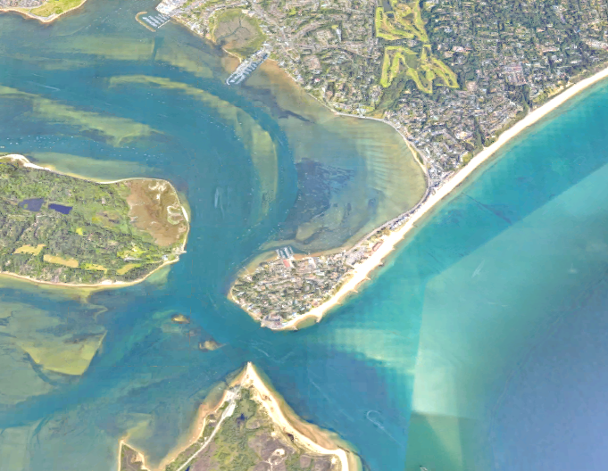

**Spits and Bars**

Explain the formation of a Bar.

Explain the formation of a Spit.

Draw a diagram to show how a bar is formed.

Label the characteristics of Sandbanks Spit, Dorset.

**Study the photograph of Sandbanks Spit, Dorset. Label the characteristics of a spit.**

**Draw a diagram to show how a bar is formed and explain how spits and bars are formed.**

DEMONSTRATE