- What do they look like?
Cloud Types
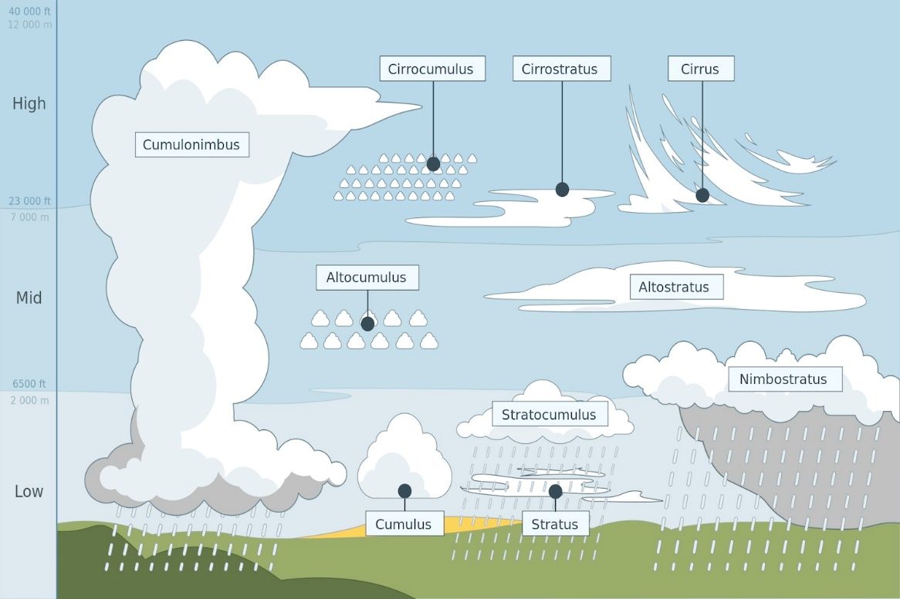
- What are their characteristics?
- What types of weather do they create?

