IB DP Geography – Population – Forced Migration: Climate Change Refugees in Small Island States e.g. Kiribati and Tuvalu in the South Pacific
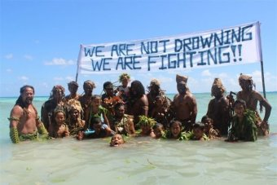
Task 1 – Briefly describe the Geography of Pacific Island States such as Kiribati and Tuvalu
Task 2 – Describe the location of Kiribati/Tuvalu

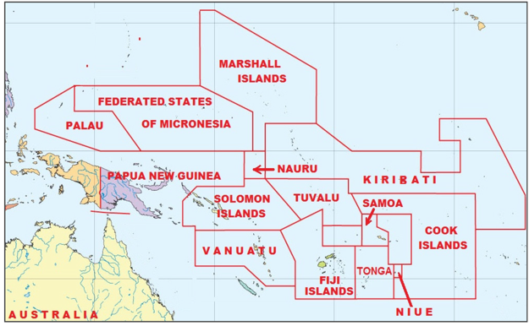

Task 3 – What are the environmental and political push factors from South Pacific Island States?
1

2

3

4

5

Task 3 – How are the countries trying to fight back against climate change?
1

2

3

4

5

What will the impacts be for source countries? | What will the impacts be for host countries?
1  2  3  4  5 | 1  2  3  4  5

