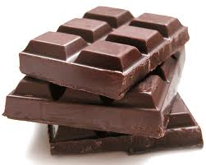
Chocolate – The Bitter Truth

During the video, answer the following questions:

1. Name some multinational companies that sell chocolate:
__________________________________________________________________________________

2. Where in the world produces the most chocolate?
__________________________________________________________________________________

3. How much of the world’s chocolate comes from here?
__________________________________________________________________________________

4. Why is it produced here?
____________________________________________________________________________________________________________________________________________________________________

5. How many there depend on chocolate for their income?
__________________________________________________________________________________

6. What problems are there for the cocoa bean farmers?
__________________________________________________________________________________________________________________________________________________________________________________________________________________________________________________________________________________________________________________________________________________________________________________________________________________________

7. What’s the average salary there per year?
__________________________________________________________________________________

8. What’s it like to live in the community villages there?
________________________________________________________________________________________________________________________________________________________________________________________________________________________________________________________________________________________________________________________________________

9. What profits did the chocolate industry make in a year?
__________________________________________________________________________________

10. Who is the world’s biggest consumer of chocolate?
__________________________________________________________________________________

