Population distribution in China
China is considered to be a middle-income emerging economy; it is the C in the list of five BRICS nations. It has a GNI per capita of US$14,390 PPP adjusted and is ranked 90th on the Human Development Index (HDI).

Theory of Knowledge
'It (China) has a GNI per capita of US$14,390 PPP adjusted and is ranked 90th on the HDI'. To what extent do these figures suggest that China is 'better' or 'worse' than other countries?
Figure 1a shows the population distribution of China's 1,373,541,278 people. As can be seen, the distribution is very uneven: almost all of the population of China is to the east of the dashed line. Most of the interior to the west of the line has densities of less than 1 person/km² and some parts are completely uninhabited.
The maps in Figures 1b–1e show some of the physical factors that may have contributed to this distribution. Re-read Global population distribution and see if you can explain the physical factorsthat have contributed to China's population distribution.
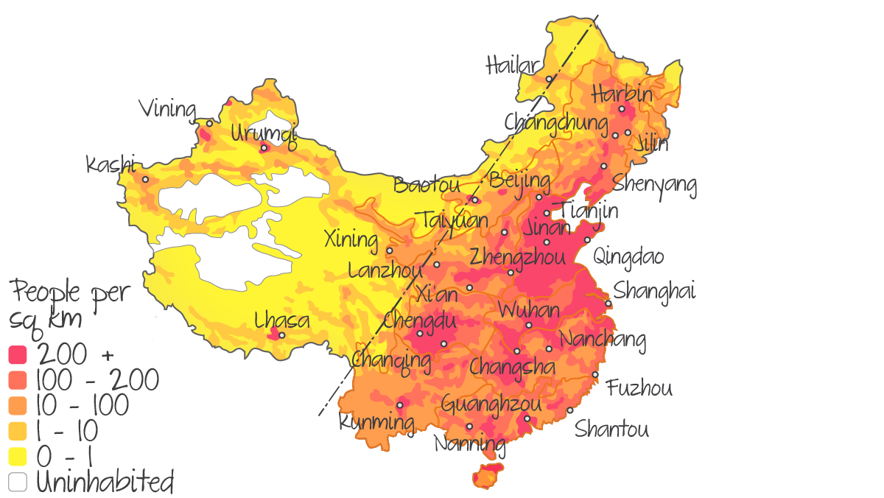Figure 1a. Population density and distribution in China.
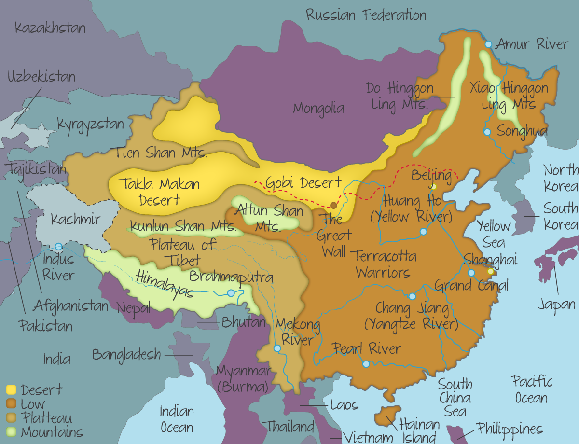Figure 1b. Physical geography of China.
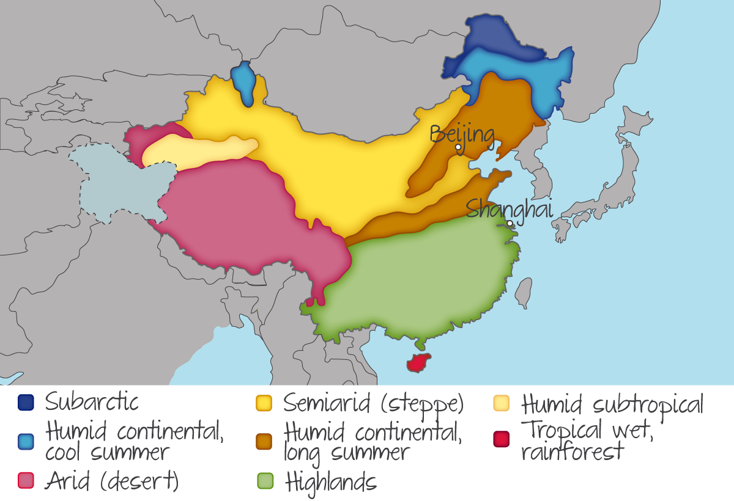Figure 1c. Climate map of China.
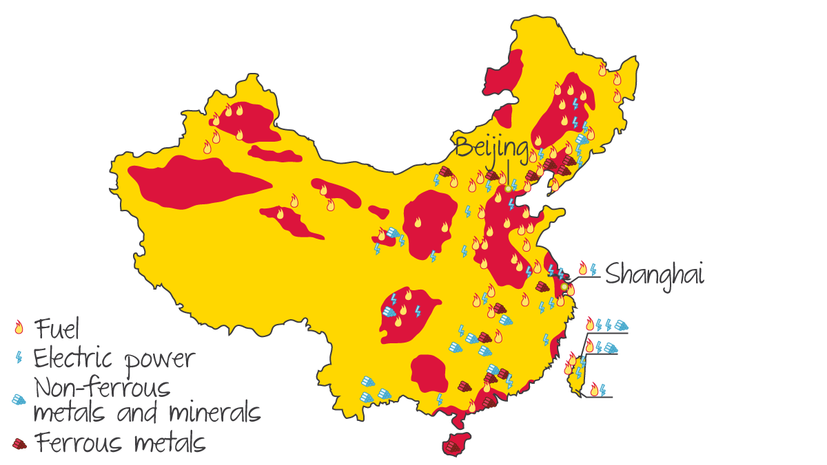Figure 1d. Natural resource locations in China.
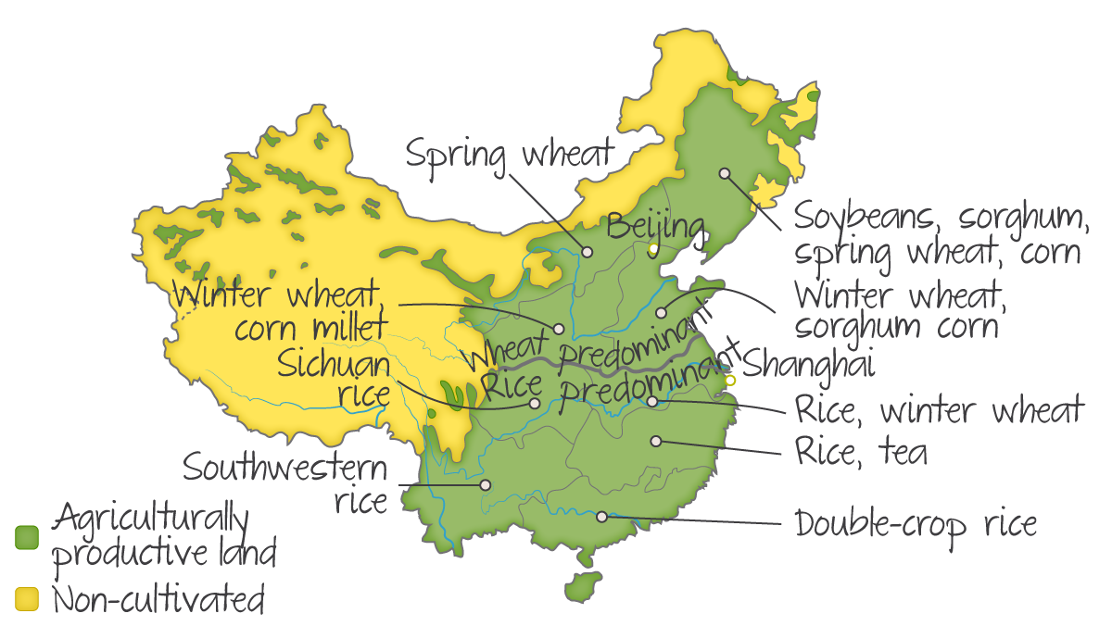Figure 1e. Agricultural activity in China.
Table 1. Impact of physical factors on population distribution in China.

Physical factor | High densities (east of the dashed line in Figure 1a) are due to: | Middle and low densities are due to:
Climate | - Equable climates: long warm summers and short cold winters | - The far north east has a harsh climate with long severe winters.  - The humid subtropics are less comfortable for human living.
Relief, altitude and latitude | - Low hills and coastal plains | - Central and western (low densities) due to high steep mountains, Tibetan Plateau and the interior deserts  - Low latitude tropical climate: hot and humid
Water supply | - Climate provides a plentiful supply of rainfall.  - Dense network of major rivers. | - The continental interior lacks rainfall and rivers.  - The line of higher density in the south follows the course of the Indus River
Natural resources | - Deposits of fuel, electric power, minerals and metals are all present. | - Fuel deposits in the north west attract some pockets of population.
Soils/agricultural potential | - Good agricultural productivity | - Large areas of no cultivation.
As Global population distribution: human factors explained, human factors also impact population distribution. The mineral resources support extensive industrial development in the east and south east of China. This has resulted in high levels of pollution; the popular image of Beijing today is of a heavily polluted city (see Figure 2). The growing industrial sector provided extensive employment opportunities which in turn attracted large numbers people to the region. As an emerging economy China is developing fast and the employment structure is shifting away from traditional industries and towards the service sector. Service industries such as banking are located in the same region and are labour intensive, so they are attracting increasing numbers of people. This is the reason for the governmental policy to restrict growth and to enforce population re-distribution. The aim is to halt the growth of the megacities of Shanghai and Beijing.
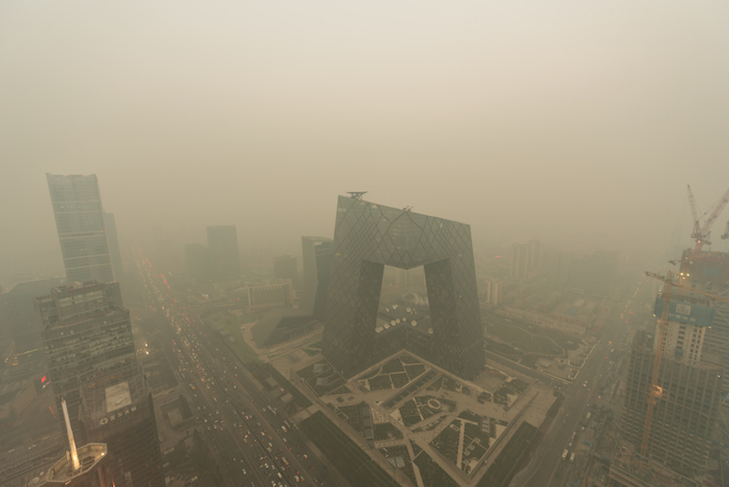Figure 2. Beijing: A polluted city.
^{Credit: Wenjie Dong Istock}

International-mindedness
China has significant pollution problems, largely due to poor environmental controls. Does China have the right to pollute the atmosphere when it has significant implications for global climate change?
Consider the past role of the Western World with regard global climate change.
Other human factors that influence the population distribution in China include:
- The low hills and coastal plains offer good communications and accessibility, with numerous ports (sea and river) for trade. High-speed trains connect many of the major cities.
- Historical influences are important: China has a long history of trade. The Silk Road was a network of trading routes dating back to the Han Dynasty (207 BC to 220 AD). It started in China and headed west to the Mediterranean Sea. The Silk Road is marked by the linear section of the middle-density population concentration that heads north west from the edge of the densely populated area.

Examiner Tip
- You will need to be familiar with two case studies of population distribution on the national scale.
- Many students prefer to use case studies of countries with which they are familiar, as the facts and figures are easier to remember.
- You do not need to use this case study or the one on Australia. You can use these as an example and develop your own case study.

