Activity 1: Chickenomics activity handout
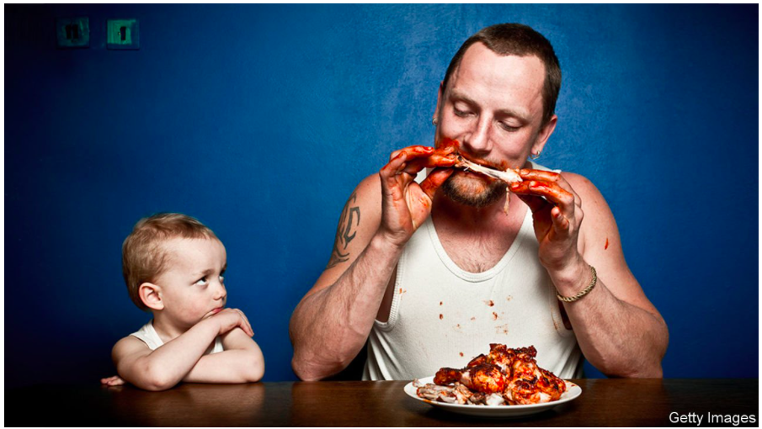

- Define production and demonstrate in a diagram similar to the ones on page 220 what production would look like in the chicken meat industry.
Figure 1: The adding of value to resources.
__________________________________________________________________________________________________________________________________________________________________________________________________________________

- Describe what diversification means, using page 221, how is the chicken industry diversified?
__________________________________________________________________________________________________________________________________________________________________________________________________________________

- What is factor productivity and how does this relate to the chicken farming industry. Give 2 statistics from the article to show that productivity has increased dramatically since the 1950’s in chicken farming productivity.
Productivity means:______________________________________________________________________________________________________________________________________
My first statistic is_____________________________________________________________________My second statistic is______________________________________________________________________

- How do economists measure productivity: Give 2 methods that can be used from page 224.

Method 1:

Average product of labour=

Method 2:

Average revenue product of labour=

- What have been the main ways in which the productivity of a chicken farmers labour has increased since the 1950’s? Read the section on page 225-226 to give you ideas and then apply this to the Chickenomics article.
Development/change: | How did this increase the productivity of the chicken farming industry?
1.
2.
3.
4.

- Read pages 226 -227. What have been the advantages and disadvantages of more capital and land intensive chicken farming practices? List as many from the article as you can:

Advantages | Disadvantages

- Read pages 228-29. Briefly explain the idea in the first column and then Mix and match the demand for the factors of production with the example from the chicken farming industry:

What determines the demand for the FOP’s? | Examples…
Consumer demand for their products (derived demand): | If grain is being used for other purposes such as bread or ethanol production there may be less available as chicken feed
Factor prices: | A farmer will only increase the size of their production if it is profitable to do so. They will not increase production if it leads to falls in productivity as this will likely l
Factor availability: | As chicken has become a more popular meat the demand for grain will increase.
Factor productivity: | If the price of grain goes up then chicken farmers costs of production will increase and they will scale back production

