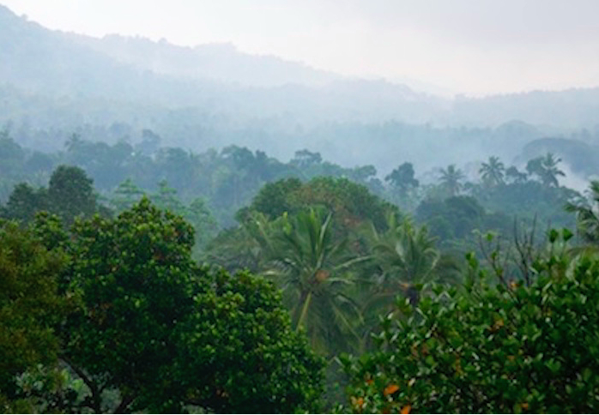
Characteristics of the tropical rainforest
Key concept: Ecosystem- a biological community of interacting organisms and their physical environment.
What: The characteristics of the tropical rainforest
How: To study the climate, soils, vegetation and animals of the rainforest and consider the interactions between these components.
Why: Unless we understand the links we cannot limit damage, conserve or restore.

Describe the general characteristics of the forest.

What is the rainforest location?

-What is their climate and why is it like this?

- What is the vegetation like and why is it like this?

How has the rainforest vegetation adapted to the conditions in the rainforest?

Drip tips:

Buttress roots:

Lianas:

Strangler fig:

Epiphytes:

What is the soil like and why is it like this

In your own words: How do the components of the rainforest interact to create it’s distinct characteristics

