Name________________________________________

Paper 2 Core Theme—Patterns and Change

Answer all questions. When relevant, answers should refer to case studies or examples, and where appropriate include well-drawn maps or diagrams.
Changing Populations [21 marks]
Section A

1. The graph shows how two countries score in the World Economic Forum’s Gender Gap Index 2012, and how each compares to the world average.

The index looks at four aspects of inequality and each ranges from 0.00 (extreme inequality) to 1.00 (total equality).

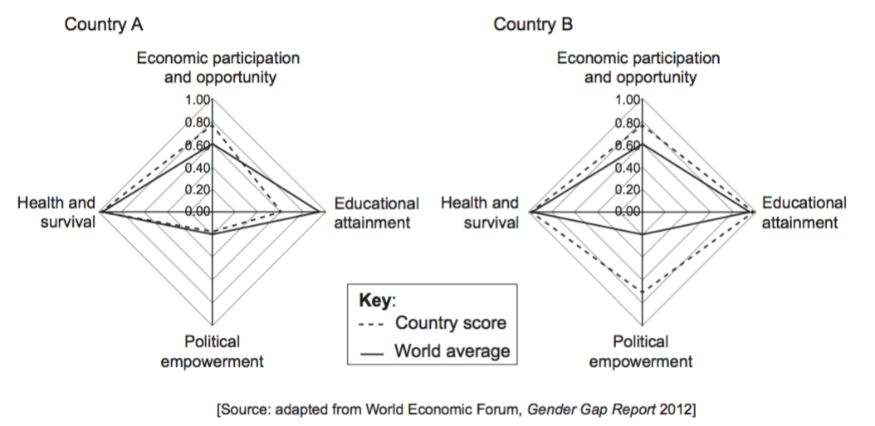

AO4
(a-i) Identify which country has greater gender equality. {1 mark}
AO4-
…………………………………………………………………………………………………………………

AO4
(a-ii) Using data from the graph, describe how gender equality in country A differs from the world average. {3 marks}

…………………………………………………………………………………………………………………

…………………………………………………………………………………………………………………
AO4-

…………………………………………………………………………………………………………………

…………………………………………………………………………………………………………………

…………………………………………………………………………………………………………………

…………………………………………………………………………………………………………………
AO1
(b) Using a named example, describe how the demographic dividend works. {3 marks}
…..………………………………………………………………………………………………………………

…………………………………………………………………………………………………………………..
AO1-
…………………………………………………………………………………………………………………..

…………………………………………………………………………………………………………………..

…………………………………………………………………………………………………………………..

AO2
(c) Explain the causes for the changing sex ratios in a defined place. {4 marks}

…………………………………………………………………………………………………………………

…………………………………………………………………………………………………………………

AO2-
…………………………………………………………………………………………………………………

…………………………………………………………………………………………………………………

…………………………………………………………………………………………………………………

…………………………………………………………………………………………………………………

…………………………………………………………………………………………………………………

…………………………………………………………………………………………………………………

…………………………………………………………………………………………………………………

…………………………………………………………………………………………………………………

AO1
(d) Define total fertility rate. {2 marks}

…………………………………………………………………………………………………………………
AO1-
…………………………………………………………………………………………………………………

…………………………………………………………………………………………………………………

…………………………………………………………………………………………………………………

AO3
(e) Evaluate a specific policy that is associated with managing population change. {4 marks}

…………………………………………………………………………………………………………………

…………………………………………………………………………………………………………………

AO3-
…………………………………………………………………………………………………………………

…………………………………………………………………………………………………………………

…………………………………………………………………………………………………………………

…………………………………………………………………………………………………………………

…………………………………………………………………………………………………………………

…………………………………………………………………………………………………………………

…………………………………………………………………………………………………………………

…………………………………………………………………………………………………………………

Section B

Answer the following question.

4. Refer to the infographic below to answer the questions that follow.

The infographic provides details of the refugee crisis, focusing on the Mediterranean Region, as a result of the conflict in Syria.

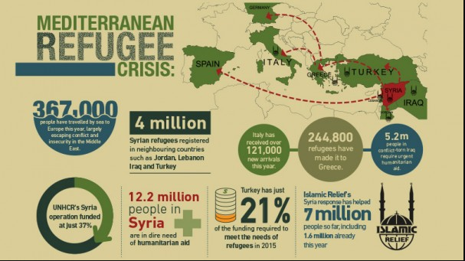
www.islamic-relief.org

(a) State the number:

AO4
(i) of countries that the infographic claims have accepted or received refugees from Syria. {1 mark}
…………………………………………………………………………………………………………………..
AO4-

…………………………………………………………………………………………………………………..

AO4
(ii) of refugees that have traveled by sea to flee the Syrian conflict. {1 mark}
…………………………………………………………………………………………………………………..
AO4-

…………………………………………………………………………………………………………………..

AO2
(b) Suggest one way in which the map depicting the Mediterranean Refugee Crisis in the infographic could be improved. {2 marks}

…………………………………………………………………………………………………………………

AO2-

…………………………………………………………………………………………………………………

…………………………………………………………………………………………………………………

…………………………………………………………………………………………………………………

 | Raw Score | Raw % | IB Grade | Adjusted %
AO1 | /5
AO2 | /6
AO3 | /4
AO4 | /6

