Case study of energy in a country

The UKs energy mix

Historically the UK used coal as this resource was in plentiful supply. Areas such as South Wales had large deposits and so coal powered power stations developed in this area (i.e. Aberthaw power station, Barry, South Wales). Coal went into decline as the resource became used up and there was an increasing awareness of the environmental damage it caused. The usage of coal has reduced from 80% 50 years ago to 38% today.
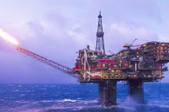
Today the energy mix in the UK is 28% natural gas, 38% coal, 21% nuclear, 11 % renewable and 2% other sources. Using a range of energy like this ensures the country is energy secure.

When gas was found in the North Sea this became a more popular source of energy in the UK. Now much of the resource has been used up so the UK mainly relies on imports.

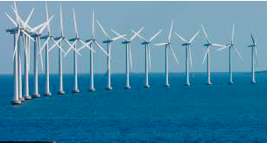
The UK has very good potential for wind power- it has an average wind speed of 8m per second. It also has a high population density so wind farms can be located near to demand. Scout Moore is the biggest onshore terminal on the Pennines. On days that there is no wind is produced so a good energy mix is needed as backup. On a windy day 20% of the energy in the UK can be produced by wind and this percentage is increasing. There have been demonstrations against wind farms being created as people are worried about the ascetics and noise from them (NIMBY) so more farms are being created offshore to reduce rejection. Offshore plants are more efficient but cost 2 times more to build.
The main benefits of wind turbines is that they reduce carbon emissions and once the expensive cost of building them is recuperated they produce cheap energy.

Sleaford in the East of England is of the 4 straw biomass power stations in the UK. This station uses straw but wood or plant matter can be used to produce electricity. The station produces enough power to generate heat and electricity for 66,000 homes. At the Sleaford power plant 240 lorries of straw are delivered each week as a input for the biomass energy. The power station processes are automated- head from the boiler produces steam which runs the turbine.
The benefit of biomass as a source of energy is that growing crops creates a carbon sink. The issue is that straw needs to be available locally as straw is a bulky input. The 4 straw based power plants in the UK are based in the East of the country. They only produce 1/15 of the energy of a gas fired power station.

Government incentives to use solar power have meant that many solar panels have been put onto private roof i.e. homes. The UK has good solar potential- 1500kw per square meter per year. The panels need to be south facing and are better in the south of the country, i.e. Dorset, where there is a higher sun intensity. There are fields covered in solar panels but farming can be done around the panels. They need to be located in an area that is accessible for machinery and has connections to the grid. Like wind power, many people are against solar panels as they feel they are a visual eyesore (NIMBY). Another issue is that they can only be used on sunny days and not through the night.
Solar power makes up less than 1% of the global energy mix but is increasing as it is very cheap and easy to harness. Technology is improving for it to be utilized in the least developed locations as appropriate technology.

