Calculations for Price Controls:

Price Floors:

Government impose a $15 price floor for Cattle Ranchers producing Beef (kg’s) following a decline in the global price for the meat.
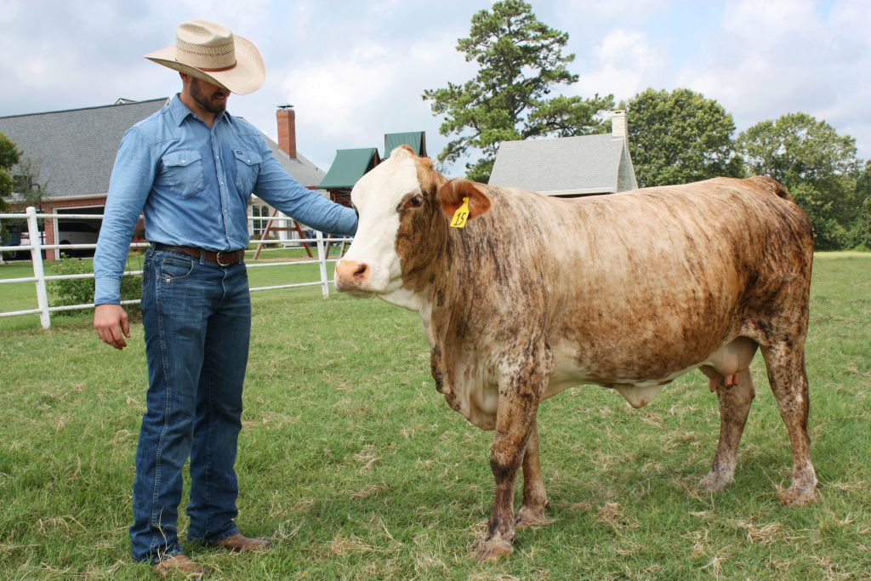

- Indicate the original equilibrium price and quantity on the graph for beef prices (000’s kg’s per month).
- Show the price floor on the diagram.
- Explain how many (kg’s) of Beef will be demanded and supplied following the imposition of the price floor.
- Calculate the change in producer revenue from Beef following the imposition of the price floor.
- The government is required to purchase the surplus in order to support the Beef producers:
- Calculate the government expenditure required for this measure
- Identify the consequential welfare loss
- Suggest two ways that the surplus may be disposed of.

Price Ceilings:

In order to support baby development and health the government decides to impose a price ceiling on baby milk powder formula. It imposes a maximum price of $10 per kg.

- Indicate the original equilibrium price and quantity on the graph for milk powder (000’s kgs per month).
- Show the price ceiling on the diagram.
- Identify the quantity of milk powder that will be demanded and supplied following the imposition of the price floor.
- Calculate the change in consumer expenditure revenue on milk powder following the imposition of the price floor.
- Explain two measures the government may take to provide cheap milk powder formula to the people.

