Biomes backpack

What: Learning about the characteristics of a biome of your choice
Why: So that we can understand the major natural vegetation or marine ecosystems that How: Through the investigation of a chosen biome’s characteristics including, climate, flora and fauna and human interactions and creating a backpack to show what you may need to survive in the biome

Introduction to your biome
First research and introduce your biome
- Describe the location of your chosen biome.
- What is the temperature and precipitation of your biome?
- Describe the flora, and fauna of this region and give reasons for this type of 'life' being found here (adaptations/ food chain)
- Who lives here/how it is used by people?
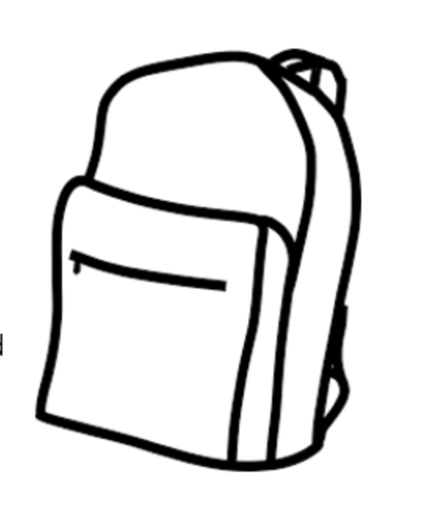
- What are the threats to the biome?
- Resources: http://kids.nceas.ucsb.edu/biomes/

What would you need to survive in your biome?

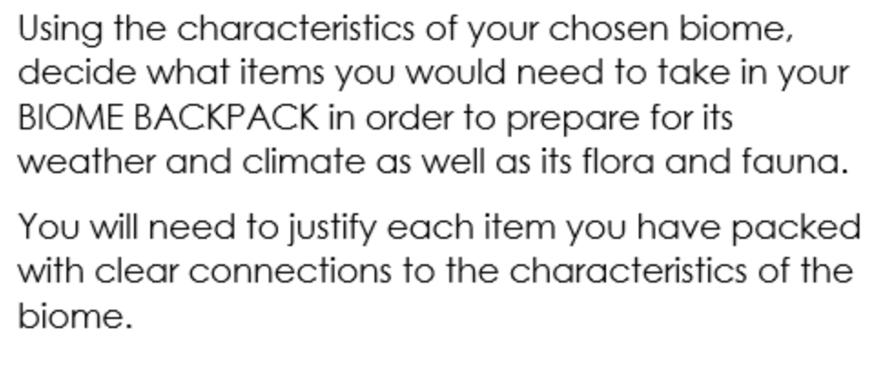
Biomes to choose from
- Desert
- Tundra
- Savanna
- Boreal Forest/Coniferous Forest/ Taiga
- Deciduous Forest/Temperate Forest
- Mediterranean

