In today’s lesson we will be looking at the various factors that prevent LEDCs from experiencing further economic development. These include

- Poverty Cycle
- Institutional and Political Factors
- International Trade Barriers
- International Finance Barriers
- Social and Cultural Factors

Poverty Cycle

1. The poverty cycle prevents many LEDCs from developing further. Complete the diagram below.

_________________________________________________________________________________________________________________________________________________________________________________________________________________________________

- The poverty cycle can also be expressed as follows.

Institutional and Political Factors

- Ineffective Taxation Structure
- Lack of Property Rights
- Political Instability
- Corruption
- Unequal distribution of income
- Formal and informal markets
- Lack of infrastructure

Government Revenue
% of GDP
 | 2004
Afghanistan | 4.6
Myanmar | 4.7
Congo, Dem. Rep. | 7.9
China | 8.8
Bangladesh | 10
Guatemala | 10.6
Cambodia | 10.7
Uganda | 12.1
Nepal | 12.2
India | 12.6
Tajikistan | 13.5
Pakistan | 13.8
Philippines | 14.8
El Salvador | 15.5
Georgia | 15.8
Kazakhstan | 16
Kyrgyz Republic | 16.1

Government Revenue
% of GDP
 | 2004
Denmark | 36.5
United Kingdom | 36.6
Hungary | 37.1
Italy | 37.7
Portugal | 37.8
Mongolia | 37.9
Sweden | 38
Austria | 38.2
Bulgaria | 38.2
Finland | 39.1
Slovenia | 40.7
Netherlands | 41.1
Bosnia and Herzegovina | 41.2
Israel | 41.6
Croatia | 41.9
France | 43.3
Belgium | 43.7
Norway | 49.3
Lesotho | 49.7
Kuwait | 54.4
Madagascar | 60.4

3. Looking at the date above in the two tables, do you notice any patterns?

______________________________________________________________________________________________________________________________________________________

- For many LEDCs this data was not available and therefore it is difficult to draw any concrete conclusions as to whether or not a large proportion of nation’s GDP being distributed by the government is more likely to promote development.

4. However, many LEDCs are constrained because of their taxation structure. Summarize the reasons for this in the table on the next page

Informal Markets

Low profit Taxes

Tax avoidance by multinationals

Direct/Indirect Taxes

5. Why does the reduction of the tax base present such a problem for LEDCs?

_________________________________________________________________________________________________________________________________________________________________________________________________________________________________

In recent years, there has been a worldwide shift from taxation of capital to taxation of labour, consumption (value added taxes) and withholding taxes (social security contributions). Taxes on corporate profits and high incomes have dropped, while taxes on consumption and withholding taxes have risen, sometimes dramatically. The rich have been the main beneficiaries, as taxes on consumption place a relatively higher burden on low incomes. These developments have taken place not only in industrialized countries but also in the South.
Taxes usually account for a considerably lower proportion of GDP in developing countries than in industrialized countries. In addition, the rich avoid taxation on income and assets in their home countries whenever possible by moving capital abroad. By 1990, Oxfam estimated that capital flight from developing countries amounted to about US$ 700 billion, and calculated that the countries affected lose US$ 15 billion in tax revenues. Oxfam’s calculations are made as follows: an average return of 10% is assumed on US$ 700 billion. This results in taxable income of US$ 70 billion. Assuming a tax rate of 22%, the tax revenues would amount to approximately US$ 15 billion. When this amount is added to the losses resulting from competition among tax havens, developing countries lose a total of US$ 50 billion in potential income.

‘The first and chief design of every system of government is to maintain justice: to prevent members of society from encroaching on one another’s property, or seizing what is not their own. The design here is to give each one the secure and peaceable possession of his own property.’ Adam Smith, Wealth of Nations

6. Define the term property rights

______________________________________________________________________________________________________________________________________________________

7. Property rights allow people to:-

8. Using the example of land explain why a lack of property rights may reduce entrepreneurial incentive.

____________________________________________________________________________________________________________________________________________________________________________________________________________________________________________________________________________________________________________

9. How might this lack of property rights also have environmental implications?

_________________________________________________________________________________________________________________________________________________________________________________________________________________________________

10. We have already discussed that political stability is a vital ingredient for economic development to occur. Complete the flowchart on the next page.

11. Explain why political instability leads to a reduction in business activity and investment.

_______________________________________________________________________________________________________________________________________________________________________________________________________________________________________________________________________________________________________________________________________________________________________________________

12. Corruption is both a cause and an effect of poor governance and levels of corruption are generally much higher in LEDCs.

The corruption may take the form of:-

- _________________________________
- _________________________________
- _________________________________
- _________________________________
- __________________________________
- __________________________________

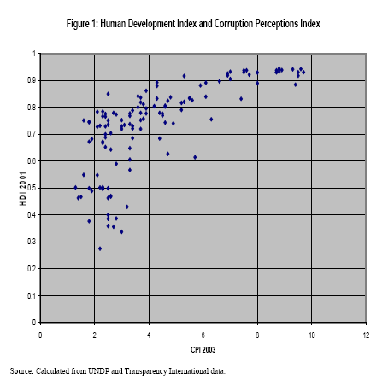

13. What does the data above indicate?

______________________________________________________________________________________________________________________________________________________
14. The impact of corruption is likely to be:-

- Less investment___________________________________________________
- Tax Evasion_____________________________________________________
- Crony Capitalism_________________________________________________
- Bribery/Indirect Tax______________________________________________
- Merit Goods____________________________________________________
- Crime_________________________________________________________
- Lack of democratic reform________________________________________

15. As well as being a negative consequence of economic growth, income inequality is seen by many economists as a barrier to future economic development. Countries with very high levels of income inequality do seem to be amongst the poorest in the world.

- It can create the following problems:-
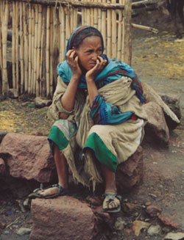

________________________________________________________________________________________________________________________________________________________________________________________________

___________________________________________________________________________________________________________________________________________________________________________
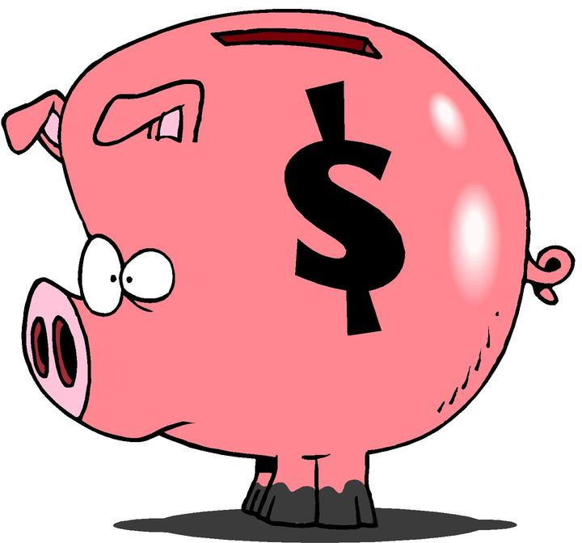
_______________________________________________________________________________________________________________________________________________________________________________________
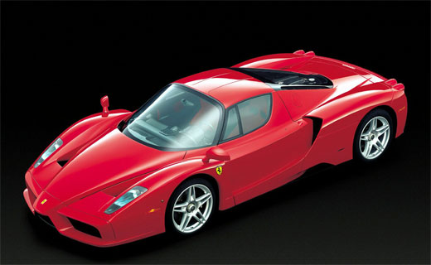
__________________________________________________________________________________________________________________________________________________________________

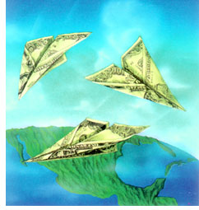
_____________________________________________________________________________________________________________________________________________________________________________________________

16. The informal sector or unofficial economy consists of the following:-

Type of Market | Example

17. Why do informal markets emerge?

_________________________________________________________________________________________________________________________________________________________________________________________________________________________________

 | Starting a business
 | Number of Procedures | Number of Days
Togo | 13 | 53
Venezuela, RB | 13 | 116
Algeria | 14 | 26
Angola | 14 | 146
Azerbaijan | 14 | 115
Ecuador | 14 | 69
Mozambique | 14 | 153
Argentina | 15 | 32
Bolivia | 15 | 50
Greece | 15 | 38
Guatemala | 15 | 39
Ukraine | 15 | 34
Belarus | 16 | 79
Brazil | 17 | 152
Paraguay | 17 | 74
Uganda | 17 | 36
Chad | 19 | 75

 | Enforcing Contracts
 | Number of Procedures | Time required (Days)
Congo, Rep. | 47 | 560
Kazakhstan | 47 | 380
Syria | 47 | 672
Algeria | 49 | 407
Benin | 49 | 570
Lesotho | 49 | 285
Congo, Dem. Rep. | 51 | 909
Chad | 52 | 526
Kuwait | 52 | 390
Lao PDR | 53 | 443
United Arab Emirates | 53 | 614
Egypt, Arab Rep. | 55 | 410
Cameroon | 58 | 585
Sierra Leone | 58 | 305
Iraq | 65 | 320
Sudan | 67 | 915
18. Do you notice any patterns from looking at the data above?

______________________________________________________________________________________________________________________________________________________

19. A large informal sector will have the following economic implications

- Loss of income/output

______________________________________________________________________________________________________________________________________________________

- Poor tax base

______________________________________________________________________________________________________________________________________________________

- Social Security

______________________________________________________________________________________________________________________________________________________

20. We will use the example of Cocoa Farmers in the Ivory Coast to illustrate why poor infrastructure can act as a barrier to economic development.

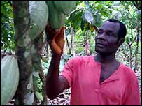

21. A lack of infrastructure such as airports, railways and seaports will have what impact on the cost of trade?

______________________________________________________________________________________________________________________________________________________

22. Why will a lack of infrastructure speed up the process of urbanization?

______________________________________________________________________________________________________________________________________________________

International Trade Barriers

23. Why might the expression “Don’t put all your eggs into one basket” be applicable when discussing the exports of certain Lesser Developed Countries?

____________________________________________________________________________________________________________________________________________________________________________________________________________________________________________________________________________________________________________

24. LEDCs are often dependent upon which industrial sector?

______________________________________________________________________________________________________________________________________________________

Task – Find the % of visible exports devoted to food, raw materials, ores, fuels and manufactured products of several LEDCs using the Excel Document on the next page.

Country | % of exports devoted to food | % of exports devoted to raw materials | % of exports devoted to ores | % of exports devoted to fuels | % of exports devoted to manufactured  products

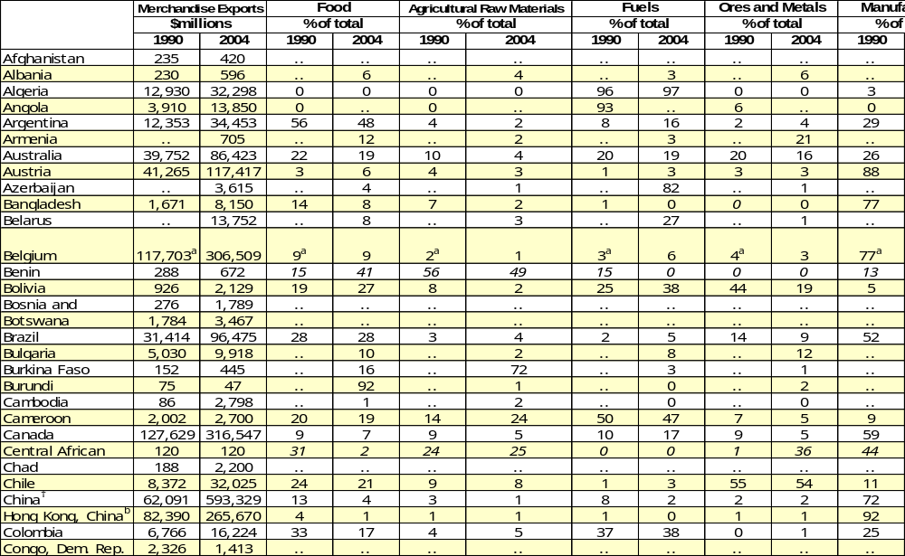
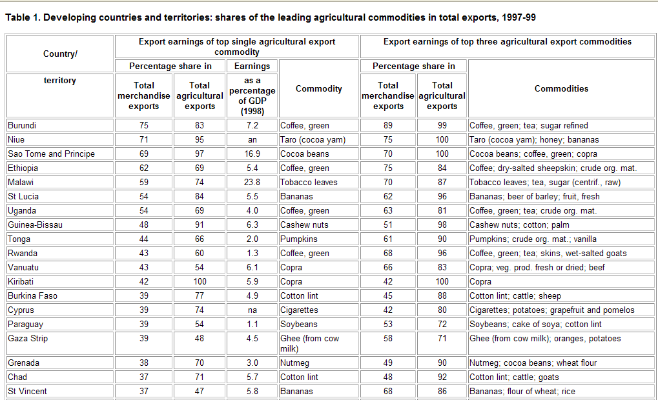

25. Illustrate on the diagram below why this may lead to stagnation in their economy.

Quantity demanded/supplied

Price

____________________________________________________________________________________________________________________________________________________________________________________________________________________________________________________________________________________________________________
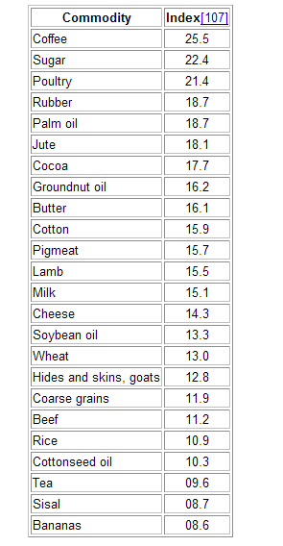

26. Explain using the economic concept ‘income elasticity of demand’ why an increase in the Real GDP of a nation may help it to develop the industrial base of its economy.

_________________________________________________________________________________________________________________________________________________________________________________________________________________________________

27. If the price of primary cash crops and commodities is steadily falling on world markets.

What impact will this have on the Terms of Trade of a developing nation?

___________________________________________________________________________

28. Give a practical example of how this might have a detrimental impact on an LEDC using tonnes of coffee and tractors.

- Why is this likely to be detrimental for a developing nation? (Give an example)

_________________________________________________________________________________________________________________________________________________________________________________________________________________________________

29. The consequences of adverse terms of trade are:-

Debt Servicing

Current Account

Vital Imports

Illegal Crops

Increase in Exports

International Finance Barriers

- Indebtedness

30. Most LEDCs have accrued large amounts of debt; money largely borrowed from financial institutions in MEDCs.

- Look at the data below that outlines debt levels in several LEDCs.

 | Total External Debt |  | Long term debt
 | $millions |  | $millions
 | 1990 | 2004 | 1990 | 2004
China | 55,301 | 248,934 | 45,515 | 131,342
Brazil | 119,964 | 222,026 | 94,427 | 171,729
Argentina | 62,233 | 169,247 | 48,676 | 127,661
Turkey | 49,424 | 161,595 | 39,924 | 108,188
Indonesia | 69,872 | 140,649 | 58,242 | 106,463
Mexico | 104,442 | 138,689 | 81,809 | 129,600
India | 83,628 | 122,723 | 72,462 | 115,199
Poland | 49,364 | 99,190 | 39,261 | 82,343
Hungary | 21,202 | 63,159 | 17,931 | 50,829
Philippines | 30,580 | 60,550 | 25,241 | 54,748
Malaysia | 15,328 | 52,145 | 13,422 | 40,713
Thailand | 28,095 | 51,307 | 19,771 | 39,819
Chile | 19,226 | 44,058 | 14,687 | 36,351
Colombia | 17,222 | 37,732 | 15,784 | 32,391
Nigeria | 33,439 | 35,890 | 31,935 | 31,304
Pakistan | 20,663 | 35,687 | 16,643 | 32,566
Venezuela, RB | 33,171 | 35,570 | 28,159 | 31,218
Peru | 20,044 | 31,296 | 13,959 | 28,679
Egypt | 33,017 | 30,291 | 28,439 | 27,353
Romania | 1,140 | 30,034 | 230 | 24,756
South Africa | .. | 28,500 | .. | 20,591
Lebanon | 1,779 | 22,177 | 358 | 18,206
Algeria | 28,149 | 21,987 | 26,688 | 20,913
Syria | 17,259 | 21,521 | 15,108 | 15,742
Bangladesh | 12,439 | 20,344 | 11,658 | 19,171
Sudan | 14,762 | 19,332 | 9,651 | 12,220
Tunisia | 7,688 | 18,700 | 6,878 | 16,243

31. When did the debt problems of the LEDCs start?

__________________________________________

32 Explain in detail why this lead to a debt crisis in the developing world.

____________________________________________________________________________________________________________________________________________________________________________________________________________________________________________________________________________________________________________

33. What happened to interest rates and the value of the dollar in the 1980s and why?

____________________________________________________________________________________________________________________________________________________________________________________________________________________________________________________________________________________________________________

 | Present Value of Debt
 | % of GNI | % of exports
 | 2004 | 2004
- Liberia | 760 | 2,133
- Sudan | 151 | 625
- Central African Republic | 75 | 599
- Argentina | 159 | 510
- Lebanon | 121 | 488
- Congo, Rep. | 331 | 356
- Uruguay | 108 | 351
- Lao PDR | 76 | 276
- Peru | 57 | 265
- Zimbabwe | 33 | 264
- Brazil | 47 | 258
- Syrian Arab Republic | 101 | 249
- Latvia | 110 | 239
- Turkey | 69 | 221
- Serbia and Montenegro | 77 | 209
- Ecuador | 70 | 205
- Colombia | 49 | 204
- Burundi | 15 | 203
- Croatia | 110 | 194
- Togo | 83 | 191

34. The value of debt in many LEDCs is several times larger than the amount of money earned from exports.

- A large proportion of LEDC debt has to be repaid in a hard currency such as the dollar. Using the table on the previous page explain why this presents a problem.

____________________________________________________________________________________________________________________________________________________________________________________________________________________________________________________________________________________________________________

35. Explain the other problems encountered by LEDCs in terms of:-

- Interest Rates

______________________________________________________________________________________________________________________________________________________

- Capital Flight

______________________________________________________________________________________________________________________________________________________

- Social Spending

______________________________________________________________________________________________________________________________________________________

Non-Convertible Currencies

36. Do LEDCs generally have fixed or floating exchange rate systems?

_________________________________________________________________________

37. To which overseas currency is the domestic currency generally pegged?

___________________________________________________________________________

38. The domestic currency cannot be freely converted in the market and the official exchange rate for a currency such as the Zambian Kwacha (ZMK) is often above the market rate.

- Explain the figures in the table below.

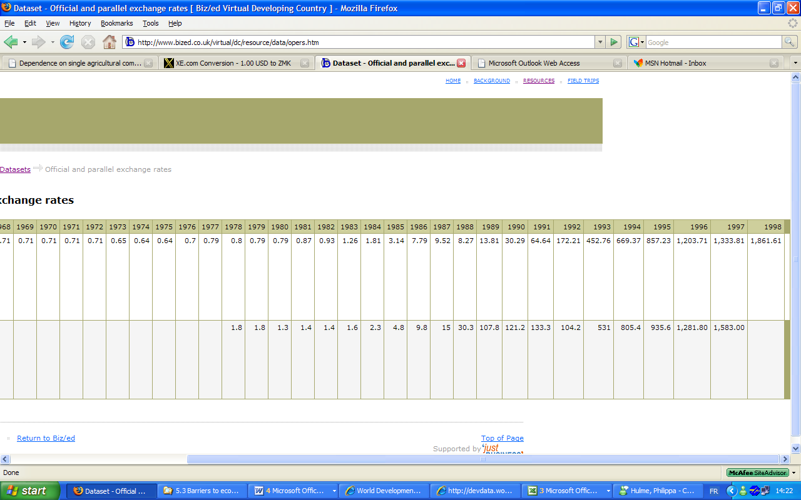
39. What is likely to occur as result?

___________________________________________________________________________

1.00 USD = 3,868.65 ZMK

- Illustrate this situation on the diagram below.

Quantity of Kwacha traded
Dollar price of Kwachas

Quantity of Dollars traded
Kwacha price of Dollar

40. The currency of a nation such as Zambia is known as

_______________________________

41. In order to purchase foreign imported goods developing nations have to convert their currency into Dollars, Pounds Sterling, the Yen etc. These currencies are known as:-

___________________________________________________________________________

42. How do LEDCs acquire ________________ currencies?

___________________________________________________________________________

43. What has happened to the value of these currencies gradually over time against the currencies of the developed world?

______________________________________________________________________________________________________________________________________________________

- Illustrate this on the diagram on the next page

Quantity of Kwacha traded
Kwacha to the Dollar

44.Give your own example of a currency that has significantly depreciated against a major world currency such as the dollar.

___________________________________________________________________________

45.Consider the impact of a non-convertible currency in terms of:-

- Trade ______________________________________________

- Foreign Investment ___________________________________

- Exporters ___________________________________________

- Prices/Resources______________________________________

46. What do you understand by the term capital flight?

___________________________________________________________________________
___________________________________________________________________________

47. Why does capital flight occur?

- __________________________________________________________________________________________________________________________________________
- __________________________________________________________________________________________________________________________________________
- __________________________________________________________________________________________________________________________________________

48. What impact does Capital flight have on the economies of LEDCs?

- Complete the flow chart below

OR

- The Development Project does not take place
- Debt is accrued for the country as a whole
- LEDC is loaned money by financial institution in an MEDC
- Money flows into undisclosed bank accounts in nations such as Switzerland
- Money goes into personal use.

49. What impact will Capital Flight have on the domestic economy in terms of the capital market and financial institutions?

_________________________________________________________________________________________________________________________________________________________________________________________________________________________________

50. How might aid donors, aid agencies and foreign investors react?

_________________________________________________________________________________________________________________________________________________________________________________________________________________________________

Social and Cultural Factors

- Religion
- Culture
- Tradition
- Gender Issues

51. As a group discuss the following questions.

1. Do you believe that religion promotes or acts as a barrier to economic development?
2. Is there a link between the poverty in Sudan and religion?
3. Why might some cultures resist western institutions?
4. Why might culture and tradition prevent the allocation of property rights?
5. What problems may arise as a result of cultural resistance to sex education?
6. Why is gender equality essential in order to promote economic development?
7. How can women’s education specifically promote development?
8. Describe the gender inequality problem that exists in healthcare.

