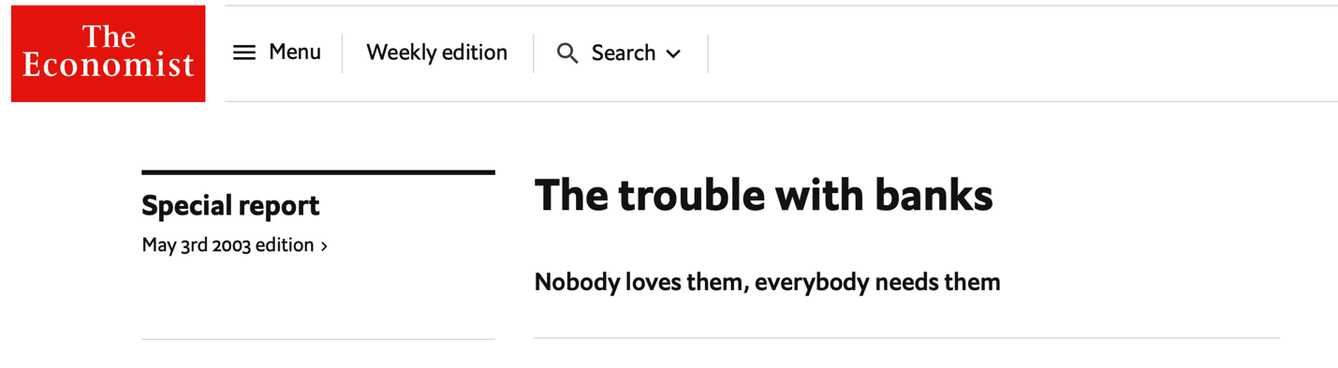
The following is a condensed article of ‘The Trouble with Banks’, this appeared in the May 3rd edition of the Economist in 2003. 5 years before the beginning of the Credit Crisis. The full article can be found on the Weebley page.

Inquiry Questions:

- Why is there Asymmetric Information between lenders and borrowers?
- Why is a borrower likely to engage in morally hazardous behavior once the loan has been agreed?
- Why are banks a solution to Asymmetric Information in the loans market?
- How can banks stop morally hazardous behavior once they grant a loan?
- ‘Banks are unusually effective at spreading financial distress’. Why do governments consider banks too important to allow to fail and insure banks against major losses?
- Why does this create another example of moral hazard in the banking industry.
- How does government intervene to minimize the risk of Morally Hazardous activity by banks?
- Is this always successful, can you think of any historical examples of where Moral Hazard in the banking sectors sent shock waves across the rest of the economy?

As you read through the article highlight any sections in red/orange that you are not sure about and be prepared to ask questions!
BANKS have proved themselves to be the most hazardous economic institutions known to man. Breakdowns in banking lie at the centre of most financial crises. And banks are unusually effective at spreading financial distress, once it starts, from one place to another. It is tempting to conclude that banks should simply be abolished. Unfortunately, that is unlikely to be possible. Banks seem to be necessary.
To see why, consider the job that any financial system has to do. It has to bring willing lenders and willing borrowers together. One way or another, this involves processing information. Two kinds of problem arise. First, the lender needs to know whether a would-be borrower is a good risk. To complicate matters, the keener the borrower—and the higher the interest rate he is willing to pay on the loan—the more likely he is to be a bad risk. This is called adverse selection: the most eager borrowers will be the least desirable, making lenders less willing to lend. The possibility of adverse selection inhibits productive lending and borrowing.
The other problem that financial systems encounter in processing information is moral hazard. Once a borrower has his loan, he may try to cheat. In investing the money, the most he can lose is the amount of the loan. But he may calculate that the greater the risk he takes with the money, the higher his chances of doing very well. Because his losses are capped, he is encouraged to take a bigger risk with his investment than he otherwise would.
This is where banks come in. They are specialists in dealing with adverse selection and moral hazard, which is why their role in financial systems everywhere is so central. They develop expertise in knowing what questions to ask borrowers seeking loans; indeed, they will already know a good deal about them if the would-be borrowers are existing customers. This allows them to screen out many of the bad risks. Access to information also makes it possible to curb moral hazard. Banks can monitor what their borrowers are up to; they can set restrictions on what the money is to be used for, and enforce them by threatening to call in loans or withhold new ones.
Could all this not be done by financial markets, at arm's length? Up to a point, but banks do have the edge. They are more likely to know a lot about the borrower to begin with. Moreover, they keep all the benefits of effective appraisal and monitoring to themselves, so they are willing to bear the risk.
“By trying to make banks safer, governments give banks the means and the motive to behave recklessly”
Unfortunately, banks do have a reason to take on more risk than they should. The reason, paradoxically, is the safety net that governments put in place to prevent bank failures. By trying to make banks safer, governments give banks the means and the motive to behave recklessly.
Banks are intrinsically fragile. They borrow from depositors with a promise to repay in full and on demand, and then mostly invest those deposits in longer-term loans. If depositors all suddenly decide to withdraw their money at once, as their contract with the bank entitles them to, the bank cannot meet the demand for funds. It will fail.
Depositors might be induced to withdraw their money by fear that the bank might be in trouble. Once this fear starts, it becomes self-fulfilling, because if there is any doubt about the bank's safety, depositors have every reason to withdraw their cash: they lose nothing by doing so. If one bank is perceived to be in danger, other banks are likely to come under suspicion too. Bank runs, once they start, tend to spread. Note that equity investors who fear a collapse in share prices face different incentives. As concern mounts, equity prices fall immediately, which makes it less attractive to sell. In a stockmarket, therefore, the price decline is somewhat self-limiting. Conversely, once a bank scare begins, there is no fall in price to deter further withdrawals. Deposits remain redeemable at par until the bank locks its doors.
Recall that banks exist because they are an answer to the problem of moral hazard: they can monitor borrowers to make sure that the funds are not stolen or wasted. But who monitors the monitors? Banks are borrowers too: they borrow from depositors. What stops banks from wasting the money they borrow? Partly, the fact that depositors will not trust their money to an institution that they suspect will be reckless with it: they will place deposits only with banks that they judge to be safe.
Once depositors stop caring about the soundness of their banks, bad banking quickly crowds out good
Once governments arrange for deposits to be insured, however, there is no longer any reason for depositors to worry about the safety of their bank. They will get their money back anyway. So banks will be able to take bigger chances with the money they lend. They will be able to lend to bad risks, charging more in interest and therefore earning bigger profits. Higher lending rates will allow them to pay depositors more too, enabling them to bid for a bigger share of the market. So once depositors stop caring about the soundness of their banks, bad banking quickly crowds out good.

Enter the regulator
Governments have long understood this. Their solution is to monitor the banks themselves. The quid pro quo for deposit insurance—itself absolutely necessary, they say, to guard against runs—is careful supervision. Require the banks to keep a certain minimum proportion of their assets in reserve, monitor their lending policies, place restrictions on the businesses they can enter, and so forth. Having lifted the burden of bank supervision from depositors, there is only one possible course: nationalise it.

