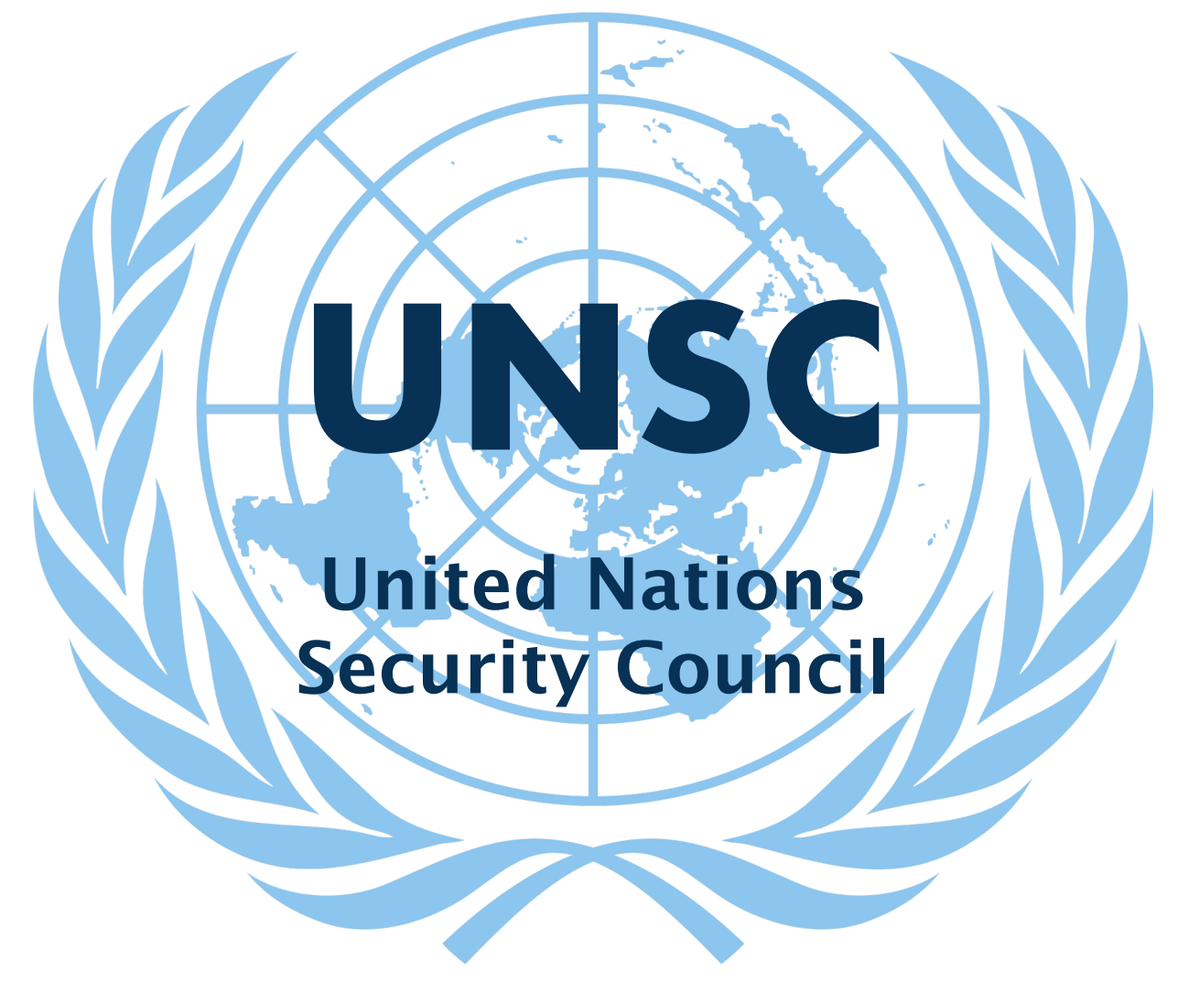

I. Committee Background

The United Nations Security Council (UNSC) was founded on October 24th,
1945. The Security Council is mainly focused on securing “international peace and
security” (About, UN, 2022). The UNSC is made up of 15 member states. There are five
permanent members (China, France, Russia, the United Kingdom, and the United

States) who have the power to reject resolutions through a veto, and ten non-
permanent members who are elected by the General Assembly every two years. The
headquarters of the Security Council are located in New York City, United States. The
position of the presidency of the Council is rotated between the member states in
alphabetical order (Current Members, UN, 2022). Since 1945, the Security Council has
been the origin of many achievements, some of which include providing security,
responding during crisis situations and giving their overall support (UN Peacekeeping,
2022). Consequently, there have been some failures in their years of functioning. For
example, according to the Council on Foreign Relations, critics are stating that “the
Council’s structure is outdated and that it fails to represent many regions of the world”
(CFR, 2021).

II. History of the Topic

- Ukraine shares borders with Russia both to the east and northeast.
- In 2014 Russia annexed the Crimea. The region was of particular interest to Russia since it depends on the Black Sea for access to the Mediterranean. The Port of Sevastopol, is one of the few ice-free deepwater ports available to Russia.
- The Ukraine is an important route for Russian gas. The continent gets nearly 40% of its natural gas and 25% of its oil from Russia
- A huge amount of this current crisis is rooted in the legacy of the Cold War (1945-1991) which was a period of mistrust and competition between the USA (the West) and the Soviet Union (the East).
- Ukraine, which was part of the Soviet Union won independence as the USSR broke up in 1991.
- Russia has always considered Ukraine to be within its ‘sphere of influence’ and is extremely hostile to allow the Ukraine to have closer ties with the EU/NATO.

III. Current Issues

February 24th 2021. Russia has begun a large-scale military attack on Ukraine, its southern neighbor, on the orders of Russian President Vladimir Putin.

There are reports of attacks on Ukrainian military infrastructure across the country, and Russian convoys entering from all directions.

In a televised speech at 05:55 Moscow time (02:55 GMT), Mr Putin announced a "military operation" in Ukraine's eastern Donbas region. This area is home to many Russian-speaking Ukrainians. Parts of it has been occupied and run by Russian-backed rebels since 2014.

Mr Putin said Russia was intervening as an act of self-defence. Russia did not want to occupy Ukraine, he said, but would demilitarise and "de-Nazify" the country.

He urged Ukrainian soldiers in the combat zone to lay down their weapons and go home, but said clashes were inevitable and "only a question of time". And he added that any intervention from outside powers to resist the Russian attack would be met with an "instant" and devastating response.

Tanks and troops have poured into Ukraine at points along its eastern, southern and northern borders, Ukraine says. Russian military convoys have crossed from Belarus into Ukraine's northern Chernihiv region, and from Russia into the Sumy region, which is also in the north, Ukraine's border guard service (DPSU) said. Belarus is a long-time ally of Russia. Analysts describe the small country as Russia's "client state".

Convoys have also entered the eastern Luhansk and Kharkiv regions, and moved into the Kherson region from Crimea - a territory that Russia annexed from Ukraine in 2014.
The Russian offensive was preceded by artillery fire and there were injuries to border guards, the DPSU said. There have also been reports of troops landing by sea at the Black Sea port cities of Mariupol and Odesa in the south. A British resident of Odesa told the BBC many people were leaving.

The Ukrainian armed forces said they had shot down five Russian planes and a helicopter - which Russia denies - and inflicted casualties on invading troops.
But later on Thursday President Zelensky said Ukraine had suffered losses and a lot of aircraft and armoured vehicles had been destroyed. Russia said it has destroyed more than 70 military targets in Ukraine. Much of the fighting appears to be centred around the east of the country. But clashes have also been taking place around Kyiv and the Black Sea port cities of Odesa and Mariupol.

In Kyiv there are huge jams on expressways as people flee the city.
Social media testimonies speak to a growing sense of panic, with some saying they are being rushed into bomb shelters and into basements. Television footage has showed people praying in the streets. Many people in Kyiv have sought shelter in underground metro stations. There were long queues at petrol stations and cash machines.

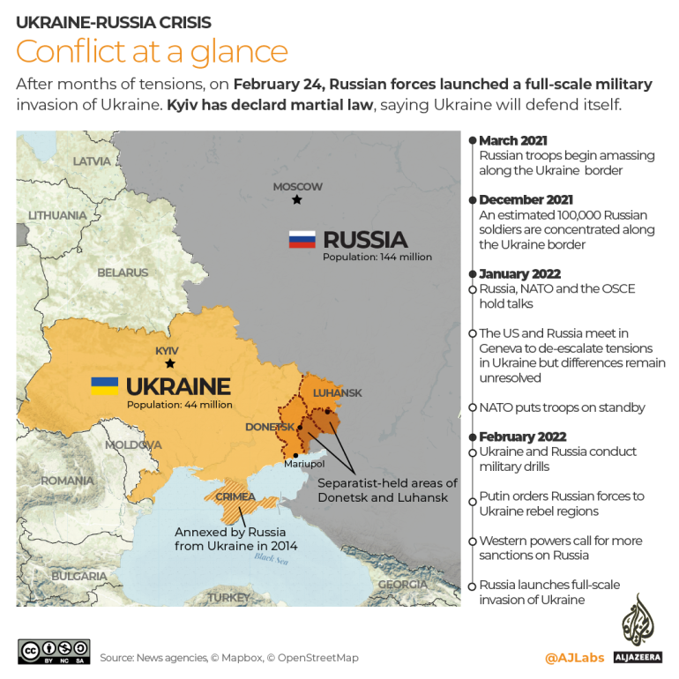

A selection of the current significant military forces in the area is provided below:

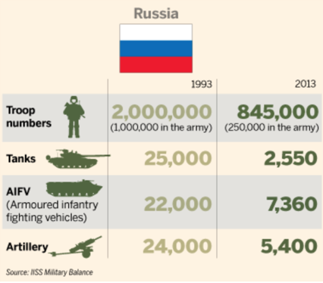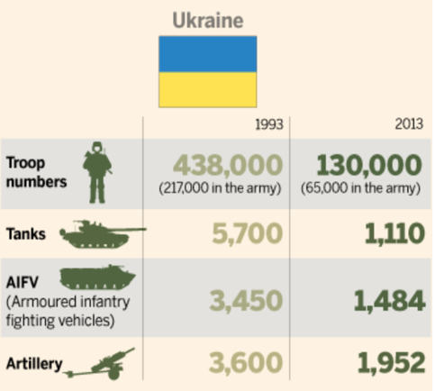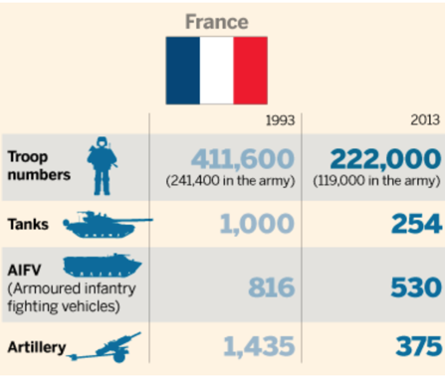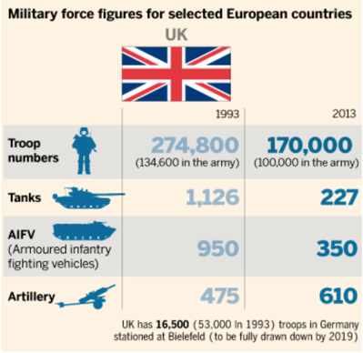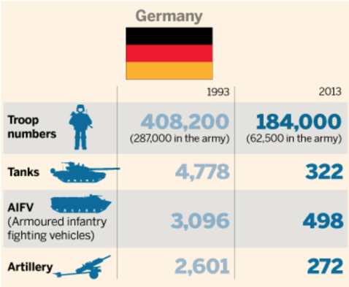

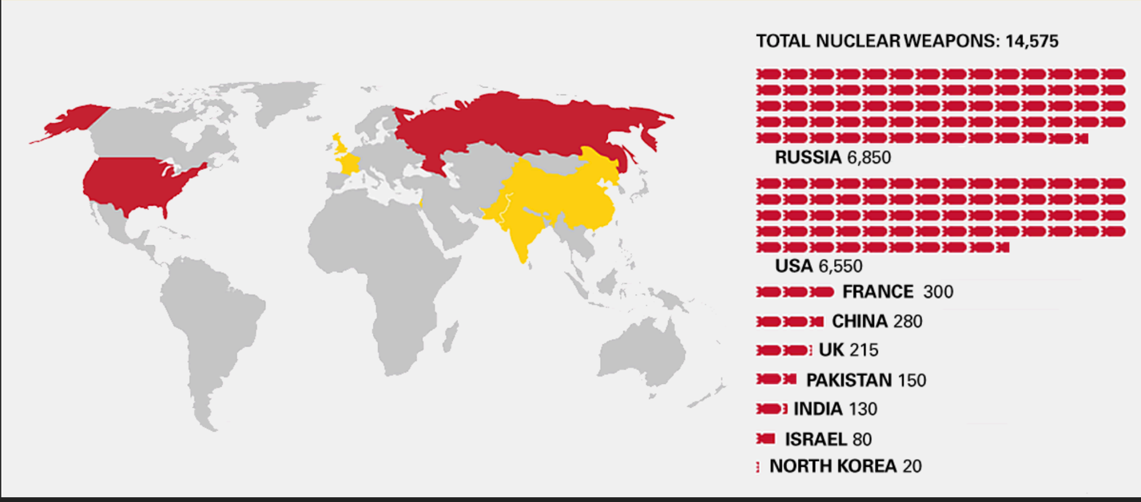

IV. UN Action
In 2014 the UN General Assembly (UNGA) reaffirmed Ukraine’s sovereignty over Crimea and has adopted resolutions on the militarisation of and human rights abuses in Crimea.
10th December 2019, The UN General Assembly approved a resolution condemning Russia’s occupation of Crimea and the city of Sevastapol and urged the withdrawal of its military forces “without delay”.
The vote in the 193-member Assembly on Monday was 63-19 in favour of the measure, with 66 nations abstaining and 45 not voting.
In addition, the resolution highlighted Russia’s actions in parts of the Black Sea surrounding Crimea and in the Sea of Azov and the Kerch Strait.
Unlike Security Council resolutions, UNGA resolutions are not legally binding, though they do reflect world opinion.

V. Essential Questions

  - What should the UNSC response to Russian incursions into Northern and Southern Ukraine be?
  - How to address the refugee crisis that will likely arise as a result of the military situation.
  - How to address the potential escalation from conventional use of military weapons to tactical and strategic nuclear weapons.
  - Are there any legitimate claims to warrant Russia’s use of military operations in the Ukraine.
  - How to resolve the Russian annexation of the Crimea (2014) and fighting in the separatist areas of Donetsk and Luhansk.
  - How to minimize the economic impact of the military situation to Europe and the rest of the World economy.

VI. References

https://unric.org/en/the-un-and-the-war-in-ukraine-key-information/

