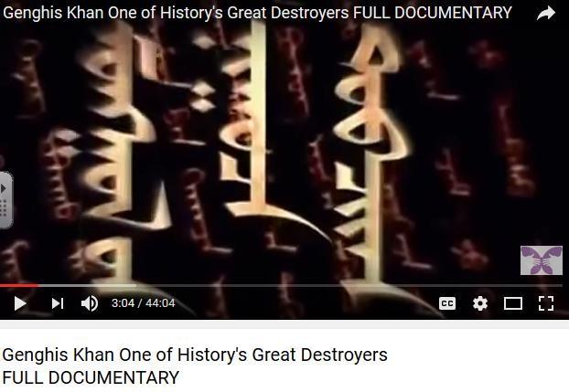

ATL Research, Critical Thinking and Communication

“Ancients Behaving Badly” – Genghis Khan

Complete the following questions:

- What is the secret History of the Mongols?

- What traumatic events and factors early on in his life shaped the person who he later became?

- What advantage did the silk layer under the Mongol armour have?

- What occurred at blue lake?

- ‘Genghis was not just a conqueror but a ruler’. To what extent do you agree with this statement.

