Anchorage Earthquake 2018!

- Where is Anchorage?

- Where did the earthquake occur? Mark it on your map: 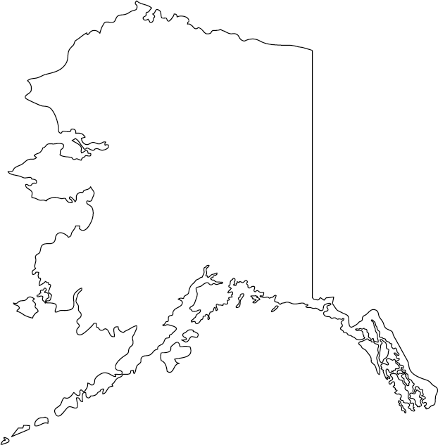

- On what date did the earthquake strike?

- What was the magnitude of the earthquake?

- How many aftershocks have occurred?

- How many deaths have occurred?

- When was the last large earthquake to strike Anchorage?

- How far was Anchorage from the epicenter?

- Why were few deaths expected in Alaska?

- Provide key details of the last major earthquake in Alaska

- Why are earthquakes so common in Alaska

- At what depth did the earthquake occur?

- Did the depth of the earthquake make the effects better or worse?

- What is the cost of the damage?

- What is the meaning of liquefaction?

- At what plate boundary did the earthquake occur?

- What is the name of the process where one tectonic plate sinks below another?

- How many earthquakes typically occur in Alaska?

- What was the record number of earthquakes that occurred in 2014?

- Watch the video clip from CBS news and take note of at least 3 impacts of this earthquake.

- What advice does the Alaska government provide for earthquake preparedness?

- Do the video clips from Business Insider (scroll down) provide any evidence to show that the government’s advice was being followed?

