Peer assessment: Sample analysis

Task: Read the analysis below and success criteria below. Annotate it with 2 colours…One for things they have done well, one for things they could improve on.
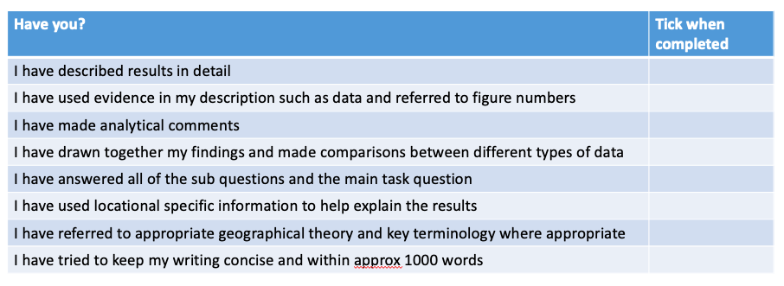

There are fewer environmental impacts the further you go away from site 1

There are fewer environmental impacts the further you go away from site 1 as seen by the EQS (fig 1). Site 1 has an EQS of 10 whereas site 4 has an EQS of 30. This is because site 1 is a honeypot site as seen by the human attractions shown in the photo in fig 2. It has more visitors (as seen by the people and car count in figs 3 and 4). Site 4 is a state park because the area has a unique environment and is home to various species of animal including turtles, marsh rabbits and snakes (reference the state park website). Evidence of protection includes signs (photo in fig 6), and lots of litter bins (fig 7). Although it had an overall lower EQS score than site 1 it did however, have the most litter (fig 8). This could be due to the circular currents of the Gulf of Mexico depositing litter in the area. Despite having the highest amount of litter (see litter survey – fig 9) site 4 had a higher EQS because the range of environmental quality indicators (see EQS table fig 10). The data therefore suggests that although tourism is being managed at site 4 the environmental impacts are greater at site 1 and therefore tourism has both a positive and negative impact on the area of study.

Using the mark scheme, what grade do you think they would get? 