After Partition: colony politics and the rise of communism in Bengal
In post-Partition Calcutta, following the tumultuous and traumatic division of the province of Bengal between Pakistan and India, one in four residents was a refugee and many families were split by the new border. Here, Kushanava Choudhury explores how the city’s refugee communities united and organised, transforming unclaimed land into more than a hundred ‘squatter colonies’, and shares the stories of the residents who fought first for survival and then for recognition…
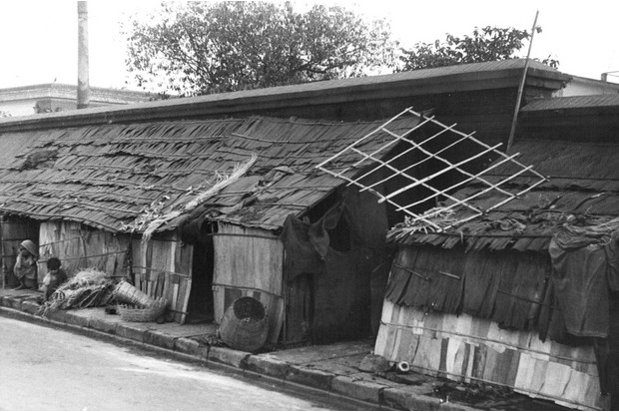
A Calcutta pavement, c1961. Refugees who had moved from East Pakistan to India made their homes on the appropriated land. (Photo By Lee Olson/The Denver Post via Getty Images)
After 1947, unlike in Delhi or Punjab, the millions of Partition refugees in West Bengal were not accommodated through expansive planning by the Indian state. More than four million Hindus crossed from East Pakistan at that time (and many millions more would cross in the coming decades). Indeed, state plans for the influx of refugees from 1947 to 1951 focused on resettling them outside West Bengal or returning them to East Pakistan. Meanwhile, the population of the Calcutta metropolitan area alone grew as much in five years as it was projected to grow in half a century. One in four residents was a refugee. In this milieu, refugees themselves had to make their own arrangements. On the edges of the city and in the surrounding districts, refugees organised politically to take over state-owned or private land by force to form at least 149 squatter ‘colonies’. Unlike in Punjab, the influx of refugees was continuous for many decades, ebbing and flowing with political conditions in East Pakistan and then Bangladesh. By the late 1970s, there were more than a thousand such colonies across the state of West Bengal. The colony areas became crucial constituencies for the communist government that was elected in the state in 1977 and remained in power until 2011.
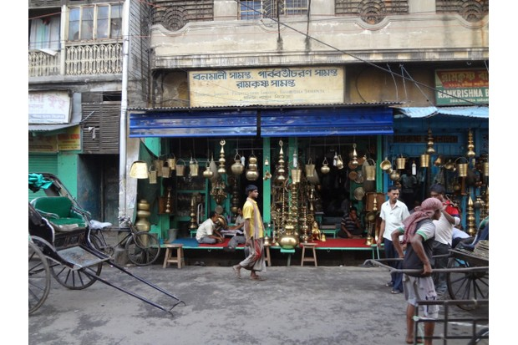
The refugees who arrived in the city of Calcutta embarked on a long struggle for respectability and recognition. Kushanava Choudhury found many reminders of this fight when he visited in 2010. (Photo by Kushanava Choudhury)

In 2010, Shibapada Bhattacharya lived in a two-storey house in Netaji colony in Baranagar, on the northern edge of Calcutta. His front room had a wooden desk, a bench and portraits of Marx, Engels, Lenin and Ho Chi Minh on the walls, much like a Communist Party office. When I went to see him, Shibapada first wanted me to tour his toilet. His nephew led me through the bedroom, where Shibapada’s grandson was playing a video game, into the back yard. In the middle of the yard stood a concrete octagonal tower which looked like an obelisk. Inside it was a squat latrine. In the early 1970s the city had been putting these toilets into slums. For Rs 200 [rupees] a piece, they agreed to install them in the squatter colonies as well. Until then the family had defecated in a pit in the yard covered by walls made of jute sacks. Before that, when the squatters first set up their shacks of bamboo and hogla grass, there were only communal troughs.
No one used the obelisks anymore: almost everyone had indoor bathrooms, much as in Shibapada’s house. But, in the history of the squatters told through their toilets, the obelisks represented the crucial point when their needs were recognised by the state. Later I noticed these obelisks everywhere in Netaji colony and other refugee areas, standing as memorials to a struggle for respectability and recognition.

Finding homes across a new border
In 1949, when the colony was founded, Shibapada’s father and uncle were living in the area already, in rented rooms in Baranagar. They had jobs in Calcutta and families in a village back in East Bengal. This bicultural lifestyle came to a rude end when the boundaries of nation-states felled these linkages, placing home in Pakistan, and work in India. The families had to be brought over, settled somehow. Many of these men were political activists. Shibapada’s uncle Madhusudan was in the Congress. Others were with the Socialists, the Radical Humanists, and some were in the Communist Party of India (CPI), which had then gone underground. In 1949 they began meeting secretly in a jute warehouse near the river Ganga. They formed an association, across party lines, forged by circumstance. In October 1949, at midnight, they sneaked into an abandoned Second World War military camp, planted bamboo poles, and cordoned off plots by rope. They made a claim. Then they waited.
The owners of the nearby garden houses complained, but the squatters had been wise to encroach on abandoned army land. The police did not come to tear it down. By tacit agreement, the Congress government let them build their colony. For Rs 50 you could get a plot, and then buy bamboo and hogla grass [stiff freshwater grass used for weaving] from the shops along the river to build a shack. Overnight they developed a squatter colony. The activists organised themselves into a colony committee, with elected members, and then sub-committees within each ward. And they built a Kali temple.
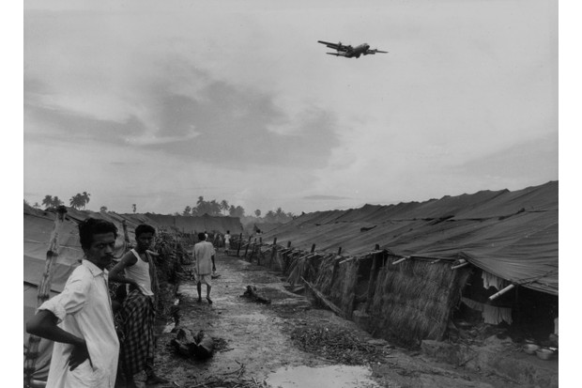
Refugees in Salt Lake Camp near Calcutta Airport in India, June 1971. (Photo by Mark Edwards/Keystone Features/Getty Images)
“The East Bengal people,” Shibapada said, laughing, “they had an idea that if there was a temple in place, they could not be evicted.” This was ‘Squatting 101’. Houses, villages, entire regions could be demolished, lives ground to nothing. But if a religious structure was destroyed, a whole community could become inflamed. Better to leave it alone. It was deft political thinking in a country where poor people could be evicted much more easily than gods.
Was there a lot of religious feeling among the refugees, I asked.
“When we first came here,” he said, “there were people here who did not get two meals a day. The struggle to survive came first. Religion came later.”

Unrecognised communities
The refugees settled on about 50 acres of land. When the first colony committee allotted plots, they also planned for schools, playing fields, a colony bazaar and neighbourhood clubs. More schools came up, each with its own school committee, all under the umbrella of the colony committee. Just as the state government was building planned townships like Salt Lake with their futuristic nomenclatures, identical water tanks and traffic circles, a different kind of planned community was being developed by the squatters in the colony, with its own organisation, its own order, its own logic. Except none of its initiatives were recognised by the state. On the maps of the government, the colony didn’t exist, its schools didn’t exist, nor its houses.
Debranjan Ghosh had been a boy when the colony was founded. “Do you remember the scene in Ritwik Ghatak’s film Subarnarekha [1965], where a colony is being established?” Debranjan asked. “Everyone is very busy. People are being brought in lorries and allotted plots according to their home districts. Dhaka people in one zone, Barisal people in another. And in the middle of all that activity a man with a blackboard is setting up a primary school. That’s just as it happened here. I saw that scene with my own eyes.” At the same time that the first plots were being distributed, and families were planting bamboo poles and making walls of hogla grass, simultaneously on an allotted plot a primary school was set up. It almost seems like it was the exact same place, Debranjan said smiling, seeing the images flickering before him in his mind’s eye.
Initially, the entire colony had one letter box. At the time, most families were split on both sides of the borders. Many letters came from family in East Pakistan. Every morning there would be a rush to the letter box. Many of the correspondences would get destroyed, Debranjan explained. It was a big problem. “Then an opportunity came.”
The central government sent surveyors from the Postal Service to upgrade the wireless tower on the adjoining land. There was a cable box of the wireless tower within the colony area. There was a man named Manas Ghosh in the colony, who founded the colony high school. He had a plan. Under his leadership a meeting was held, and overnight the cable box was dug up and removed, and the land covered over as if nothing had existed. When the surveyors came and saw what had happened, they called the police. A huge crowd of colony people gathered and occupied the land around the cable box.
“The surveyors said: ‘You have to co-operate with us.’ And Manas Ghosh said: ‘You help us too. First remove these police officers. Next provide door-to-door postal delivery.’ That’s how we got postal delivery in the colony!”
Debranjan relished the story, that spirit of the colony to organise, to play shrewd politics to secure the basic resources needed for survival. What they did was blatantly illegal, of course. Law had drawn the lines that had made them homeless, but it had made no arrangements for their survival. When law abandoned them, there was only politics as recourse. Each struggle had been like that, to get piped water, electricity, municipal services, to get their schools recognised and their garbage collected, to have the right to stay, and ultimately to have ownership titles to their plots. Just like the postal delivery, like Shibapada’s obelisk toilets, each had come incrementally though agitation, organising, and permanent mobilisation.
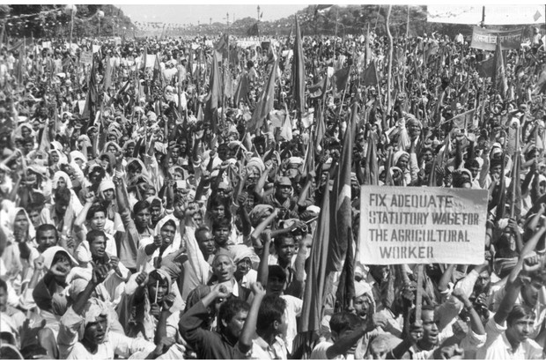
The colony style of mobilisation – of organising and squatting to make demands – produced a prototype of politics that would be copied by communists in other struggles. Pictured is a communist march protesting wages, c1980. (Photo by Keystone/Getty Images)

In the beginning, they only had the right to survive. If the congress government at the time had wanted to, Debranjan said, they could have stopped the colony from being formed. But they didn’t. Nor did they accede to the demands of local landlords to take action, by sending police to evict the squatters. What’s more, he said, several local Congress people – without any party directive – helped them in surveying the land and planning the colony. Most Bengali Hindus who voted at all had supported the Congress in the pre-Partition days. Like Shibapada, Debranjan himself came from a Congress family. But the experience of Partition turned his father and uncles against the Congress. Debranjan said: “In the 1,000 years of Bengal’s history – 800 years of Muslim rule, 200 years of British rule – nothing like this had happened in Bengal. No event occurred where millions of people, for religious reasons had to lose their homeland, had to leave the hearth of their seven ancestors.
“Congress blamed Partition on the Muslim League [the political party that called for a separate Muslim nation-state to be created at the time of Partition]. But the people who worked for Congress in East Bengal, the people who were educated, the people who knew what really happened knew that the Muslim League was not the only party to blame. Congress had a very big role,” he said. “That’s how they became anti-Congress.”

A move towards communism
Partition pushed people like Ghosh’s parents leftward. Some became socialists or radical humanists, and eventually communists. When the second colony committee was set up, a public assembly was held in the central field and then a vote was taken. It went into the hands of leftists. In time Debranjan, like Shibapada, joined the Communists too.
In 1950, a state-wide refugee coalition was formed by colony committee leaders belonging to the various political parties across the 100-plus squatter colonies. This cross-party organisation, called the United Central Refugee Council (UCRC), had political activists from several leftwing parties, including the Communist Party of India (CPI), as well as the Congress.
Initially, after Partition, the CPI was wary of the Hindu refugees. They were seen as tradition-bound, religious people, who could not be forged into an urban proletariat. At the party level, the CPI at the time were trying to mobilise workers and Muslims, who remained a quarter of West Bengal’s population. They kept their distance from the trainloads of Hindu refugees arriving at Sealdah station, and planting bamboo stakes into lands all along the city’s outskirts. It wasn’t until 1951 that the communists began to engage formally with the refugees.
In 1951, the congress government introduced a bill – commonly called the Eviction Bill – in the state legislature to facilitate the eviction of squatters from state and private land. Primarily targeted at refugees, it resulted in mass mobilisation by the UCRC in protests and rallies across Calcutta and the surrounding districts. In the assembly, the UCRC position was most vocally expressed by Jyoti Basu – who would later become Bengal’s first communist chief minister – and was then one of the only Member of Legislative Assembly (MLA) from the CPI.
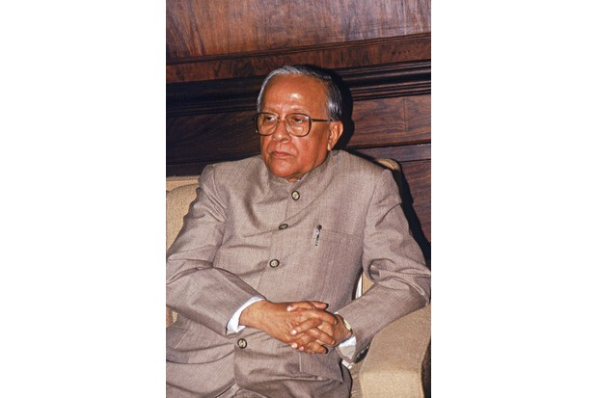
Jyoti Basu became Bengal’s first communist chief minister. (Photo by CPI-M/West Bengal News Portrait)

One of Basu’s main arguments was that the refugees had to be registered to vote, and recognised as citizens of India ahead of the first election in 1952. While the evictions authorised by the amended Rehabilitation Bill which was passed could not practically be enacted, the mobilisation linked refugee movements with electoral politics. In 1952, Basu was elected as an MLA from Baranagar. Basu would rely on the refugee vote in Netaji colony and neighbouring colonies to hold that seat for the next 20 years. The colony style of mobilisation – of organising and squatting to make demands – produced a prototype of politics that would be copied by communists in other struggles across the state.
After the communists came to state power in 1977, they gave ‘recognition’ to and ‘regularised’ the institutions and practices which already existed on the ground in the refugee colonies. This culminated in the provision of formal land titles that turned squatters into homeowners. Decades of popular mobilisation in the colonies led to incremental legal recognition and granted millions of citizens the ability to exist, to not be dispossessed, and to begin new lives.
Kushanava Choudhury is the author of The Epic City: The World on the Streets of Calcutta, (Bloomsbury, August 2017)

