Activity 2.1 Private sector and Public sector enterprises.

Introduction: The ownership of firms is another thing that distinguishes firms from one another. Most of the firms in the USA are privately owned under different legal forms. See the table on page 200. Some firms are State-Owned enterprises (SOE's), owned by the state and referred to sometimes as nationalized industries. An example of one of these is the world’s largest energy company Saudi Aramco. Another example of an SOE is Amtrak in the USA. Watch the two videos and answer the following questions:

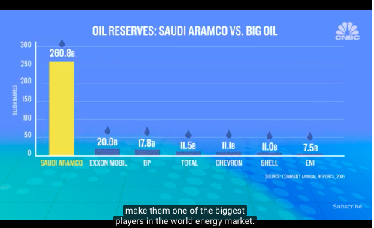
2.1a) Watch the first documentary on Saudi Aramco

- Who owns Aramco?

- When was Aramco first founded? What was its original name?

- Who owned it in the beginning? Was it a private or public enterprise?

- What happened in 1980?

- Give an example of a primary sector activity it engages in?

- Give an example of a secondary sector activity it engages in?

- Give an example of a tertiary sector activity it engages in?

- How much oil reserves does Aramco have?

- How much is the market capitalization of Aramco estimated by the Saudi government to be?

- Which famous companies does this make Aramco bigger than?

- How much of Aramco is the Saudi government looking to sell to private investors (via the stock exchanges)?

- What will the Saudi government do with the revenue generated from the sale of the small stake in Aramco?

- Does this mean that Aramco will now be a privately-owned enterprise or still a State-Owned Enterprise?

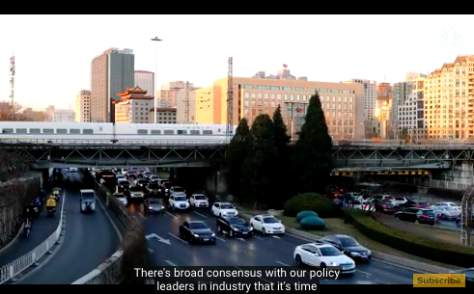
2.1b) Watch the second documentary on the USA’s lack of high-speed rail

- What is the quality and development of the Chinese high-speed rail system?

- When was America’s rail system built and what are the potential problems with this?

- Why did the importance of railways as part of the transport mix in the USA decline from the 1950’s onwards?

- What are some of the challenges of encouraging more people to use AMTRAK in the USA. How does the example of the Acela line from Boson to DC expose some of the challenges of high speed rail.

- How is the High-speed railway between San Fransisco and Los Angeles being funded, who will own it once built?

- What are the challenges of building high speed rail for a private sector firm, what for example is the cost per mile of construction? What other challenges are there?

- How is the proposed Houston to Dallas high speed rail construction being funded?

- What are some of the benefits of the Houston to Dallas project?

- Why is there a strong argument that governments should fund, build and operate such projects (public ownership/SOE’s)?

- Why is there a strong counterargument that private sector should fund, build and operate such projects (private ownership)?

