A Brief history of India before 1857
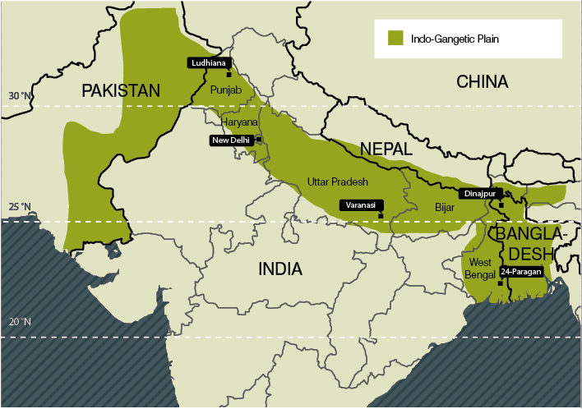
The History of India begins with the Indus Valley Civilization, which spread through in the north-western part of the Indian subcontinent, from 3300 BC to 1300 BC. This Bronze Age civilization collapsed at the beginning of the second millennium BC and was followed by the Iron Age Vedic period, which extended over much of the Indo-Gangetic plains and which witnessed the rise of kingdoms known as the Mahajanapadas.
In the fifth century, large parts of India were united under the great Indian Emperor Ashoka. He also converted to Buddhism, and it is in his reign that Buddhism spread to other parts of the Asia. In the reign of Mauryas, Hinduism took shape fundamentally. In the eighth century Islam came to India and by the 11th century it firmly established itself in India. The North Indian dynasties of the Lodhis, Tughlaqs, and numerous others, whose remains are visible in Delhi and scattered elsewhere around North India, were finally succeeded by the Mughal empire, under which India once again achieved a large measure of political unity.
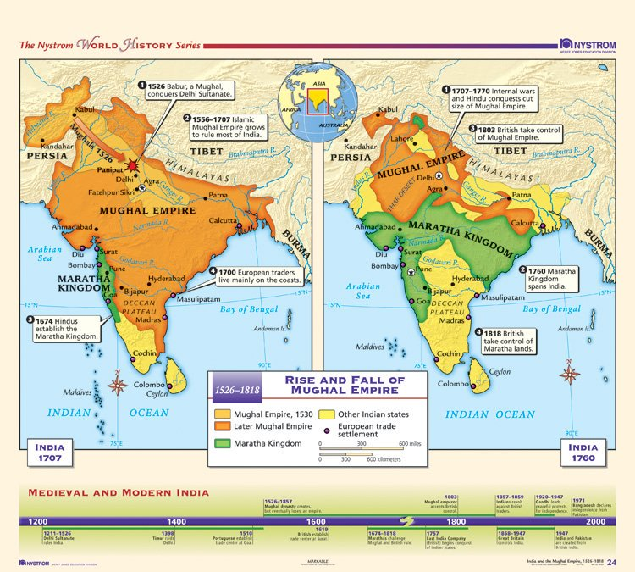
The Mughal dynasty were a Muslim dynasty of Turkic-Mongol origin that ruled most of northern India from the early 16th to the mid-18th century. After that time it continued to exist as a considerably reduced and increasingly powerless entity until the mid-19th century. The Mughal dynasty was notable for its more than two centuries of effective rule over much of India, for the ability of its rulers, who through seven generations maintained a record of unusual talent, and for its administrative organization. A further distinction was the attempt of the Mughals, who were Muslims, to integrate Hindus and Muslims into a united Indian state.

In 1707, the last great Mughal emperor died. His successors were weaker than he had been, and they were far less effective at governing. They were also seemingly blind to changing political realities in India. The emergence of competing regional kingdoms in 18th-century India had had a dynamic effect, opening up new sources of opportunity for revenue-hungry states and numerous social, military, and economic actors.

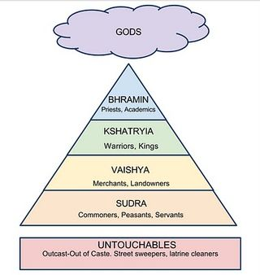
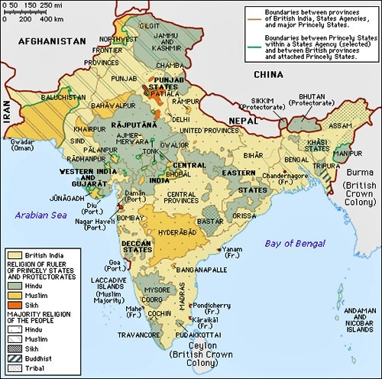
With the decline of Mogul central authority, the period between 1707 and 1761 witnessed the rise of the provinces and regional princes. This resurgence of regional identity led to both political and economic decentralization as Mogul military powers declined. The provinces became increasing independent from the central authority both economically and politically. Aided by trade in local raw produce and artifacts, these provinces became virtual kingdoms. Bengal, Bihar, and Avadh in Northern India were among the new independent regions where these developments were most apparent. Their rulers became almost independent warlords recognizing the Mogul Emperor in name only. These provinces laid the foundations for the princely states under the Raj.
In many regional states, both Hindu and Muslim rulers needed to seek out the favor of Brahmins (see Caste System) For these rulers, Brahmins were often the source of power and legitimacy in the countryside, providing ritual affirmation for Hindu rulers and giving legitimacy to Muslim rulers. Regional states that wanted their cultivators to pay taxes often had to have the approval of the Brahmins
In due course, the growth of the regions at the expanse of Mogul central authority, gave local land- and power-holders enough influence to take up arms against Mogul authority and declare their independence. This gave rise to the princely states of British India. Selfish goals prevented these rebels from consolidating their interests into an effective challenge to the empire. These princes relied on the support from their relatives, lesser nobility, and peasants. Their rule was very personalized with followers swearing allegiance to the ruler alone and not to the state. As such, with the death of a prince, allegiance was reshuffled and loyalty divided. The selfish motives of each princely state, made cooperation impossible. Each local group strove to maximize its share of the spoils at the expense of the others. The princes were thus never strong enough to dominate any sizeable territories and the Mogul Empire, shrank though it lasted in name until 1858.
As regional states began to make war on one another, everyone from common soldiers, or sepoys (Soldiers), to advisors and strategists saw a boom in employment across India. Regional states such as Mysore, Awadh, and the Maratha confederacy built large armies. In fact, historians have estimated that 2 percent of India’s population was in uniform full-time in the 1700s.
There were also substantial numbers of part-time soldiers. Given the vagaries of the monsoons, cultivators and farmers, when faced with bad harvests, would often join armies part- time to supplement their incomes. Coupled with full-time soldiers, it would be fair to say that around 5 percent of India’s population was engaged in direct warfare.
The emergence of regional warfare also affected India’s environment. Beginning in the 1700s, regional kingdoms began clearing forests to increase the amount of taxable, arable land. This meant more revenue for the army, court, scribes, and administration. For some, it could be the difference between victory and defeat. Deforestation also offered a tactical advantage: Fewer trees meant less cover for the enemy.
All regional states practiced something called military fiscalism. The kingdoms were increasingly shifting their spending and prerogatives toward armies, and this affected how agriculture was expanded, taxed, and administered. For example, kingdoms that wanted to raise more revenue extended agricultural cultivation into wastelands. They cleared forests, displacing forest dwellers and tribal adivasi Settling the lands required capital and credit, which brought Hindu merchants and moneylenders into the picture. Newly settled lands also required administrators and scribes, around whom shops and canteens began to sprout.

Colonial India

Powerful nations, including England, Spain, Portugal, France and Holland, had used their financial and military power to establish colonies in Asia, Africa and the Americas. Many colonies, such as in North America and in Australia, were created by military conquest. The conquerors drove out or killed the native peoples, whom they regarded as subhuman. They then settled the land with immigrants from their own countries. Other colonies, such as India, were first opened through trade and commerce which eventually led to their foreign economic domination and political control. England’s colonies included India, Burma, Ceylon, Malaysia, Singapore and hundreds of other territories large and small worldwide. The English defended their conquests by claiming that they were a superior race with a noble mission: to spread Western civilization. This sounds very racist today. But it was then a firm belief of most Englishmen.
The East India Company
In the late 1500s, European explorers started sailing east for trading purposes. The Spanish and the Portuguese were originally dominant on these new sailing routes, but after the destruction of the Spanish Armada in 1588 the British and Dutch were able to take more of an active role in trade with the East Indies. The Dutch initially took a lead in this, focusing mainly on spices and in particular the trade of peppercorns.
Concerned that the English were falling behind to the Dutch on these new trading routes, on the 31st December 1600 Queen Elizabeth I granted over 200 English merchants the right to trade in the East Indies. One of these groups of merchants called themselves Governor and Company of Merchants of London Trading into the East Indies, later to become simply The East India Company.
As the name suggests, the Company’s humble origins was as a small group of investors and businessmen looking to capitalise on these new trading opportunities. Their first expedition left for Asia in 1601 with four ships commanded by James Lancaster. The expedition returned two years later with a cargo of pepper weighing almost 500 tons! James Lancaster was duly knighted for his service.
Although these initial voyages turned out to be extremely profitable for the shareholders, increased competition in the mid-1600s made trading much more difficult. Wars, pirates and lower profit margins forced the Company to grow into new markets where competition was less fierce. It was during this time that the Company also decided that it could not compete with the more powerful Dutch East India Company in the trading of spices, so instead turned its attention to cotton and silk from India.

British involvement in India during the 18th century can be divided into two phases, one ending and the other beginning at mid-century. In the first half of the century, the British were a trading presence at certain points along the coast; from the 1750s they began to wage war on land in eastern and south-eastern India and to reap the reward of successful warfare, which was the exercise of political power, notably over the rich province of Bengal. By the end of the century British rule had been consolidated over the first conquests and it was being extended up the Ganges valley to Delhi and over most of the peninsula of southern India. By then the British had established a military dominance that would enable them in the next fifty years to subdue all the remaining Indian states of any consequence, either conquering them or forcing their rulers to become subordinate allies.
The Company evolved into a commercial concern only matched in size by its Dutch rival. Some 3000 shareholders subscribed to a stock of £3 200 000; a further £6 million was borrowed on short-term bonds; twenty or thirty ships a year were sent to Asia and annual sales in London were worth up to £2 million. Twenty-four directors, elected annually by the shareholders ran the Company's operations from its headquarters in the City of London.
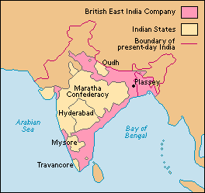
Towards the end of the 17th century India became the focal point of the Company's trade. Cotton cloth woven by Indian weavers was being imported into Britain in huge quantities to supply a worldwide demand for cheap, washable, lightweight fabrics for dresses and furnishings. The Company's main settlements, Bombay, Madras and Calcutta were established in the Indian provinces where cotton textiles for export were most readily available. These settlements had evolved from 'factories' or trading posts into major commercial towns under British jurisdiction, as Indian merchants and artisans moved in to do business with the Company and with the British inhabitants who lived there.
The Company had grown so large that it had come to dominate the global textile trade, and had even amassed its own army in order to protect its interests. Most of the forces were based at the three main ‘stations’ in India, at Madras, Bombay and Bengal.
Although the forces of the East India Company were at first only concerned with protecting the direct interests of the Company, this was to change with the Battle of Plassey in 1757.
Faced with a local uprising led by Siraj ud-Daula (with some French assistance!), the Company’s army led by Robert Clive quickly defeated the insurgents. However, this was to be a turning point for the Company and the following years saw it take full administrative powers over its territories, including the right to tax anyone living within its boundaries.
Although the 1600s and early 1700s saw the East India Company primarily focused on the trade of textiles, by the mid 18th century the Company’s trading patterns began to change. The reasons for this were two-fold.
Firstly, the industrial revolution had changed the way that the Company dealt with the textiles trade. Prior to this, highly skilled weavers were employed in India to make cottons and silks by hand. These light, colourful and easy to wear garments were popular amongst the fashionistas and upper classes of Britain. By the time of the Industrial Revolution, Britain had started producing these garments in its own factories, dramatically lowering prices (due to mass production) and bringing the fashions into the reach of the middle classes.
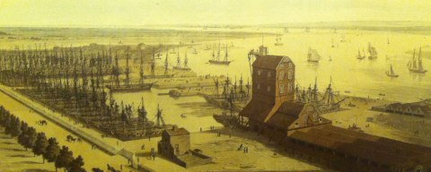
The second reason for this change in trading patterns was the growing desire in Europe for Chinese tea. This was a potentially massive market for the Company, but was held back by the fact that the Chinese only traded their tea for silver. Unfortunately Britain was on the gold standard at the time, and had to import silver from continental Europe, making the whole tea trade financially unviable.

The East India Company didn’t actually own many of the ships in its fleet. It rented them from private companies, many of which were based at Blackwall in East London. The picture above is of Mr Perry’s Yard, which also built ships for the British navy.

So how did the East India Company make its fortune in Chinese tea?
In short, through illegal drugs! The Company started encouraging opium production in its Indian territories, which it then gave to private merchants (heavily taxed, of course) to be sold to China. The tax revenues from this funded much of the Company’s profitable tea business.
Unfortunately this broke Chinese law, although it was tolerated by the authorities for a good 50 years until the trade balance fell to such a point that the Chinese could not afford to let it continue. This came to a head in 1839 when the Chinese demanded that all opium stock be handed over to its government for destruction. This ultimately led to the Opium Wars.
“…there is a class of evil foreigner that makes opium and brings it for sale, tempting fools to destroy themselves, merely in order to reap a profit.”
Commmissioner Lin Zexu, 1839

At the same time as the Opium Wars, the Company started witnessing an increasing amount of rebellion and insurgence from its Indian territories. There were many reasons for this insurgency, and the Company’s rapid expansion through the sub-continent during the 18th and early 19th century had not helped matters.

The East India Company's trade was built on a sophisticated Indian economy. India offered foreign traders the skills of its artisans in weaving cloth and winding raw silk, agricultural products for export, such as sugar, the indigo dye or opium, and the services of substantial merchants and rich bankers. During the 17th century at least, the effective rule maintained by the Mughal emperors throughout much of the subcontinent provided a secure framework for trade.

The Company's Indian trade in the first half of the 18th century seemed to be established on a stable and profitable basis. Those who directed its affairs in London could see no case for military or political intervention to try to change the status quo. The British did, however, start to intervene in Indian politics from the 1750s, and revolutionary changes in their role in India were to follow. This change of course can best be explained partly in terms of changed conditions in India and partly as a consequence of the aggressive ambitions of the local British themselves. Conditions in India were certainly changing. The Mughal empire had disintegrated and was being replaced by a variety of regional states. This did not produce a situation of anarchy and chaos, as used once to be assumed. Some of the regional states maintained stable rule and there was no marked overall economic decline throughout India.

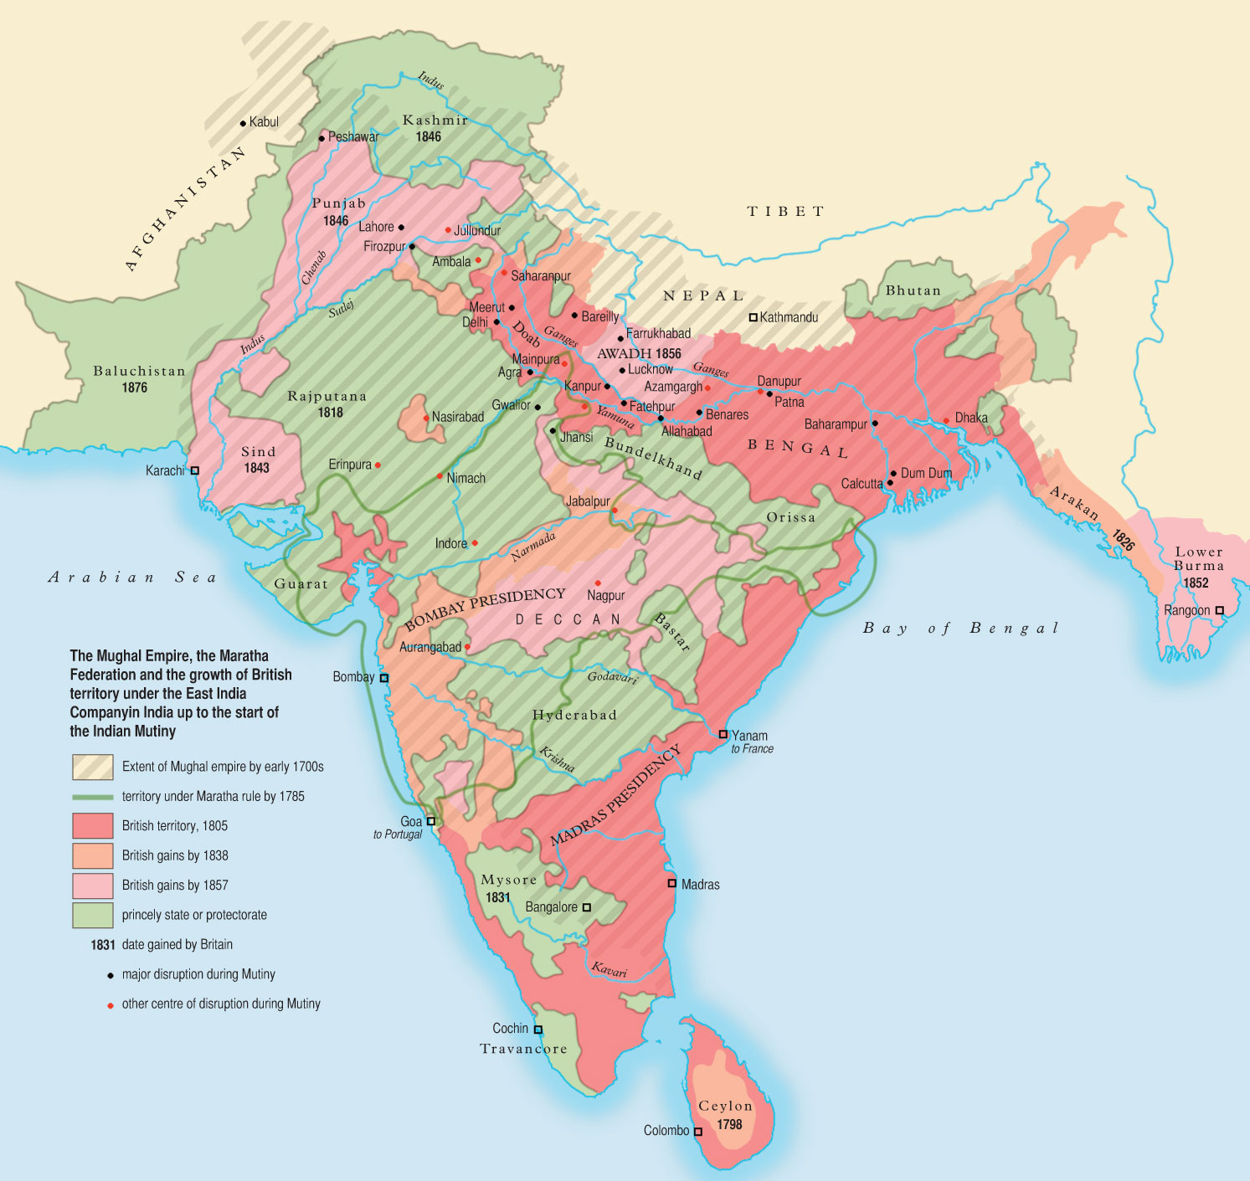
There were, however, conflicts within some of the new states. Contestants for power in certain coastal states were willing to seek European support for their ambitions and Europeans were only too willing to give it. In part, they acted on behalf of their companies. By the 1740s rivalry between the British and the French, who were late comers to Indian trade, was becoming acute. In southern India the British and the French allied with opposed political factions within the successor states to the Mughals to extract gains for their own companies and to weaken the position of their opponents. Private ambitions were also involved. Great personal rewards were promised to the European commanders who succeeded in placing their Indian clients on the thrones for which they were contending. A successful kingmaker, like Robert Clive, could become prodigiously rich.

The Anglo-French conflicts that began in the 1750s ended in 1763 with a British ascendancy in the southeast and most significantly in Bengal. There the local ruler actually took the Company's Calcutta settlement in 1756, only to be driven out of it by British troops under Robert Clive, whose victory at Plassey in the following year enabled a new British satellite ruler to be installed. British influence quickly gave way to outright rule over Bengal, formally conceded to Clive in 1765 by the still symbolically important, if militarily impotent, Mughal emperor.

What opinion in Britain came to recognise as a new British empire in India remained under the authority of the East India Company, even if the importance of the national concerns now involved meant that the Company had to submit to increasingly close supervision by the British state and to periodical inquiries by parliament. In India, the governors of the Company's commercial settlements became governors of provinces and, although the East India Company continued to trade, many of its servants became administrators in the new British regimes. Huge armies were created, largely composed of Indian sepoys but with some regular British regiments. These armies were used to defend the Company's territories, to coerce neighbouring Indian states and to crush any potential internal resistance.
Company government

The new Company governments were based on those of the Indian states that they had displaced and much of the effective work of administration was initially still done by Indians. Collection of taxes was the main function of government. About one third of the produce of the land was extracted from the cultivators and passed up to the state through a range of intermediaries, who were entitled to keep a proportion for themselves.

In addition to enforcing a system whose yield provided the Company with the resources to maintain its armies and finance its trade, British officials tried to fix what seemed to them to be an appropriate balance between the rights of the cultivating peasants and those of the intermediaries, who resembled landlords. British judges also supervised the courts, which applied Hindu or Islamic rather than British law. There was as yet little belief in the need for outright innovation. On the contrary, men like Warren Hastings, who ruled British Bengal from 1772 to 1785, believed that Indian institutions were well adapted to Indian needs and that the new British governments should try to restore an 'ancient constitution', which had been subverted during the upheavals of the 18th century. If this were done, provinces like Bengal would naturally recover their legendary past prosperity.

By the end of the century, however, opinions were changing. India seemed to be suffering not merely from an unfortunate recent history but from deeply ingrained backwardness. It needed to be 'improved' by firm, benevolent foreign rule. Various strategies for improvement were being discussed. Property relations should be reformed to give greater security to the ownership of land. Laws should be codified on scientific principles. All obstacles to free trade between Britain and India should be removed, thus opening India's economy to the stimulus of an expanding trade with Europe. Education should be remodelled. The ignorance and superstition thought to be inculcated by Asian religions should be challenged by missionaries propagating the rationality embodied in Christianity. The implementation of improvement in any systematic way lay in the future, but commitment to governing in Indian ways through Indians was waning fast.

The conquests that had begun in the 1750s had never been sanctioned in Britain and both the national government and the directors of the Company insisted that further territorial expansion must be curbed. This proved a vain hope. The Company's new domains made it a participant in the complex politics of post-Mughal India. It sought to keep potential enemies at a distance by forming alliances with neighbouring states. These alliances led to increasing intervention in the affairs of such states and to wars fought on their behalf. In Warren Hastings's period the British were drawn into expensive and indecisive wars on several fronts, which had a dire effect on the Company's finances and were strongly condemned at home. By the end of the century, however, the Company's governor general, Richard Wellesley, soon to be Marquess Wellesley, was willing to abandon policies of limited commitment and to use war as an instrument for imposing British hegemony on all the major states in the subcontinent. A series of intermittent wars was beginning which would take British authority over the next fifty years up to the mountains of Afghanistan in the west and into Burma in the east.

While England profited from its colonies, the colonies suffered oppression and disease. In the 19th century, the British did bring notable advances of the Industrial Revolution to India. But a century of British rule drove a wealthy and vital India into poverty and weakness. Britain introduced English education in 1835 to strengthen its power. Indians excelled in the new education system, with unintended results. They read, in English, how the American colonies banded together in 1776 to free themselves from Britain and establish a democracy. They learned how the French gained freedom by over- throwing their king in 1789. Indians rightly concluded that their ancient land—Bharat Mata, “Mother India”—had the same right as America and France to be free and independent. But it would take a century to achieve this goal.
The British colonialism in India changed the course of history in India . The British came to India in the early 17th century. At that time when the British East India Company was built up in India to break the Dutch monopoly over spice trading. With time the East India Company expanded its forces and began to control the nation. However its policies were despised by Indians and together they rebelled against the company. This prompted the defeat of the company and the administration of India went immediately under the Queen in 1858.

