Coastal Recession: A threat to the coastline
Case Study: Holderness Coast, East Riding, NE England

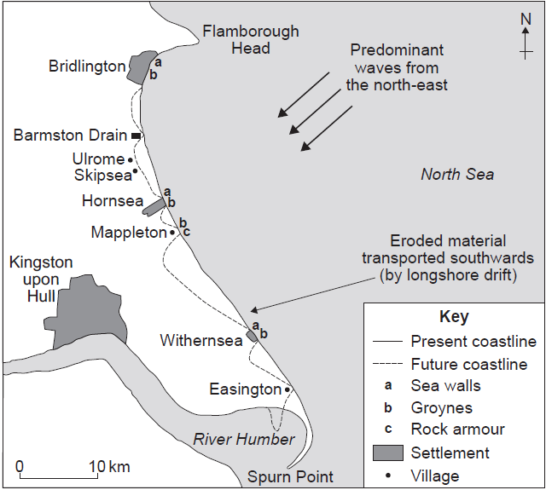

Causes of recession at Holderness
Geology of the coastline: Holderness is mostly comprised of boulder clay that was deposited during the last ice age. This material is soft rock and so is easily eroded by the action of the sea.
Processes of erosion and weathering: The cliff foot erosional processes of hydraulic action and abrasion undercut the cliffs at their base and erode the soft material. Rain water saturates the boulder clay at the top of the cliff and lubricates a slip plane. The processes of undercutting and weathering cause material to become unstable - eventually cliff material slips down into the sea under the force of gravity (cliff slumping).
The strong currents of the North Sea rapidly transport material along the shore (longshore drift operates from north to south along this coastline). This leaves little opportunity for beach development and as a result cliffs are exposed to the action of the sea. Today, Holderness is one of the fastest eroding coastlines in the world.
Variation in recession along the coastline: Most of Holderness is comprised of soft boulder clay, however, the northern most part of the coastline is made up of chalk. Chalk is a more resistant rock and so less easily eroded. Therefore, to the north of the coast we find a headland (Flamborough Head), this area protrudes out to sea as it erodes much more slowly.

Effects of cliff recession:
It is not cost effective to protect areas of low land value. This has resulted in 14 villages being lost from the coastline since Roman Times. Many farmers have also lost their livelihoods, been forced to migrate or diversify. For example Ringborough Farm has lost 145 acres since 1939, meaning that half of the farm’s land has been lost to the sea. The farmer has moved his farm buildings back from the coast (they are now considered to be 300 years away from being lost as a result of recession). These changes have been at the farmer’s expense, causing significant difficulties for the business. The farmer has also been forced to diversify and now part of his business involves selling bottled gas, this was in substitution for pig farming as the piggery was lost to the sea.
The rapid rate of cliff recession has meant that there has been a need to protect areas of high value with hard engineering defences e.g. the settlement of Hornsea on the Holderness Coast. The problem with this is that it can speed up the processes of erosion further along the coast (where there is an absence of protection). Not only does this threaten other coastal communities (e.g. those further south in Lincolnshire) but it can also have dire consequences for the environment. For example groynes, such as those at Hornsea, trap sediment and reduce the amount of material reaching the natural spit at the southern end of Holderness (Spurn Point). Without replenishment, Spurn Point may erode; this area is an SSSI (site of special scientific interest) and it is an important habitat for many bird species (e.g. oyster catchers).

Exam questions:
For a named area that you have studied, explain the causes of coastal recession (7)
Explain how coastal erosion can cause a threat to the coastline (7)

Case Study: Coastal Management at Holderness, East Riding, NE England.
The 1949 Coast Protection Act allows local authorities in England to decide how best to manage their stretches of coastline.
Coastal retreat is very rapid along much of Holderness – it is one of the fastest eroding coastlines in the world. The decision as to what parts of Holderness to protect with coastal engineering is based on cost-benefit analysis. The areas that receive protection are those that would be very costly to replace as a result of retreat. These areas include the larger population settlements of Hornea, Withernsea and Bridlington. Mappleton is also defended, depite being a small settlement of 249 people. This is because there is a coastal road that runs close to the cliffs that it would be very expensive to re-route. Furthermore, residents at Mappleton have lobbied the government to demand protection for their historic village. A further area that is defended is Easington, this is because Easington gas station is located here. 25% of the nation’s gas comes through Easington and so the loss of station to erosion could have dire consequences for the English economy.
Defences at Holderness:
use of groynes to trap moving beach material and provide a protective beach in front of the cliff
the construction of sea walls and revetments as wave-resistant structures at the base of the cliffs
artificial off-shore breakwaters like tyres and concrete blocks, forcing waves to break off-shore.
sea wall used to protect Easington Gas Station (cost 4.5 million)

Defences at Mappleton:
- In 1991 a rock revetment and two rock groynes were built to encourage the build up of beach material by trapping material transported via longshore drift. This means that waves break on the beach rather than attacking the cliffs, as a result sand accumulated and halted erosion.
- However, south of Mappleton, the rate of erosion has increased significantly.
- Material that usually moves south via longshore drift is becoming trapped within the groynes. Now there is no beach to protect the cliffs in these areas - the sea reaches the base of the soft cliffs and erosion occurs.

Managed retreat
Smaller villages and farmland do not typically receive protection – at least not from costly hard engineering schemes such as groynes, sea walls and rock armour. For example the local authority has decided not to defend the village of Kilnsea (population 80) as it is not seen to be cost effective. This has left villagers feeling abandoned and it is likely that this settlement will eventually be lost to the sea.
At Sandy Beaches Caravan Park the authorities have been practicing managed retreat. The caravan site has already lost 50 bases to the sea. It is participating in the local council’s roll back scheme. For every 4 bases that are lost the council provide the finds to buy 5 more bases. The site owner purchases land from farms further inland, rolling back the development.
Exam questions:
Explain the various ways in which coastlines can be managed from the threats they face (7)

