**8 facts about Richard the Lionheart**

Richard I (1157-1199) – aka Richard the Lionheart – is remembered for being a chivalrous English king; for battling Saladin during the Crusades; and for rebelling against his father, Henry II (1133-1189). His name has become an English legend, but how much do you know about him? Was he really betrothed at the age of nine? Did he spend most of his time abroad, fighting the Crusades? And did King Richard ever meet the legendary Robin Hood, as the 1973 Disney film suggests?

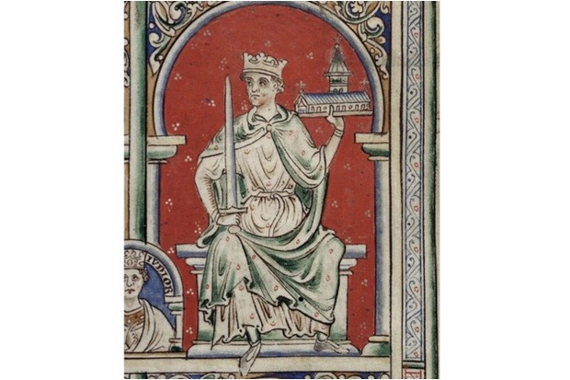

**Despite being born in England, Richard may not have spoken English**

Richard was born in September 1157 in what was then known as ‘the King’s Houses’, a palace built by his great-grandfather Henry I outside the north gate of Oxford city because it was a comfortable ride from there to his hunting tower at Woodstock. Standing near the present site of Worcester College, the palace was later demolished, but a commemorative plaque on the north side of Beaumont Street records its existence and the possibility that two kings of England may have been born there: Richard I and his younger brother John. However, Richard did not spend a great deal of time in England and he may not have learned to speak English. In his whole reign, he spent no more than six months north of the Channel.

**There was a notable social divide in England**

At that time, half of England was owned by a network of 200 related Anglo-Norman families (and the rest by the crown and the church). In the century since the Norman Conquest, followers of William the Bastard and his successors married noble Anglo-Saxon women to form a new French-speaking aristocracy. Their wealth and even their food were supplied by the toil of their native Anglo-Saxon serfs, few of whom rose to greatness.

Traces of the racial and class divide of this time still exist in modern English. For the live animals herded, tended, milked and slaughtered by the natives we still use their Anglo-Saxon names like *sheep, calf, cow* and *swine*. For the cooked meat on the table, which only the French-speaking overlords were allowed to eat, we use the French equivalents: *mutton, veal, beef*and*pork*.

More cruelly still, the poor natives were not allowed to hunt wild animals for food in the forests, or even gather winter fuel there. Some modern placenames tell this story: Cannock Chase in Staffordshire is so named because ‘chase’ comes from the French word *chasse* meaning ‘hunt’. It was originally enclosed land, where the game was reserved for the exclusive pleasure of the overlords. A peasant defying the “forest laws for the protection of vert and venison” risked a long term in prison – or even death.

**Richard was betrothed at nine years old**

At the age of nine, Prince Richard was betrothed to 9-year-old Princess Alais, daughter of the French King Louis VII. She was a pawn in the power struggle between the Plantagenet dynasty that ruled England – and much of France – and the Capetian French kings in Paris. Richard’s father, Henry II of England, was also Count of Anjou and Duke of Normandy – titles that Richard would eventually inherit. Richard’s mother Eleanor was the Duchess of Aquitaine. So both were technically vassals of Louis VII for their French possessions.

Yet Henry II tricked the weakling Louis VII into handing over his young daughter, promising that she would marry Richard when she had come of age. Like most of Henry’s promises, this was never fulfilled, resulting in poor Alais being kept for 25 years as a prisoner, during part of which time Henry II used her as his mistress.

**Richard was unwilling to get married and produce an heir**

When Richard succeeded his father to the throne at the age of 31 in 1189, he had an obligation to father an heir for the kingdom in order to avoid the kind of chaos that did ensue when he died childless and his brother John succeeded to the throne ten years later.

But Richard’s lack of interest in women and unwillingness to marry any of a long list of eligible princesses meant that the part of queen at his coronation was played by his formidable mother Eleanor of Aquitaine, the only noble woman to whom he showed any consideration.

**Did Richard meet the legendary Robin Hood?**

Whether Richard met the legendary outlaw Robin Hood in Sherwood Forest, we do not know, although film buffs call him ‘Richard of the Last Reel’ because he appears at the end of every Robin Hood film as the heroic, and supposedly victorious, crusader monarch returning to punish treacherous Prince John and the wicked Sherriff of Nottingham.

The truth is that, having insulted and alienated most of his Christian allies while on crusade against Saladin, Richard was unable to return to his kingdom except by sneaking in disguise through the territory of the Duke of Austria, one of the many enemies he had made in the Holy Land. Once caught, he was handed over to the German emperor, who demanded a huge ransom for his liberation, and the enduring legend of ‘Good King Richard’ originated as a PR campaign by Queen Eleanor to persuade the citizens of the Plantagenet empire to stump up the crippling ransom.

**Were tournaments really so chivalrous?**

Tournaments in Richard’s lifetime were not the ordered ritual they later became, with noble ladies watching two knights charging at each other along separated tracks, each endeavouring to unseat the other with his lance. The *mêlée*of the 12th century featured two teams of heavily armed and armoured knights setting upon each other with whatever weapons they liked in a no-rules lethal forerunner of tag wrestling.

The painting of emblems on shields was originally to enable knights in a *mêlée* to recognise their own team-mates. The name Plantagenet comes from the habit of Richard’s grandfather, Count Geoffrey of Anjou, wearing a sprig of bright yellow broom – *genêt* in French – in his helmet as a highly-visible recognition symbol. Often, the shock of head-on collision between two knights shattered the wooden shafts of their lances, with splinters penetrating the eye-slits of their helmets and blinding them.

In both battle and the *mêlée*, an unhorsed knight risked being trampled to death by the horses, which is what happened to Richard’s brother Prince Geoffrey. Knights taken prisoner in a *mêlée*were freed after paying a ransom to their captors, which was calculated on their rank and wealth. So Richard could see nothing wrong with his subjects having to stump up crippling taxes to ransom so important a person as their king. In effect, this nearly bankrupted his kingdom for the second time in his short reign that ended in 1199.

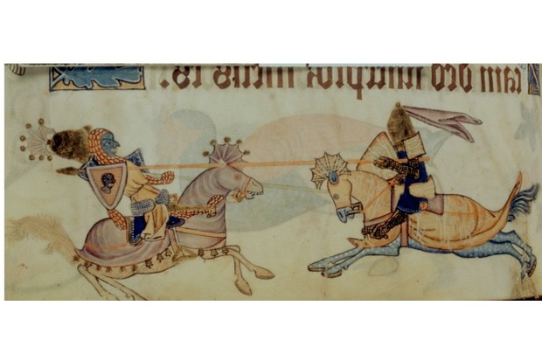

An image of Richard I and Saladin. Found in the British Library, c1325-1335. (Photo by Photo12/UIG/Getty Images)

**Richard spent the majority of his life at war**

To understand Richard’s thinking, we have to take into account that, like many nobly born knights, he spent his whole life in warfare. The idea of chivalry and protecting the poor did not exist in the 12th century, when knights prosecuted their incessant power struggles not in pitched battles against a more or less equally matched enemy, but strategically by slaughtering defenceless peasant men, women and children, burning their humble homes, laying waste their fields and cutting down their orchards to bring starvation to the survivors, thus depriving their enemy of the support base that financed his unproductive way of life. It was, to use a modern expression, total war – an idea that the church struggled with, but could not stop.

**Richard knighted his cook**

On a lighter note: in those days of little hygiene, the cook was an important member of a noble household because his mistakes could kill his employer. After one particularly memorable feast, which put Richard in great good humour, he impulsively knighted his cook, making him ‘lord of the fief of the kitchen of the counts of Poitou’. Arise, Sir Cook!

**Douglas Boyd’s *Lionheart, the true story of England’s Crusader King*was published by The History Press in 2014.**