Genghis Khan – Expansion into Asia (Khwaresmia) 1219-21

The events in the Mongolia up to 1218 had been devastating and bloody but not unprecedented.

Aims
As Genghis Khan planned to involve a third culture – the Muslin World – no culture before them had wielded such destructive power.
The Muslim World was about to suffer tenfold that of China. Although numbers are likely exaggerated by Islamic writers they were nonetheless appallingly high.
You could suggest that the motive was a racial or religious hatred or the application of an ideology but that was not the case. Racism is selective and the Mongols were not. They believed in a superiority over all not some. There was no crusading ambition to spread shamanism or create a master race or a desire to exterminate despised opponents or win lebensraum in Central Asia.
The overriding consideration was conquest, a destiny imposed on Genghis Khan by heaven. Destruction was a matter of strategy. Whatever achieved victory was good, whatever delayed victory was bad – it was that simple.

Background – Kuchlug and the Naimans
To understand this first link in the chain of events we must go back almost a century.
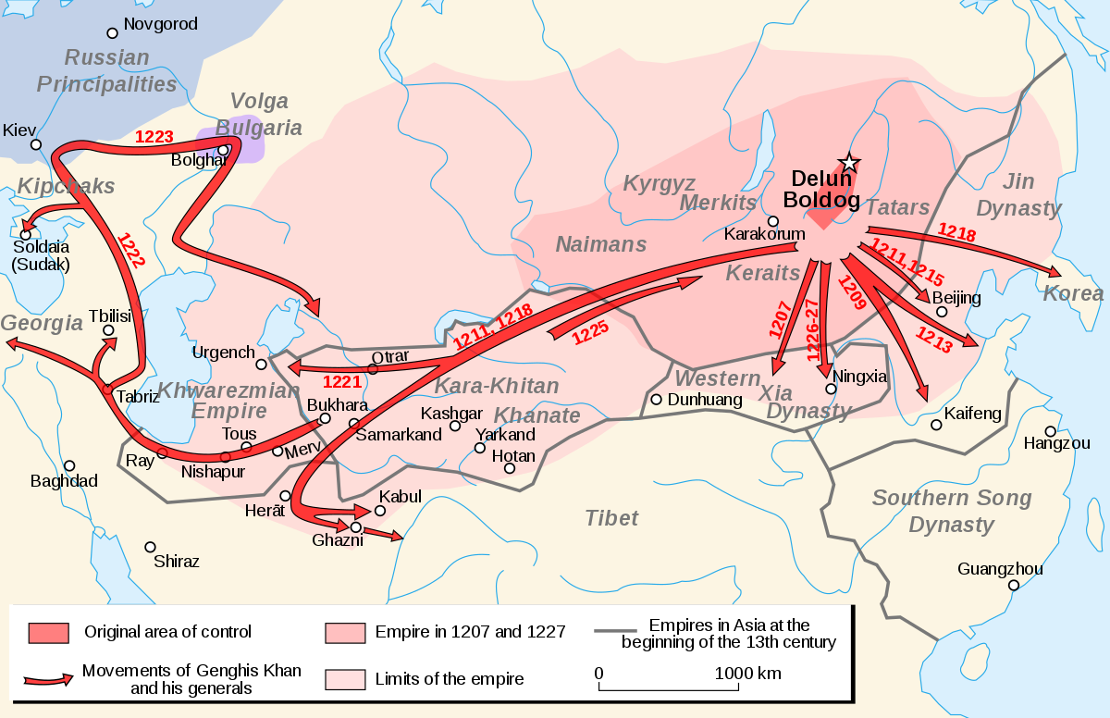
When the Khitan, ruling as the Liao were driven from the Dragon Throne by the Jurchen (Jin) in 1124, a member of the ruling house, Yeh-Lu Ta Shih had gathered together 200 followers and fled 2,500 kilometers westward, over the Tien mountains, far beyond the new rulers of northern China. A decade later Ta Shih, forged an empire the size of Europe, out of the anarchic region of inner Asia peopled by a mix of Turkish

tribes and Islamic peoples. He took the title Gur Khan and named his kingdom Khara Khitai – ‘Black Cathay’. Once established he began to exhort tribute from his Muslim neighbor.

70 years later, Kuchlug arrived and welcomed by the Gur Khan, securing his position by marrying the Khan’s daughter. Juvaini – He ‘leaped forth like an arrow from a strong bow’ to seize power.
His treachery won him few friends and he made things progressively worse. At the command of his new wife he converted to Buddhism and became violently hostile to Islam, demanding that Islamic leaders renounce their faith, alienating his own subjects.
When the imam of Khotan reviled him ‘Dust be in thy mouth, thou enemy of the faith!’. Kuchlug had him crucified on the door of his own madrasa.

In Genghis’s eyes this unstoppable fanatic would one day use his new base to seek revenge for his father and grandfather and risk the security of the Mongol nation. He had to be eliminated.

After years of hard campaigning in China this should not have been a hard task. In 1218 Genghis entrusted Jebe with the task of eliminating Kuchlug. There would be no great sieges and he left with 20,000 men. Geography was his greatest challenge – a march of 2600 kilometres, across the Mongol grasslands, then over the 3000 metre Altai mountains and after that through the rugged heights of the Tien Shan, where peaks reached up over 5,000 metres.
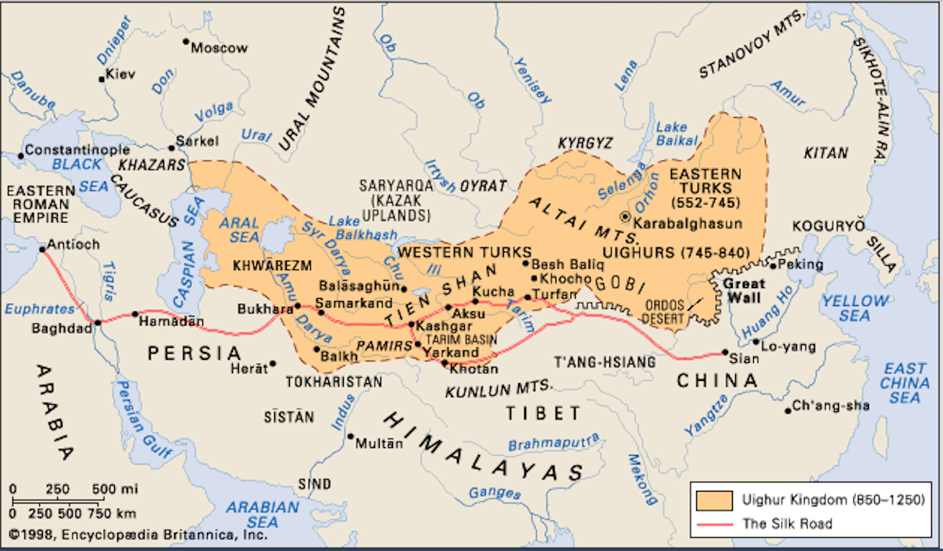
The army, following the Silk Road Trails would have skirted Issyk Kul, the world’s second largest alpine lake. Some 80 kilometres from Isshk Kul’s western end lay Kulchug’s capital, Balasagun – now vanished.
Military success came easily – as the Mongol’s approached Kuchlug fled south for 400 kilometres high over the Tien Shan and down to the Silk route Emporium of Kashgar.
When Jebe went in pursuit he banned pillaging, which meant that Kashgar’s Uighur inhabitants were happy to see him. Kuchlug fled again, over the desert to the Pamirs, following the Ghez river which leads to what is now Pakistan.
‘Chased like a mad dog’ by the Mongols Kuchlug and his followers entered a dead-end valley. Coming upon some local hunters, seeing a chance of glory and cash, caught Kuchlug and handed him over. The Mongols cut off his head and to confirm their conquest, paraded it through the cities of their new domains. Thus ended Genghis’s struggle with three generations of Naiman rulers.

The Mongol Envoy Visit
Their defeat over Kuchlug brought the Mongols into contact with their Islamic neighbor – a kingdom straddling much of present-day Uzbekistan and Turkmenistan, overlapping into Iran and Afghanistan. It was known as Khwarezm. This was an unruly region on Islam’s eastern borderlands. It was in a constant state of war among several participants, including the Khans of Khara Khitai.
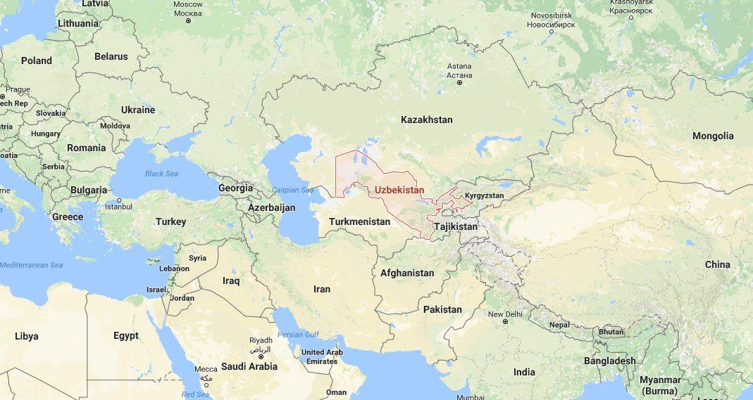

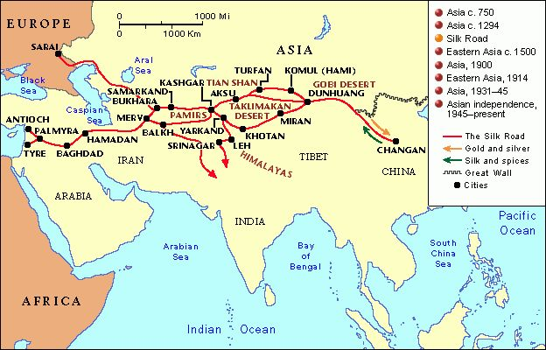
Khwarezm had also expanded into the provinces of Khurasan and Transoxania. It thus controlled the great Silk Road emporia – Samarkland, Bukhara, Urgench, Khojend, Merv and Nishapur.
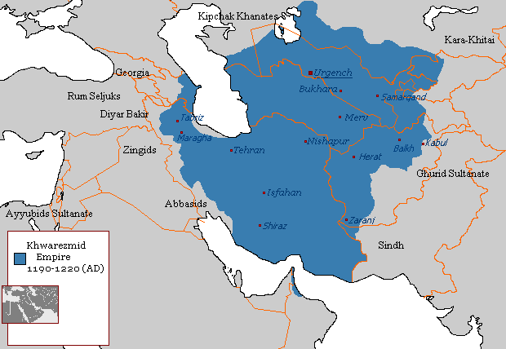
It was a confused and brutal time: Samarkland alone endured 70 attacks by Khara Kitai forces, almost one a year. Under this pressure, in about 1210 Khwarezm’s Shah, Mohammed concluded a brief alliance with Kuchlug, then on his way up. The result was that Kuchlug seized power in Khara Khitai, Mohammed was free to begin building an empire, thus starting a train of events that led to the next stage in Genghis’ journey towards transcontinental dominion.
The key to what follows is the personality of Khwarezm’s Shah Mohammed.
No-one had a good word to say about him. His mother Terken, who ran her own court also takes a share of the blame in the disaster that would follow.

Mohammed a volatile and insecure Turk tried to impose his will on his mainly Iranian people by force. One Sultan – Othman incited a rebellion in Samarkland and killed all of the Khwarezmians in the city, butchered them and hung their bodies in bits around the bazaars. When Mohammed seized the city again 10,000 died, including Othman – so when the Shah made it his capital – it had, to say the least, a disaffected. He had also fought with the caliph in Baghdad, so there was no chance of his presenting himself as the defender of the faith. He was also a notorious libertine. Juvaini portrays him ‘constantly satisfying his desires in the company of fair songstresses and in continual drinking of purple wine’.

Genghis has no interest in involving himself in this mess and claimed his only interest was in establishing a trade link. But Mohammed miscalculated the threat, aware of events in China he doubted that Genghis was capable of peace – “there is for me no difference between yourself, the Gur Khan and Kuchlug…..Let there be war in which swords are broken and spears are shattered’.

Genghis still insisted that he was intent on trade. War meant a further prolonged campaign, more borders to defend and possible defeat. Three merchants from Bukhara had arrived in Mongolia to exploit the newly opened up route through China. On their return Genghis had a huge delegation travel with them to forge a trade link. The delegation numbered something from 100 (Secret History) to 450 as other sources suggest. They were all Muslims except for a Mongol leader – their aim: to set up business in Islamic lands. The delegation also carried a message to the Shah from Genghis;

‘in order that they may acquire the wondrous wares of those regions; and that henceforth the abscess of evil thoughts may be lanced by the improvement of relations.’ (there are various versions but the sentiment remains the same).
In 1217 the delegation arrived in Otrar, a thriving border town, governed by Inalchuk (the other villain). He was a relative of Mohammed’s mother and would not have risked acting on his own initiative. He was the one who opened the gates to hell in a double outrage.
First, he accused the merchants of spying and arrested them all. Genghis was appalled by this act but refused to be provoked. He offered one last olive branch, sending three envoys, who gave Mohammed a chance to disclaim all knowledge of his governor’s act and hand him over for punishment.
Mohammed made the wrong choice – he had at least one but possible all three envoys killed.
To add insult to injury, as Juvaini claims ‘the Shah at once gave orders for that party of Muslims….. to be put to death’ and their rich goods be seized. Inalchuk ‘Little Lord’ had the whole party executed. Remembering the delegation were all Muslim except the leader this was not going to win over his own people.

To kill one single envoy would have been enough provocation for war but 100 or even 450 more was a statement of war. When the news reached Genghis Juvaini describes him as flying into a whirlwind of rage. He ‘went alone to the summit of a hill’ (Burkhan Khaldun) and prayed for three nights praying ‘I am not the author of this trouble, grant me strength to exact vengeance.’

The Mongol Attack
This began a new phase in Genghis Khan’s career. Up to this point tradition ruled. To invade China and even pursuing a tribal enemy over thousands of kilometres is understandable. But no nomad chief, while still wedded to his home base, would ever willingly have undertaken the task of subduing an empire so far from home, let alone one that was the dominant power in Inner Asia. In Genghis’s eyes he had no choice. Not only had he been humiliated and directly challenged; if the threats were not met he would almost certainly become a victim of an ambitious shah eager to expand his authority to China’s fertile lands. The Secret History claims he had no doubts about what was needed to be done ‘Let us ride out against the Islamic people, to gain vengeance’.

It was at this decision point where the issue of Genghis’s succession was raised. There followed a heated discussion over which son would succeed. The natural choice would be the eldest son Jochi. However, the second son Chagadai refused to accept this claiming ‘Are you saying we have to be governed by this Merkit bastard?’ The two brothers broke put in fight and had to be held back by Boorchu and Mukhali. Once the situation was calmed the third son Ogedei was selected as heir. However, Genghis claimed that ‘Mother Earth was wide and her rivers many’ and that each would get his own portion.

Genghis took personal charge of the campaign that needed meticulous planning, sought all the help that he could get. He learned from his mistakes in China where some cities had been besieged and taken three times because there was no adequate bureaucracy to hold the conquered territory.
It was at this point that Chu-Tsai or ‘long-beard’ as Genghis called him made his appearance. A captured Jin official, he was a Khitan who could trace his roots back to the Liao Dynasty. He was a studious intellect who was devout Buddhist. He found himself summoned to Genghis, who needed someone to set up and run an imperial bureaucracy. Chu-Tsai saw that conquest was proof that Heaven’s Mandate had settled upon Genghis. From now on he would play an important role in molding the character of the Khan and his Empire, working on his master’s curiosity about spiritual matters.

Genghis sent out requests for troops to his vassals in the borderlands of Mongolia, in Uighur lands, in Manchuria and Xi Xia (Tanguts). The military commander in Xi Xia Asher, saw an opportunity to gain independence – Fighting a war in China and Asia was surely impossible? He warned the King ‘If Genghis is really that weak why did he ever bother to become Khan?’ They refused to offer support. Genghis was furious but could not respond – he was needed elsewhere but ‘if I am protected by Eternal Heaven’ oh then there would be a reckoning indeed.

In 1219 Genghis led his army westward, swatting minor tribes along the way. This was a different sort of army that the one that had swept across the Gobi into Xi Xia and Northern China; different also from the one led by Jebe in pursuit of Kuchlug.
With between 100,000 and 150,000 soldiers, each with two or three horses, it retained the fast-moving, hard-riding flexibility of long established nomadic armies. They could cover 100 kilometres a day across deserts, swim rivers and materialize and vanish as if by magic. But there was now a hard core that was something entirely new. The sieges of Beijing and other Chinese cities had provided the Mongols with the best in siege technology and expertise. Tied to horses and camels were battering rams, scaling ladders, four-wheeled mobile shields, trebuchets and huge siege bows which could fire arrows like masts to punch holes in walls a kilometer away. This formidable combination of nomadic cavalry and siege weaponry had never been seen before.
The use of captured people also evolved. In the past captured civilians were a hindrance to the speed and agility of the nomadic army. Slaves needed looking after and this was not possible. This Mongol army had a new agenda – now prisoners had a triple use – as a forced slave labour force, specialist artisans and as soldiers in the non-nomadic contingents. They became cannon fodder, driven ahead of the army to fill in moats, take the full force of defenses and to put fear in the hearts of the defenders who could not bear to incinerate their own flesh and blood.

So what rolled westward in 1219 was a juggernaut, steered by its cavalry. It was a cumbersome, ever growing, beast which demanded the building of roads and bridges. The old cavalry lost none of their maneuverability. With every city taken, its non-nomadic contingents strengthened in wealth, numbers, weapons and power.
Of course, no-one saw this at the time or foresaw the consequences. Genghis had no long-term plan other than to redress wrongs, pay his troops and guarantee security. He could not have known that he was embarking on something to which there was no natural limit.

Ahead of him Genghis used propaganda and sought to use the divisions in the Khwarezm Empire to his advantage. He promised that if civilians did not resist they would be spared but if the chose to fight they would be sacrificed.

Faced with the Mongol threat Mohammed’a mistrust was his undoing. Fearful of committing all of his numerically superior forces to one commander out of fear that if victorious he might turn against him. Thus, the Khwarezm forces were never committed to a pitched battle, the troops were spread out between cities and were defeated one by one. Mohammed put his own survival above national interests. He himself did not take part in the battles, fleeing as soon as the Mongols approached. In these conditions resistance was sporadic and it was often beleaguered citizens who offered the stiffest resistance.

February 1220 – Otrar, whose governor could expect no mercy from the Mongols fell after a bitter five-month siege. Qaracha, sent by the Shah with 50,000 men to defend Otrar, slipped out of the city at night but was captured by the Mongols and, on the orders of Genghis’ sons, was executed as a traitor to his ruler.
Inalchuq barricaded himself with 20,000 troops in the inner citadel, the battle lasted for another month until most of the defenders had been killed and Inalchuq, short on weapons, was forced to shower the attacking Mongols with roof tiles. He was finally captured and executed. Genghis and Tolui did not wait for the fall of the city but moved on with the main Mongol army to Bukhara leaving Chaghatai and Ogodei in command of the besieging forces at Otrar.

On the approach to Bukhara, seeing the Mongol army, the main garrison of 12-20,000 men evacuated the city. 500 Turkish troops remained behind, barricaded into the citadel. The following day, March 1220, the population surrendered. They were driven out of the city and the men were forced to accompany the Mongol army to play the role of cannon-fodder at future sieges. Bukhara was plundered and, during this episode fire broke out and destroyed the city.

The treatment of the population of Bukhara can be taken as a model. If however a town put up a stiff resistance and caused the Mongols heavy losses, then after the capture of the town the male inhabitants were massacred, except for craftsmen and women who were distributed amongst the victors and dragged away into slavery. (Read Weatherford pages 3-9)
The fall of Bukhara had a psychological effect which brought into the open the tensions within the Khwarazmian empire. Mohammed’s strategic plan of spreading his troops among the cities proved to be disastrous – cities no longer proved an unsurmountable obstacle for the Mongol cavalry men.
Genghis moved on from Bukhara to Samarkland. This rich and flourishing trading centre which Mohammed had intended to make his residence was strongly fortified. A full army had been allocated to its defense. Juvaini puts the garrison at 110,000 men, 60,000 elite Turkish troops and 50,000 Tajiks and it was generally believed that the city could hold out for years against any attack. Yet the influential merchant princes and the opposition clerics had common interests with Genghis and were unwilling to fight him. After a sortie attempted by the Turkish troops with the use of elephants had been dealt with by the usual Mongol tactic of coaxing the emeny into an ambush, a delegation of senior clerics came to Genghis and offered surrender of the city. They and 50,000 of their followers were guaranteed their lives and protection. The inhabitants were driven out of the city, 300 craftsmen were distributed among the princes and military commanders, the remainder were allowed to return to the city and a fine of 20,000 dinars was imposed on them. Five days later the remaining 30,000 Turks of the garrison surrendered and were massacred.

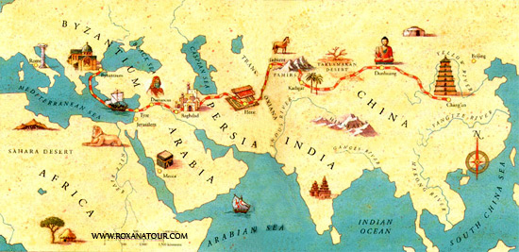
According to Juzjani the fall of Samarkland took place in March 1220 after a ten-day siege. The fall of Samarkland decided the outcome of the war. Pursued by Jebe and Sobodei, Mohammed fled from one area to another and wherever he went he called on the populace to grab their valuables and flee as resisting the Mongols was pointless. Terken, on receiving news of Genghis’ success, ordered the execution of all feudal lords, their sons and officials were held hostage at her court. She fled to one of the most remote fortresses in Mazandaran where, four months later, a shortage of water and supplies compelled her to surrender to the Mongols. The Sultan’s children were killed and Terken was sent to Mongolia to live out her days in humiliating conditions. Mohammed himself fled from his pursuers to die of pneumonia in January 1221 on a small island in the south-eastern reaches of the Caspian Sea.

The war did not end with the death of Mohammed. He had nominated Jalal ad-Din as his successor. Jalal was a bold, energetic but cruel person. After the flight of Terken a struggle for power broke out among the feudal lords. The Turkish feudal lords were opposed to Jalal ad – Din and fled to Afghanistan to organize resistance against the Mongols. At Parwan he was able to defeat a unit of the Mongol army – the first Mongol defeat of the whole campaign.
Genghis set out in pursuit of Jalal ad – Din leaving the command of the Mongol forces in Khwarezm to his sons. Forced marches led Genghis to the Indus as Jalal was preparing to cross it. Encircled by Mongols he was forced to fight. His army was destroyed but Jalal was able to save himself by forcing his horse into the water and reaching the far bank. The Mongols wanted to pursue him but Genghis held them back.

The Mongols had conquered the greater part of the Khwarezm empire but had not fully subjugated it. Nevertheless, when he received news of a Tangut rebellion Genghis decided to return home. Initially he intended to return home via India but the geography and illness swept his forces and he retreated the way he had come.

In the Spring of 1223 Genghis met his sons Chaghatai and Ogodei but Jochi remained in Khorasan. There had been a conflict between Jochi and his brothers over the siege of Urgench. This city was allocated to Jochi and he prepared to protect the city form destruction. He banned plundering and fought with his brothers and his father’s approach to the war. Juzjani claims the rift was so deep that Jochi threatened to kill his father. When Genghis was informed of this threat by Chaghatai he gave orders that Jochi should be secretly poisoned.

Genghis sent for Jochi but he refused. Chaghatai and Ogodei were sent against him but before it came to actual hostilities news of Jochi’s death were confirmed. It is known that Jochi showed a tendency for independence ut it is unlikely that he died of natural causes at the age of 40. Genghis cannot escape suspicion of having been the instigator of the death. It was clear to Genghis that his own death would lead to war between Jochi and Chaghatai. If Genghis was indeed responsible he must have been motivated by political considerations rather than personal feelings.

Before making the next stage of the march homewards Genghis made arrangements for the administration of the conquered lands. He received reports on the significance and state of the towns from Yalavach – one of Genghis’ Islamic ambassadors. Yalavach would play an important role in the administration of the empire under Genghis and his successors. Yalavach and his son Mas’ud were appointed to administer the cities helped by their understanding of Muslim society.
Personal representatives of the Khan (darughachi), with a seal of office and full powers were placed in the cities. They were responsible for collecting taxes, levying troops, organizing courier service, conducting census and dispatching tribute to the court. Equally important was their responsibility for the supervision and control of local feudal lords.
In 1224 having completed these arrangements for the administration of his new empire Genghis moved eastward to spend the summer in Irtysch. In 1225 he set off back to the homeland in Mongolia where he issued instructions and laws designed to preserve his work and ensure that it continued after his death. Two main points were – 1. ‘anyone who ….. on his own authority seeks to seize the position of emperor, shall be executed without mercy or pity.’ 2. Instructions to his descendants ‘They shall conqueror the whole world and shall live in peace with no people which has not freely submitted to them’.

Genghis Khan’s Last Campaign

Genghis had one last task to complete. Not only had the Tanguts refused to provide him with auxiliary troops for his western campaign but had also taken advantage of his absence to rebel.
The overthrow of the Tanguts would assist in bringing to a successful conclusion the struggle with the Jin, who after Mukali’s death in 1223 had retaken some of the territory taken by the Mongols.

In the summer of 1226, despite his advance age, Genghis, accompanied by his favourite wife Yisui, placed himself at the head of the army which attacked the Tangut empire. The Tanguts offered stiff resistance but were defeated in a decisive battle and the Mongol forces approached the Tangut capital Ningxia. However Genghis soon fell ill and felt his hour of death was approaching. Concerned for his succession he summoned his sons Ogodei and Tolui – Jochi was already dead and Chaghatai was not part of the campaign. He spoke to them as follows;
‘My sickness is too serious to cure and one of you will have to defend the throne and the power of the state and expand this structure which has been given such firm foundations ….. because if all my sons should wish to be Khan and ruler, refusing to serve each other, will it not be as in the fable of the single-headed and the many headed snakes.’
Ogodei was then officially recognized as the successor to his father.
The princes and the leaders met and discussed calling off the campaign. Genghis sent a message to the Tangut ruler but the response was insulting. When his words were delivered Genghis ‘his body on fire with fever’ exclaimed ‘Since he makes such great speeches, who could we withdraw? Even if it kills me I shall go and take him at his word. Mat eternal Heaven be my witness.’ The Tangut army were defeated and the Tangut king surrendered but was killed and fearful revenge was meted out on the Tangut people. Genghis Khan’s last campaign ended in a blood bath.

