Directions for teacher:

1. Divide students up into groups of 4 or 5 (either works as directed in the directions on the student worksheet)

2. Have students pick one of the characters in the Murder Mystery (no one is to duplicate roles)

3. Pass out the envelopes that contain enough copies of the map, summary sheets (if included), and all the dialogue strips.

4. Students will take turns reading their dialogue strips out loud to each other in numerical order. When done this way, it reads like a conversation. Student might want to take notes in the notes section because clues to the murder are in the dialogue strips.

5. Once a group is finished reading all their dialogue strips, encourage them to talk about the murder and share their opinions. Everyone is going to remember different clues. They can write down who they think did the crime. There are content question to answer for each murder mystery.

6. When all groups are finished, have a discussion about content, who they think the murder is and then tell them the solution.

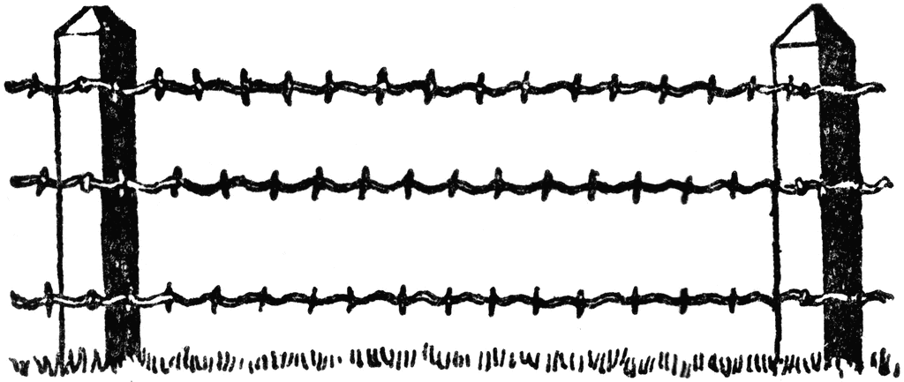

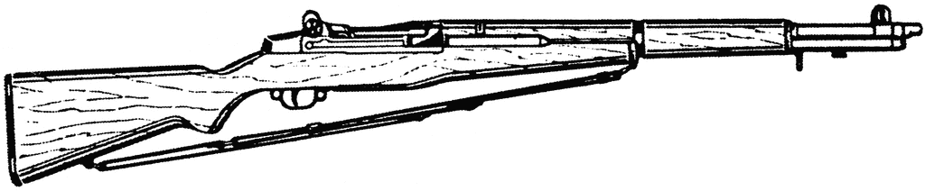
Lily Castillo

Name

Movement Murder Mystery

Each person in your group needs to pick one of the roles listed below. If you only have four people in your group no one should pick the police man. Once roles are assigned, open your envelope and find the slips with your character’s name on them. Each slip also has a number. Find who has number one and read that one first. Then whoever has number two should read the next one and so on. In each of the statements the character makes, there are clues to who committed the murder. Keep notes in the open area below so you can remember the clues and make a guess who committed the crime. You are free to question each member of the group After you make your guess, answer the questions at the bottom. The answers are in the statements.

Murder on the Immigration Express
Characters:

1. Police/Immigration Officer- Knows the basic of the murder of Lily Castillo.
2. Jose Pena- Man responsible for helping the Castillo’s sneak into the US.
3. Jorge Castillo- Husband of Lily, the murdered person. They were sneaking into the US from Mexico.
4. Maria Rodriguez- Sister of Lily. She was picking up the Castillo’s at the border.
5. Carlos Perez- Co-worker of Jorge Castillo. He was also sneaking into the US.

Notes___________________________________________________________________________________________________________________________________________________________________________________________________________________________________________________________________________________________________________________________________________________________________________________________________________________________________________________________________________________________________________________________________________________________________________________________________________________________________________________________________________________________________________________________________________

Who do you think committed the murder and why? ________________________________________________________________________________________________________________________________________________________________

Use your clues to answer these questions below:
1. What is immigration?

2. What kind of jobs do immigrants work?

3. List 3 pull factors that can cause this type of migration.
1.
2.
3.

4. List 3 push factors that can cause people to want to move somewhere else.
1.
2.
3.

5. What are some other examples of migrant workers)?

6. Would you consider this type of migration internal, interregional, international or forced? Why?

7. How is this Murder Mystery an example of Chain Migration?

8. What is happening to the Net Migration of both the US and Mexico in this story?

9. Which character in the story is engaged in circular migration?

Murder on the Immigration Express

There has been a murder committed. Lily Castillo is dead. Lily and her husband, Jorge, live in Nuevo Leon, Mexico. For the past several years, they have been working, and saving, to earn enough money to cross the border into the United States. Together they have saved about $5,000. Jose Pena is a man of questionable character. He has spent time in prison and now makes a living smuggling people in and out of the United States. The Castillo’s are paying Mr. Pena $3,000 to take them into the US, help them get jobs, and provide them with fake documents so they can get a bank account. The Castillo’s kept their plan very secret. The only one that really knew was Carlos Perez, a co-worker of Jorge. Jorge and Carlos use to be friends but they got into a fight one night at a card game. Now, Carlos was blackmailing the Castillo’s to pay his way over into the US. If they did not pay, he would tell the police in Mexico about their plans and they would be arrested.

Here is some additional information about your characters:

1. Police/Immigration Officer: Knows key clues about how the crime was committed. The police officer is an immigration officer who patrols the border looking for people trying to cross into the US. They were only a few hundred yards away when they heard the gun shots. They were on the scene very quickly.
2. Jose Pena: Man responsible for sneaking families over the Mexican border into the US. After being released from prison for armed robbery, Mr. Pena found smuggling people into the US was far more profitable. He is known to hang out with other thieves, gangsters, and drug dealers.
3. Jorge Castillo: Husband of Lily Castillo. Was trying to cross the border when Lily was killed. Jorge has worked in a market for many years. He and his wife have no kids and have dreams of joining her family in Texas. They have worked for several years to save enough money to get their life started in the US, but they are going to do it as illegal immigrants.
4. Maria Rodriguez: Sister of Lily Castillo. She lives in the US and was waiting to pick up the Castillo’s. Maria has lived in the US for almost ten years. She married a US citizen and is now a US citizen herself. She has been trying to get her sister to join her for some time in their home state of Texas. At the time of the murder, she was just a few hundred feet away in her car. She was at the arranged meeting point to meet her sister and her husband.
5. Carlos Perez: Co-worker of Jorge Castillo. He was also crossing the border. Carlos and Jorge were friends until they got in a fight during a card game. Carlos was so angry at Jorge that he blackmailed him for the money to also cross the border into the US.

Directions:
Find your individual card labeled #1 and read it aloud. Make sure everyone can hear it. Repeat this process with cards 2-10. Take notes to keep the information straight and solve the crime. Each member in the group can come to a different solution.

#1 Police/Immigration Officer: Here are the facts of the case. Last night at 3:30 AM, Lily Castillo was shot dead only a few feet away from crossing illegally into the United States. She was shot with what appears to be a rifle and died instantly. Several more shots were fired but because I was patrolling the area I was able to get there quickly. I could see through the border fence and could see a gunshot flash in the distance. It is obvious that the person who shot Mrs. Castillo was not in the party trying to cross the border. Maria Rodriguez was also in a similar position as me, what does she have to say?

#2 Maria Rodriguez: I saw the same thing the officer did. I did not know the exact location they would cross the Rio Grande River and under the border fence but I had a good idea. I heard four shots over about a ten second span. It was right about then the immigration officer showed up with their lights on. I just talked to Lily yesterday. She told me how scared she was because Jose Pena and Carlos Perez are not good people. She was scared they might try to rob her and her husband of the other $2,000 they had. I am so sad my sister is dead!

#3 Jose Pena: There is no doubt I have stolen things before. In fact, what I do now to make a living is not exactly legal, but I did not know about the Castillo’s having $2,000 with them. Besides $2,000 is not that much. I made $3,000 bringing them to the US and I will make $3,000 more this weekend with another family. There are 7 million illegal immigrants in the US from Mexico. Do the math; I am making plenty of money.

#4 Carlos Perez: Yes, you make plenty of money, but once a criminal always a criminal. I know you knew about the Castillo’s having $2,000. Before you left you asked me what we were going to do for money once we got to the US. I told you about them having $2,000. Now that I think about it, right after I told you about the $2,000, you went somewhere to make a phone call. Officer, what you do not know is that Jorge Castillo was planning on taking the money he and his wife had saved and splitting once they got out of Mexico. He was going to leave her with nothing!

#5 Jorge Castillo: That is just not true! Besides Carlos is the biggest criminal here anyway! He is blackmailing me for money and I believe that he wanted the other $2,000. Carlos use to be my friend, but ever since we got in that fight, he has been trying to damage my reputation. I do not think it was a coincidence that when the bullets began flying, Carlos was nowhere around. Carlos has lots of friends; he probably had one hide out and jump us. As far as me leaving my wife, that was not going to happen. We had some relationship problems a while ago but everything has been great. We were looking forward to starting a new life and having kids soon.

#6 Police Officer: We have a few more facts from the case. We ran a check on the best friends of Jose Pena. All of his best known criminal friends are accounted for. We check the cell phone records of Carlos Perez and we have found some phone calls to an unknown number. At the scene of the crime, we found the spot where the shooter was located when they fired. We have found the weapon and it was purchased in the US. Whoever it was, they escaped on foot because we did not find any tire tracks. We know they wore a men’s size 9 boot, because they left the boots they were wearing at the scene. We do not know what direction they ran. There is a chance they floated down the Rio Grande to escape. Maria, why were you running around the scene when I arrived?

#7 Maria Rodriguez: When I heard the shots I went into a panic. I was driving up and down the road slowly since I did not know the exact place they were going to cross. When I heard the shots I jumped out of the car and ran to see what was going on. I then realized that I was running where bullets were being fired! I thought that was dumb so I turned around and ran away. I was very confused. I want to know where everyone was at when the shots were fired. Whoever knew about the ambush would have distanced themselves away from the gun fire.

#8 Carlos Perez: I was standing closest to where the bullets came from. If it was not for a little luck I would have been the one who got shot. All four of us has just crossed the Rio Grande and were making our way to the fence. As we were walking I felt a rock in my boot and stopped to get it out. Not more than three seconds later shots rang out. As for those unknown phone calls, I will tell you who I called. I have a cousin who works at a beef slaughter house in El Paso. Like most immigrants he had found me a manual labor job. I did not need the $2,000 because he had things all arranged for me. Besides, I wear a size 10.5 shoe and my cousin wears a size 11.

#9 Jose Pena: When the shots rang out I was standing next to the fence. I was prying open the fence for us to crawl through. Maria keeps saying that she did not know where we were going to be when we made our way into the US, and that is not true. I gave Jorge specific directions on where we would be. I have traveled this route many times and I always tell people meet at the “Gas Station 10 Miles” sign. It does not get easier than that. The police officer has already said none of my criminal friends were in the area and I wear a size 11.5 shoe. Why did Jorge yell out, “No, not Lily!” when she was shot?

#10 Jorge Castillo: I was standing next to Lily when she was shot. We were standing right behind Jose, waiting for him to get the gate open. When Lily was shot I went right to her because I wanted to try to keep her alive. I already had out my knife so I cut off a piece of my shirt to wrap it over the wound but it was too late. I do not recall what I yelled out. I was upset because my wife had just been shot. I think it is obvious that one of these two criminals killed Lily. Jose probably met someone on one of his many trips to the United States. Or maybe it was Carlos’s cousin. They wanted the money my wife and I had saved. Officer, which one are you going to arrest?

**********************Solution******************************************
Police Officer: I am going to arrest all four of you. Jose Pena, I am going to arrest you for helping people sneak into the US illegally. Carlos Perez, I am going to arrest you for blackmailing Jorge Castillo and making him pay your way to the US. Blackmail is a federal offense. Maria Rodriguez and Jorge Castillo, I am arresting you for the murder of Lily Castillo and the attempted murder of Jose Pena and Carlos Perez. When you look at where everyone was when the shot was fired, Maria was the only one not accounted for. It was Maria’s job to kill Carlos. Carlos was lucky the rock was in his shoe otherwise he would be dead (His bending over is what allowed the bullet to hit Lily). Jorge was just getting ready to kill Jose with his knife, who was holding the fence back, when Lily was shot. That is why he had his knife handy to cut a bandage for her wound. It appears they were planning on taking back the $3,000 they paid Jose for getting them across the border.

Answer Key

1. What is immigration? Movement from another country into yours

2. What kind of jobs do immigrants work? Manual Labor

3. List 3 pull factors that can cause this type of migration.
1. Economic, Social, Religious, etc…
2.
3.

4. List 3 push factors that can cause people to want to move somewhere else.
1. Economic, Social, Religious, etc…
2.
3.

5. What are some other examples of migrant workers (might have to google this one)?
UAE Workers, Hispanics to Canada, Pakistan to India, Syrians to Turkey, etc…

6. Would you consider this type of migration internal, interregional, international or forced? Why?
International, it is from one country to another

7. How is this Murder Mystery an example of Chain Migration?
The Castillo’s were joining family in the US

8. What is happening to the Net Migration of both the US and Mexico in this story?
Net migration of the US is going up/ Mexico net migration is going down

9. Which character in the story is engaged in circular migration? Jose Pena

