Why was Apartheid Introduced?
Sample Sourcework Exercise in the style of IB Paper 1

Source A: A cartoon by David Low, 1948
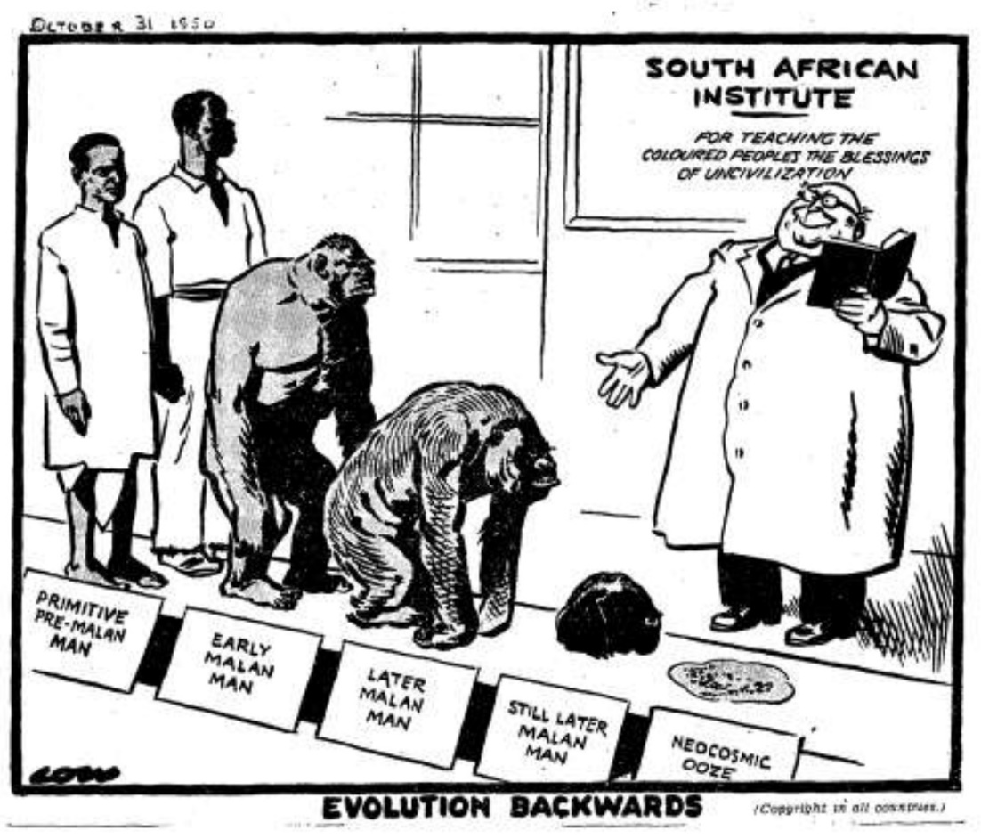

Source B
South Africa has a complex problem. Stated briefly it is: The contact of the White race with the Black has resulted in the emergence of a set of conflicting living conditions and outlooks on life which seriously hamper South Africa’s progress to nationhood. The White race, possessing superior military strength and at present having superior organising skill has arrogated to itself the ownership of the land and invested itself with authority and the right to regard South Africa as a White man’s country. This has meant that the African, who owned the land before the advent of the Whites, has been deprived of all security which may guarantee him an independent pursuit of destiny or ensure his leading a free and unhampered life. South Africa’s two million Whites are highly organised and are bound together by firm ties. The advantages on the side of the Whites enable two million White men to control and dominate with ease eight million Africans and to own 87 per cent of the land while the Africans scrape a meagre existence on the remaining 13 per cent. The White man means to hold to these gains at all costs and to consolidate his position, has segregated the African in the State, the Church, in Industry, Commerce etc., in all these relegating him to an inferior position where, it is believed, the African will never menace White domination.
ANC Youth Manifesto, 1944

Source C
The choice between us is one of two divergent courses: either that of integration, which would in the long run amount to national suicide on the part of the Whites; or that of apartheid, which professes to preserve the identity and safeguard the future of every race, with complete scope for everyone to develop within its own sphere while maintaining its distinctive national character, in such a way that there will be no encroachment on the rights of others, and without a sense of being frustrated by the existence and development of others…it is the primary task and calling of the State to seek the welfare of South Africa, and to promote the happiness and well-being of its citizens, non-White as well as White…such a task can best be accomplished by preserving and safeguarding the White race.
National Party Election Speech, 1948

Source D
The immediate causes of the turn to apartheid can be traced to the events of the Second World War. Between 1940 and 1946 South Africa underwent a huge economic and social transformation as a result of the country’s participation in the Second World War. Factories expanded to fill the wartime need for many goods, including military supplies, drawing workers into the cities from all over the country…both Africans and whites moved to the urban centres and, for the first time, began to outnumber whites there. The massive influx of Africans created serious problems because of the myriad restrictions limiting African entry and residence in the cities. Africans were legally prohibited from entering cities without proper documentation and could only live in specially designated townships, or locations, controlled by the local municipality. Since the strict enforcement of these laws during the war would have seriously impeded the war effort, the government relaxed most restrictions for the duration of the war. The result was the growth of the urban African population under trying conditions, with little accommodation or services provided. Africans were forced to find shelter anywhere and ‘squatter’ camps – a collection of impromptu shacks without sanitation or running water – emerged around the major industrial centres. One of the largest, near Johannesburg in Orlando with more than 20,000 residents, eventually became the basis for the township of Soweto. Whilst the government and the local authorities were unwilling to recognize that African workers were becoming part of the permanent urban population, Africans themselves took matters into their own hands and created their own urban communities.
The Rise and Fall of Apartheid (2004) by Nancy Clark and William Worger

Questions
1. a) According to Source B, why was there a race problem in South Africa? [3 marks]
1. b) What message is conveyed by Source A? [2 marks]
2. With reference to its origin, purpose and content, analyze the value and limitations of Source C for a historian studying the reasons why the National Party favoured a policy of apartheid. [4 marks]
3. Compare and contrast what Sources B and D reveal about the causes for the introduction of apartheid. [6 marks]
4. Using the sources and your own knowledge, evaluate the reasons why the National Party won the 1948 election in South Africa. [9 marks]

