4.6 The roles of foreign aid and multilateral development assistance
Foreign Aid

- In today’s lesson we will be looking at:-

- What is meant by Foreign Aid.
- The different forms of Foreign Aid
- The effectiveness of Foreign Aid

  - What is Foreign Aid ?

________________________________________________________________________________________________________________________________________

  - Why do you think that MEDCs might give foreign aid to LEDCs?

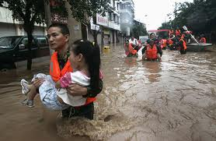

- _________________________
- _________________________
- _________________________
- _________________________
- _________________________
- _________________________

  - Define the terms that appear in the table below.

O.D.A.

N.G.O.

  - Complete the flow chart below to explain the difference between O.D.A. and aid from N.G.O.s

Official Aid | Foreign Aid | Bilateral
MEDC government to international aid agency to LEDC. | Unofficial Aid | e.g. Oxfam, Save the Children, Red Cross
NGOs | MEDC to LEDC | Multilateral

  - Aid might come in the form of ‘humanitarian aid’. Of what three components does this consist?

- ___________________________
- ___________________________
- ___________________________

  - Foreign aid is also given to achieve more long-term objectives such as ‘economic development’. What is the difference between a grant and a concessional long-term loan?

Grant - ________________________________________________________________________________________________________________________________________

Concessional Long-term loan -
________________________________________________________________________________________________________________________________________

  - What development projects might be support and funded by project aid?
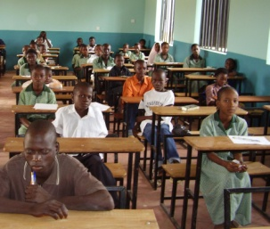
________________________________________________________________________________________________________

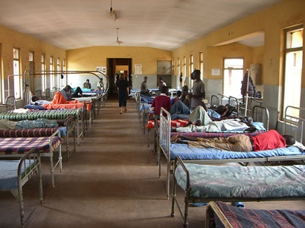
______________________________________________________________________________________________

  - Explain the role of NGO in the aid donation process.

Scale - ______________________________________________________________
Objectives ___________________________________________________________

9. The following terms are also frequently used and you need to understand their precise meaning.

- Soft Loans
- Tied Aid

Money is lent on favourable terms i.e. at interest rates lower than market rates and/or with longer amortisation periods

A type of bilateral aid granted in the form of a reciprocal agreement.

10. How do the donor country and the recipient benefit from ‘tied aid’?
____________________________________________________________________________________________________________________________________________________________________________________________________________
  - Why do you think that MEDCs might provide foreign aid to LEDCs?
- __________________________________________________________________________________________________________________________________________________________________________________________________________________________________________________________________________________________________________________________________________________________________________
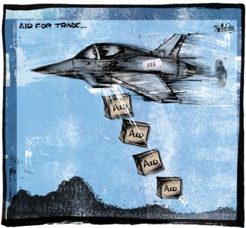

______________________________________________________________________________________________________________________________________________________

Official Development Assistance – Zambia Case-Study
- Zambia receives a considerable amount of official development assistance from a wide variety of donor nations and aid agencies.

- The chart below indicates the proportion of the nation’s GDP accounted for by ODA.
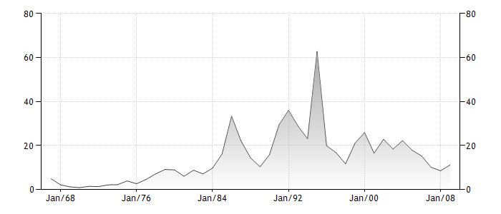
- The chart on the next page illustrates the amount of ODA received by Zambia in US Dollars.

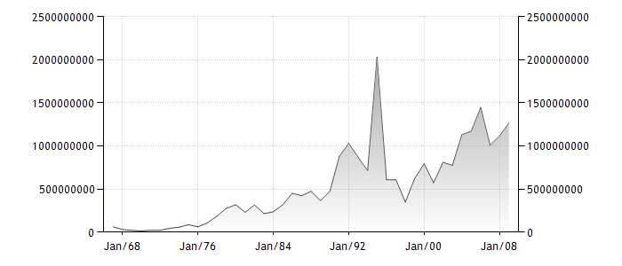
- Why do you think that Zambia might have received a sharp increase in ODA in 1995?

___________________________________________________________________________________________________________________________________________________________________________________________________

  - Follow the link below and summarise the nations from which Zambia receives much of its O.D.A.

http://www.tradingeconomics.com/zambia/net-official-development-assistance-received-us-dollar-wb-data.html

_______________________________________________________________________________________________________________________________________________________________________________________________________________________________________________________________________________________________________________________________________________________________________________________

  - The effectiveness of foreign aid is the subject of considerable debate and controversy. There is a significant body of research that suggests that there is no correlation between the amount of aid received by an LEDC and its G.D.P. growth.

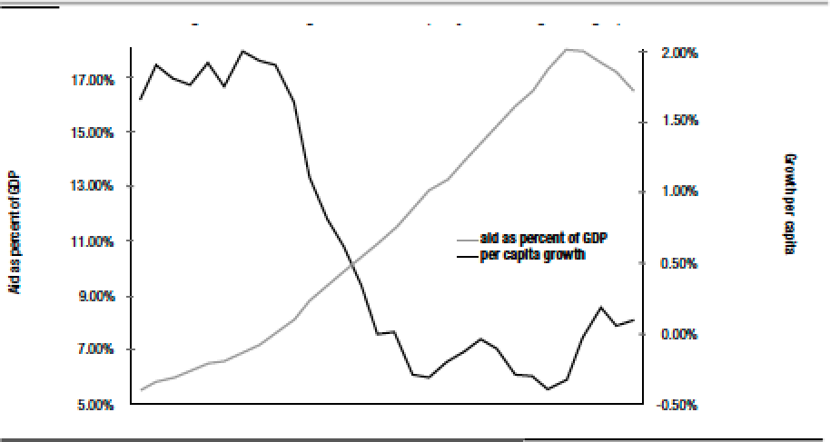
- Who often receives foreign aid in LEDCs?

_________________________________________________________________________________________________________________________________________________________________________________________________________________________________
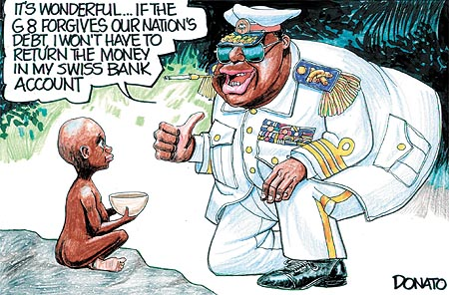
  - Will foreign aid money necessarily stay in the country?

____________________________________________________________________________________________________________________________________________________

  - Why might a nation give aid for political reasons?
_________________________________________________________________________________________________________________________________________________________________________________________________________________________________

  - In the table below, explain the other issues that are linked to the provision of aid.

Tied Aid |  | Long-term provision of large quantities of food may force down domestic prices.
Aid dependency |  | Aid is focused at the modern sector (industrialization) leading to income inequality between modern and traditional sector workers.
Aid and economic policies |  | Not as effective as untied aid. The LEDC is obliged to buy goods and services that may be over-priced.
Food aid |  | MEDCs start to think that problems in their own country are more important than those overseas.
Focus of aid |  | There is little incentive to be innovative and people develop a welfare mentality.
Aid weariness |  | Leads to massive problems of indebtedness for developing countries.
Repaying financial aid |  | Aid is only available if the country agrees to adopt free market policies of liberalization, deregulation and privatization
  - A popular part d) question on the data response paper takes the following format.

‘To what extent is trade more effective then aid at promotion economic development?’

- Use the writing frame below to respond to this question.

Trade is more effective than aid because. | Diagrams
However, aid has a role to play in economic development because……….. | Diagrams
Conclusion

  - In the table below outline the role of the International Monetary Fund.

IMF

  - What exactly does it mean when a country has a ‘balance of payments problem’?

____________________________________________________________________________________________________________________________________________________________
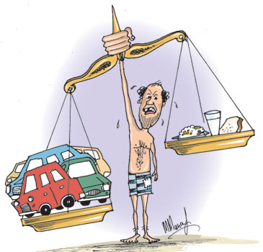
  - Why might a country require a loan from the IMF?

________________________________________________________________________________________________________________________________________________________________________________________________________________________________________

  - Complete the diagram below.

  - Why might an IMF loan be advantageous to a developing nation and help them to progress?

________________________________________________________________________________________________________________________________________________________________________________________________________________________

  - The IMF have been criticized in the past for the measures that they have insisted that countries take if they are to receive IMF assistance.

- What is often the cause of excessive current account deficits?

____________________________________________________________________________________________________________________________________________________________________________________________________________________________________

- What measures do the IMF insist upon?

Government Spending
Exchange rate
Trade
Price controls/Subsidies
Privatisation
Liberalisation

  - On the diagram below illustrate the impact that this would have upon the economy of a developing nation.
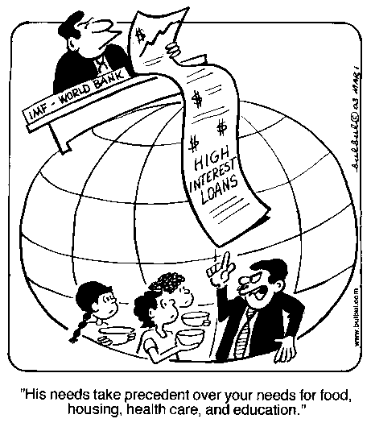
Price
Level

Real GDP

  - Use the text on the next page to answer the following questions about the World Bank.

- – What are the two main institutions that comprise the World Bank?
- - What is the aim of the IBRD?
- – What is the focus of the IRA?
- - When was the World Bank founded?
- - What strategic themes drive the bank’s work?
- – What do the World Bank provide?
- – What do the above support?
- – What do the World Bank offer in addition to finance?

We are not a bank in the ordinary sense but a unique partnership to reduce poverty and support development. We comprise two institutions managed by 188 member countries: the International Bank for Reconstruction and Development (IBRD) and the International Development Association (IDA). The IBRD aims to reduce poverty in middle-income and creditworthy poorer countries, while IDA focuses exclusively on the world’s poorest countries. These institutions are part of a larger body known as theWorld Bank Group. Established in 1944, the World Bank is headquartered in Washington, D.C. We have more than 9,000 employees in more than 100 offices worldwide.
Six strategic themes drive the Bank’s work, focusing on the poorest countries, fragile and conflict-affected states, the Arab world, middle-income countries, global public goods issues, and delivery of knowledge and learning services.
We provide low-interest loans, interest-free credits, and grants to developing countries. These support a wide array of investments in such areas as education, health, public administration, infrastructure, financial and private sector development, agriculture, and environmental and natural resource management. Some of our projects are cofinanced with governments, other multilateral institutions, commercial banks, export credit agencies, and private sector investors.
We also provide or facilitate financing through trust fund partnerships with bilateral and multilateral donors. Many partners have asked the Bank to help manage initiatives that address needs across a wide range of sectors and developing regions.
Innovative Knowledge Sharing
We offer support to developing countries through policy advice, research and analysis, and technical assistance. Our analytical work often underpins World Bank financing and helps inform developing countries’ own investments. In addition, we support capacity development in the countries we serve. We also sponsor, host, or participate in many conferences and forums on issues of development, often in collaboration with partners.

