Terms of Trade

- The difference between the terms of trade and the balance of trade.
- Calculation of the terms of trade.
- Causes of changes in a country’s terms of trade in the short-run and long-run.
In 1960, developing nation A had to sell 50 tonnes of grain to buy an imported tractor. In 2000 the same developing nation had to sell 200 tonnes of grain to buy the same tractor. The nation is said to have experienced a deterioration in its terms of trade.

- What is the difference between the balance of trade and a nation’s terms of trade?

_____________________________________________________________________________________________________________________________________________________________________________________________

- Terms of Trade is officially defined as the following :-

Index of terms of trade = Weighted Index of average export prices x 100

Weighted Index of average import prices

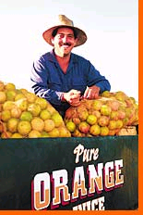
- If import prices rise and export prices fall then we say there has been a worsening of the terms of trade. Why is this the case?

___________________________________________________________________________________________________________________________________________________________________________

- If import prices fall and export prices rise we say there has been an improvement in the terms of trade. Why is this case?

_______________________________________________________________________________________________________________________

5. Look at the export/import price statistics below

Year | Index of average export prices | Index of average import prices | Calculation | Terms of Trade
1 | 100 | 100
2 | 104 | 101
3 | 105 | 107
4 | 111 | 111
5 | 107 | 109
6 | 105 | 109

- Describe what is happening to the terms of trade of the nation between year 1 and year 6.

_____________________________________________________________________________________________________________________________________________________________________________________________________________________________________________________________________________________________________________________________________

If the terms of trade improve, a given quantity of exports will buy more imports. Conversely, if the price of a basket of exports falls, then a country will need to sell more exports in order to keep imports at the same level.

Causes of Changes in a country’s terms of trade

The causes of a change in a country’s terms of trade can be divided into short and long term.

Short term

1. Illustrate and explain how demand and supply conditions for exports may lead to a change in a nation’s terms of trade.
Price
Qty demanded/supplied
Price
Qty demanded/supplied

____________________________________________________________________________________________________________________________________________________________________________________________________________________________________________________________________

- What will happen to the terms of trade of Nation A if its domestic rate of inflation exceeds that of its trading partners?

____________________________________________________________________________________________________________________________________________________________________________________________________________________________________________________________________

3. Illustrate and explain how a change in the exchange rate of Nation A can lead to a deterioration of its terms of trade.

____________________________________________________________________________________________________________________________________________________________________________________________________________________________________________________________________

$ price of Pesos
Qty of Pesos traded

Long term

5. What impact will rising incomes in the developed world have on the prices of some of the manufactured products and services that are mainly produced in the richer nations (MEDCs)?

___________________________________________________________________________________________________________________________________________________________________________________________________
Price
level
Real GDP

6. What impact will this have on the terms of trade of developing nations who produce a greater proportion of primary sector goods (LEDCs)?

___________________________________________________________________________________________________________________________________________________________________________________________________

7. What will happen to the price of a nation’s exports if there are long-run improvements in productivity/technological developments within the country and thus the terms of trade?

___________________________________________________________________________________________________________________________________________________________________________________________________

Consequences of Changes in a country’s terms of trade

An improvement or deterioration in a nation’s terms of trade can have positive or negative consequences.

Complete the table below to summarise this.

Change in a nations terms of trade | Cause | Positive/Negative
Deterioration | 1 - Depreciation/Deval. | Positive – PEDx + PEDm > 1
 | 2 – Productivity increase | Depends
 | 3 – Lower inflation than.. | Depends
 | 4 – Falling incomes | Negative
Improvement | 1 – Appreciation | Depends
 | 2 – Fall in supply | Depends
 | 3 – Higher inflation than.. | Depends
 | 4 – Rising incomes | Positive
- Write down the formula for the price elasticity of demand for exports below.

% change in qty demanded of exports x 100
% change in average price of exports

- In order for a fall in the average price of exports (assuming a constant exchange rate) to lead to an increase in export revenue, then price elasticity of demand for exports would have to exceed ______________.

However, if the LEDC is receiving payment for its exports in the foreign currency (e.g. the dollar), then demand for exports will have to be price elastic in order for revenue to increase following a devaluation.

9. Would you say that demand for the exports of developing nations such as copper, coffee and cotton is price elastic or inelastic?

___________________________________________________________________________________________________________________________________________________________________________________________________

10. Write the formula for the price elasticity of demand for imports.

% change in qty demanded of imports x 100
% change in average price of imports

- If import prices are rising (assuming a constant exchange rate), what would be the impact of a less than proportionate fall in their demand?

__________________________________________________________________________________________________________________________________

Improvement in the Terms of Trade (beneficial?)

The impact of an improvement in the terms of trade depends upon the reason for the improvement.

12. There is an increase in demand for the exports of Nation A due to:-

13. Illustrate this on the diagram below:-

Average Export Price

Quantity of Exports

14. An improvement in the terms of trade that is caused by an increase in demand for exports leads to:-

_________________________________________________________________

15. Why might there be an improvement in the terms of trade if nation A is experiencing higher inflation than the countries with which it trades?

__________________________________________________________________________________________________________________________________

16. Will this improvement in the terms of trade lead to an improvement in the current account position of nation A?

- Look at the diagram below.

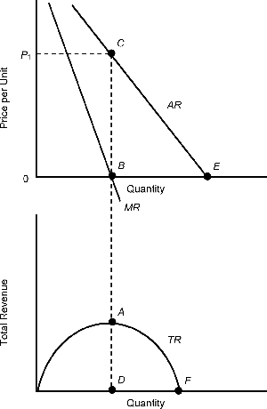

17. What happens to the price elasticity of demand as the price falls?

__________________________________________________________________________________________________________________________________

18. Using the diagram above explain under what circumstances will an improvement in the terms of trade (caused by inflation) lead to an improvement in the current account of the balance of payments?

____________________________________________________________________________________________________________________________________________________________________________________________________________________________________________________________________

19. When will an improvement in the terms of trade of a nation caused by a left shift in the supply of exports lead to an improvement in the current account?

__________________________________________________________________________________________________________________________________

20. When will an improvement in the terms of trade, caused by a currency appreciation, lead to an improvement in the current account position of a nation?

___________________________________________________________________________________________________________________________________________________________________________________________________

Deteriorating terms of trade and LEDCs

21. In this section we will be focusing on the impact of a deterioration in the terms of trade for developing nations that rely on non-oil exports (commodities).

- In the table below, summarize the reasons why there has been a fall in the prices of commodities.

Reason | Explanation
Global Supply

Synthetic substitutes

Income elasticity of demand

Agricultural Policies

Technology

21. Take two of the above reasons and use a demand and supply diagram to illustrate the impact on the market price of the commodity.
Price
Qty demanded/supplied
Price
Qty demanded/supplied

22. What is the impact on the current account of commodity dependent LEDCs when their terms of trade deteriorate?

____________________________________________________________________________________________________________________________

23. Explain why this is the case in terms of price elasticity of demand.

________________________________________________________________________________________________________________________________________________________________________________________________________________________________________________________

24. Is demand for imports in developing nations likely to be price elastic or inelastic and why?

__________________________________________________________________________________________________________________________________________________________________________________________

25. As the price of imports rises relative to the price of exports, what is likely to happen to import expenditure?

__________________________________________________________________________________________________________________________________________________________________________________________

26. What are the consequences of a deteriorating terms of trade for developing nations that depend upon commodities?

________________________________________________________________________________________________________________________________________________27. _________________________________________________________________________________________________________________________________________________________________________________
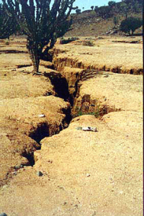
28. _____________________________________________________________________________________________________________________________________________________________________
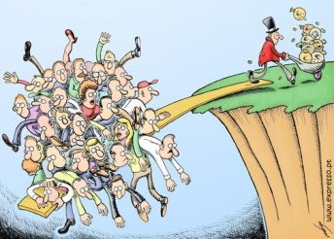
29. _______________________________________________________________________________________________________________________________________________________________________________________
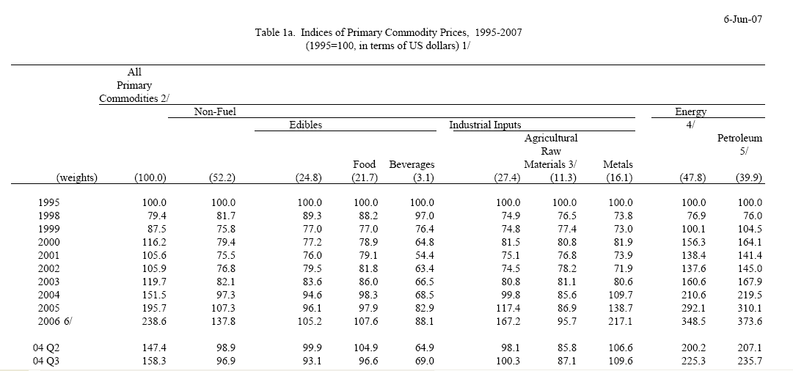
29. What do you notice about the prices of primary commodities in general?

1995-2001

_________________________________________________________________

2001-2006

_________________________________________________________________

30. Can you explain this movement?

____________________________________________________________________________________________________________________________________________________________________________________________________________
Price
level
Real GDP

24. What does the data indicate about the nature of commodity prices?

____________________________________________________________________________________________________________________________________________________________________________________________________________

