3.3 Resource stewardship and the SDGs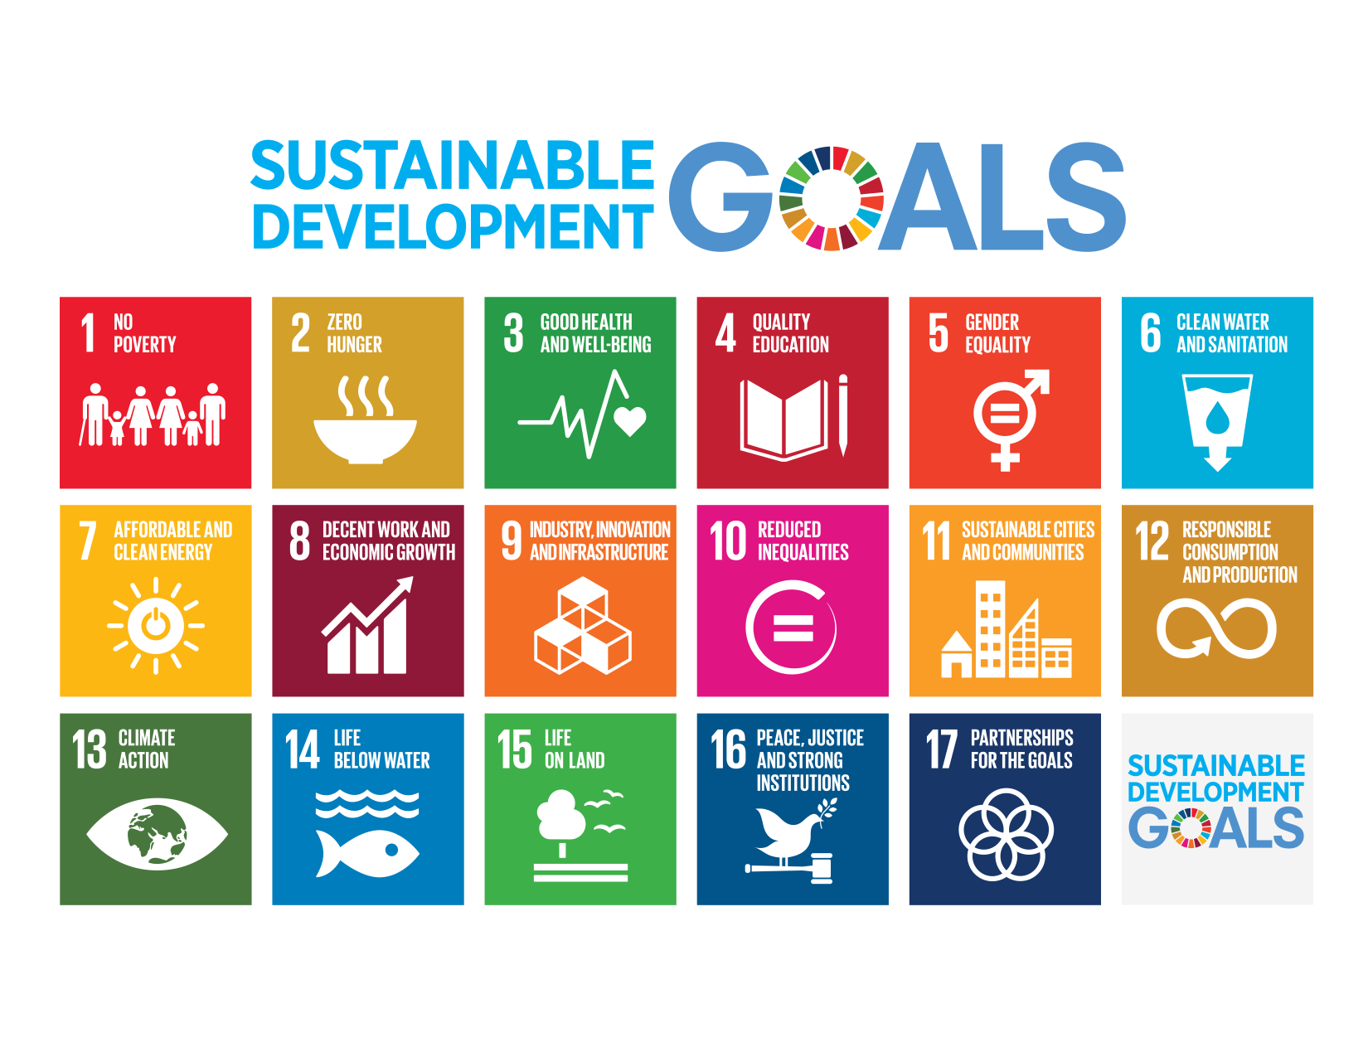
The aim of this task is:
- To be able to discuss the role of the UN Sustainable Development Goals as resource stewardship strategies and progress made toward meeting them

You will focus on SDGs linked to food, energy and water.

Resource stewardship is the responsible planning and management of resources

Worked example - although you will need to complete the final paragraph >

Sustainable Development Goal - number and title

Goal 2: End hunger, achieve food security and improved nutrition and promote sustainable agriculture
1 sentence from the introduction to the goal linked to resource stewardship
- If done right, agriculture, forestry and fisheries can provide nutritious food for all and generate decent incomes, while supporting people-centred rural development and protecting the environment.
2 facts and figures linked to resource stewardship
- 500 million small farms worldwide, most still rainfed, provide up to 80 per cent of food consumed in a large part of the developing world.
- Since the 1900s, some 75 per cent of crop diversity has been lost from farmers’ fields.
3 goal targets linked to resource stewardship
- By 2030, double the agricultural productivity and incomes of small-scale food producers, in particular women, indigenous peoples, family farmers, pastoralists and fishers, including through secure and equal access to land, other productive resources and inputs, knowledge, financial services, markets and opportunities for value addition and non-farm employment
- By 2030, ensure sustainable food production systems and implement resilient agricultural practices that increase productivity and production, that help maintain ecosystems, that strengthen capacity for adaptation to climate change, extreme weather, drought, flooding and other disasters and that progressively improve land and soil quality
- By 2020, maintain the genetic diversity of seeds, cultivated plants and farmed and domesticated animals and their related wild species, including through soundly managed and diversified seed and plant banks at the national, regional and international levels, and promote access to and fair and equitable sharing of benefits arising from the utilization of genetic resources and associated traditional knowledge, as internationally agreed
2 visualizations from either the SDG Atlas online or interactive SDG Dashboard

Try and link your visualizations with a hyperlink to the online visualization.
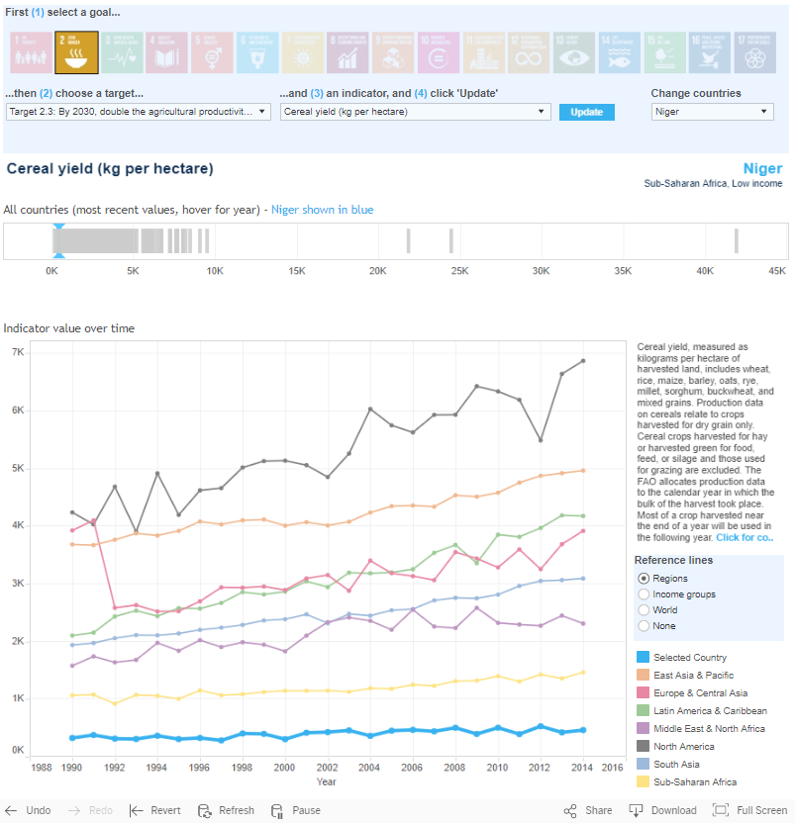

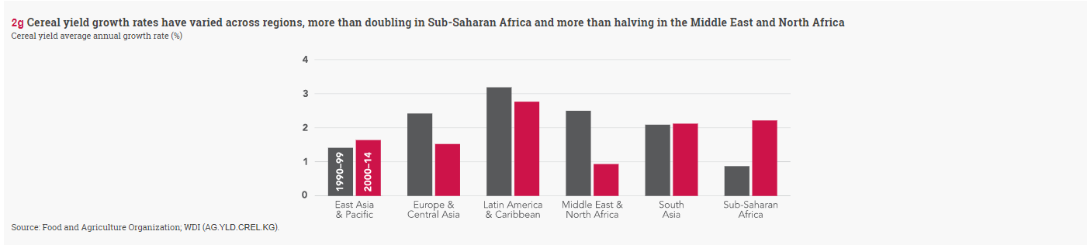
1 paragraph of describing and explaining progress made towards meeting the SDG
?????

Sustainable Development Goal - number and title

?????
1 sentence from the introduction to the goal linked to resource stewardship
- ?????
2 facts and figures linked to resource stewardship
- ?????
- ?????
3 goal targets linked to resource stewardship
- ?????
- ?????
- ?????
2 visualizations from either the SDG Atlas online or interactive SDG Dashboard

Try and link your visualizations with a hyperlink to the online visualization.
1 paragraph of describing and explaining progress made towards meeting the SDG
- ?????

Sustainable Development Goal - number and title

?????
1 sentence from the introduction to the goal linked to resource stewardship
- ?????
2 facts and figures linked to resource stewardship
- ?????
- ?????
3 goal targets linked to resource stewardship
- ?????
- ?????
- ?????
2 visualizations from either the SDG Atlas online or interactive SDG Dashboard

Try and link your visualizations with a hyperlink to the online visualization.
1 paragraph of describing and explaining progress made towards meeting the SDG
- ?????

Sustainable Development Goal - number and title

?????
1 sentence from the introduction to the goal linked to resource stewardship
- ?????
2 facts and figures linked to resource stewardship
- ?????
- ?????
3 goal targets linked to resource stewardship
- ?????
- ?????
- ?????
2 visualizations from either the SDG Atlas online or interactive SDG Dashboard

Try and link your visualizations with a hyperlink to the online visualization.
1 paragraph of describing and explaining progress made towards meeting the SDG
- ?????

Sustainable Development Goal - number and title

?????
1 sentence from the introduction to the goal linked to resource stewardship
- ?????
2 facts and figures linked to resource stewardship
- ?????
- ?????
3 goal targets linked to resource stewardship
- ?????
- ?????
- ?????
2 visualizations from either the SDG Atlas online or interactive SDG Dashboard

Try and link your visualizations with a hyperlink to the online visualization.
1 paragraph of describing and explaining progress made towards meeting the SDG
- ?????

