The Historical Investigation

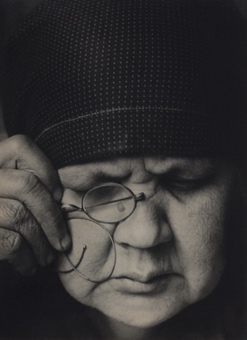

Alexander Rodchenko: Portrait of Mother.

What will you investigate in close detail?

Materials taken from the IBDP History Guide (IBO), Teacher Support Material (IBO) and Training materials provided by Ed Bond (IBDP History category 2 training, Brussels 2015)
Table of Contents

Purpose of internal assessment 3
Time allocation 3
Guidance and Responsibilities 4
Academic honesty and authenticity 5
Internal assessment details—SL and HL 5
Preparation and Planning: Topics and Research Questions 6
Section 1: Identification and evaluation of sources 9
Section 2: Investigation 9
Section 3: Reflection 10
Using assessment criteria for internal assessment 12
Internal assessment criteria—SL and HL 14
Key stages in helping students to prepare for the internal assessment task 17
Works Cited 18

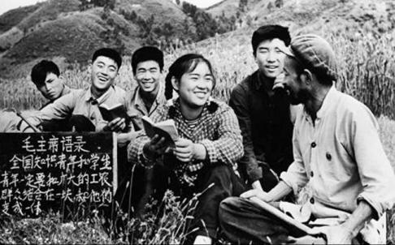

Chang, Minnie. The zhiqing (educated youth) who were sent down to do farm work with local peasants study Chairman Mao's red book with a local farmer in the field. What do you want other people to know about?

Purpose of internal assessment
Internal assessment is an integral part of the course and is compulsory for both SL and HL students. It enables students to demonstrate the application of skills and knowledge, and to pursue their personal interests, without the time limitations and other constraints that are associated with written examinations.
HL Students the IA is worth 20% of the final grade
SL Students the IA is worth 25% of the final grade
The internal assessment requirements at SL and at HL for history are the same. All students complete a historical investigation into a historical topic of their choice. The internal assessment allows flexibility for students to select a topic of personal interest. The topic need not be related to the syllabus and students should be encouraged to use their own initiative when deciding on a topic. The free choice of topic means that the historical investigation provides a particularly good opportunity for students to engage with topics that are of personal interest, or topics related to their own local or national history.
The idea is to actually experience the authentic work of an historian – developing an enquiry and exploring source material.

Time allocation
Internal assessment contributes 25% to the final assessment in the SL course and 20% in the HL course. This weighting should be reflected in the time that is allocated to teaching the skills and understanding required to undertake the work, as well as the total time allocated to carry out the work.
It is recommended that a total of approximately 20 hours (SL and HL) of teaching time should be allocated to the work. This should include:
- time for the teacher to explain to students the requirements of the internal assessment
- class time for students to work on the internal assessment component and ask questions
- time for consultation between the teacher and each student individually
- time to review and monitor progress, and to check authenticity.

Guidance and Responsibilities
The historical investigation submitted for internal assessment must be the student’s own work.
Teacher Responsibility:
The teacher should play an important role during both the planning stage and the period when the student is working on the internally assessed work. Teachers are responsible for:
- sharing the requirements of the type of work to be internally assessed
- sharing the assessment criteria; students must understand that the work submitted for assessment must address these criteria effectively.
- Guide students in the selection of a topic and development of the research question, which will be approved by the teacher
- make students aware of any relevant ethical considerations when undertaking their investigation, for example, the need to show sensitivity or to respect confidentiality
- Reading and giving advice to students on one draft of the work, but should not edit the draft.
- ensuring that all students understand the basic meaning and significance of concepts that relate to academic honesty, especially authenticity and intellectual property.
- Authenticating the students’ work for academic conduct and honesty.
Student Responsibility:
- To select the topic and develop the research question
- to initiate discussions with the teacher to obtain advice and information
- Read the assessment criteria and sample essays
- Work individually to complete all the elements of the IA.
- Submitting one draft and one final version of the IA.
- Following the guidelines for academic honesty and clarifying any issues at every stage and at any time during the investigation process
- Ensuring that all planning and drafting materials are available for scrutiny in relation to any queries relating to planning and/or academic honesty
- Meet deadlines
Recommended:
- Start work early and plan a schedule
- Record sources as research progresses
- Plan the structure of the IA

Academic honesty and authenticity
Authenticity may be checked by discussion with the student on the content of the work, and scrutiny of one or more of the following.
- The student’s initial proposal
- The first draft of the written work
- The references cited
- The style of writing compared with work known to be that of the student
- The analysis of the work by a web-based plagiarism-detection service

Please note: The same piece of work cannot be submitted to meet the requirements of both the internal assessment and the extended essay. Nor should the topics be similar or rely on similar or the same source material.

Former Romanian Prime Minister Victor Ponta was ensnared in a plagiarism scandal in 2012. Picture credit: Armenpress

Internal assessment details—SL and HL

Historical investigation
Duration: 20 hours
Weighting: 25% SL, 20% HL
Students at both SL and HL are required to complete a historical investigation into a topic of their choice. The historical investigation is made of up three sections.
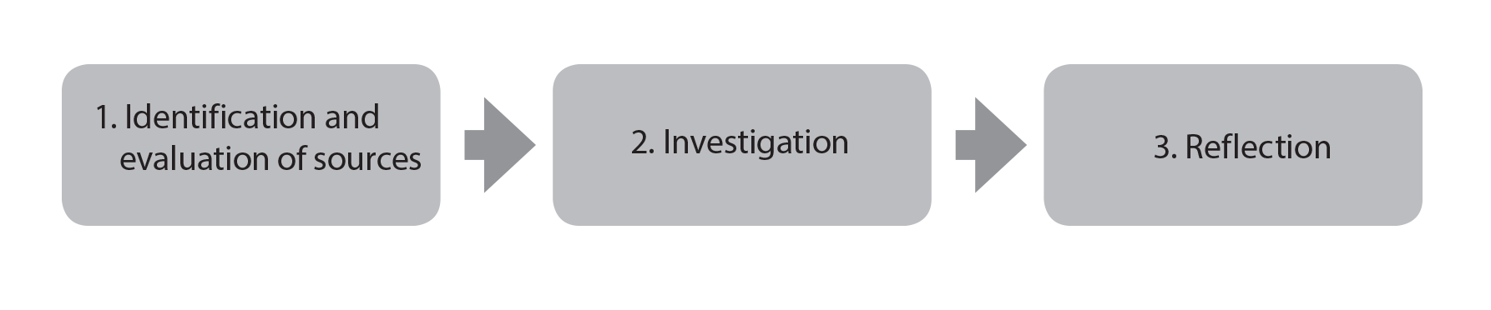

Preparation and Planning: Topics and Research Questions
Topic choice: Students have a free choice of topic for their historical investigation:
- the topic need not be related to the syllabus and students are encouraged to use their own initiative when deciding on a topic.
- the topic must be historical, and therefore cannot be on an event that has happened in the last 10 years.
- It is crucial that there are sufficient sources to support the investigation, and that the investigation can be assessed by the criteria for internal assessment.
The investigation is an opportunity for students to demonstrate the application of their skills and knowledge to a historical topic of their choice. The emphasis must be on a specific historical inquiry that enables the student to develop and apply the skills of a historian by selecting and analysing a range of source material and considering diverse perspectives.
Developing a research question: The key to a successful response is formulating an appropriate question. A sound question will have a clear command term, a narrow focus (and an appropriate time span), and will be a question rather than a statement
Suggestion #1: Use the History DP command terms
Command term | Definition
Analyse | Break down in order to bring out the essential elements or structure.
Compare | Give an account of the similarities between two (or more) items or situations, referring to both (all) of them throughout.
Compare and contrast | Give an account of similarities and differences between two (or more) items or situations, referring to both (all) of them throughout.
Contrast | Give an account of the differences between two (or more) items or situations, referring to both (all) of them throughout.
Discuss | Offer a considered and balanced review that includes a range of arguments, factors or hypotheses. Opinions or conclusions should be presented clearly and supported by appropriate evidence.
Evaluate | Make an appraisal by weighing up the strengths and limitations.
Examine | Consider an argument or concept in a way that uncovers the assumptions and interrelationships of the issue.
To what extent | Consider the merits or otherwise of an argument or concept. Opinions and conclusions should be presented clearly and supported with appropriate evidence and sound argument.

Suggestion #2
Explore topics and questions related to one (or more) of the six key concepts in history:
Causation | Consequence | Continuity | Change | Significance | Perspectives

Activity: From topic to research question
Topic Idea | Research Question | Command word/Concept
Collapse of the Egyptian Old Kingdom | To what extent was weak leadership responsible for the collapse of the Egyptian Old Kingdom in 2125 BC? | ‘To what extent’  Significance: how important was weak leadership in relation to other causal factors?
Bamberg Witch Trials (1623 – 1633) | How significant were economic problems as a cause of the Bamberg Witch Trials (1623 – 1633)?
Stolypin’s agricultural reforms
The deaths of Nicolae and Elena Ceausescu
Youth movements in the USSR
The experience of one individual during World War II
The Phanariot regime in Romania
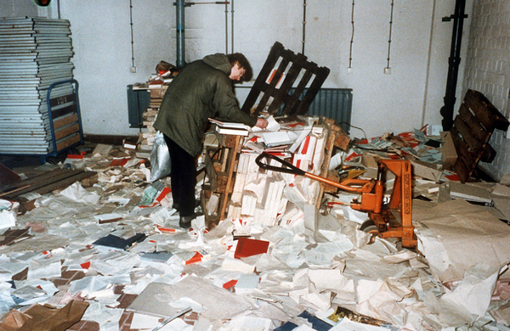

Inside the Berlin-based Stasi headquarters after demonstrators stormed the premises on January 15, 1990. Hopefully you’ll be able to find your source material easily! (Germanyinfo)

Activity: rescue the question!
Some students struggle with the HI because the RQ is flawed. Common problems include: too descriptive, too broad/big, not historical, too difficult to analyse.
Rescue these RQs from some of the common errors and flaws:
Flawed Question | Improved Version
What were the causes of the Russian Revolution of November 1917?
How did technological developments cause 20th century wars?
What have been the consequences of the Romania’s accession to the European Union (2007)?
To what extent is ‘The Book Thief’ an accurate portrayal of life in Nazi Germany?
How did Mao control China?
How did art change under authoritarian regimes?
Was it morally correct for the USA to use atomic weapons in World War II?
How accurate is the movie ‘Tora Tora Tora’?
Was the experience of my Grandma in the Young Pioneers typical?
Why did communism collapse in Eastern Europe in 1989?

Section 1: Identification and evaluation of sources
This section requires students to analyse in detail two of the sources that they will use in their investigation. The sources can be either primary or secondary sources. In this section students must:
- clearly state the question they have chosen to investigate (this must be stated as a question)
- include a brief explanation of the nature of the two sources they have selected for detailed analysis, including an explanation of their relevance to the investigation – they must be relevant to your investigation (i.e: you will use them in Section 2)
- analyse two sources in detail. With reference to the origins, purpose and content, the student should analyse the value and limitations of the two sources in relation to the investigation.
N. B: Primary sources can provide rich analytical opportunities, and secondary sources can be more useful – so one of each may be a good starting point. You may use images, charts, graphic sources, but these come with their own challenges.

Section 2: Investigation
This section of the internal assessment task consists of the actual investigation. The internal assessment task provides scope for a wide variety of different types of historical investigation, for example:
- a historical topic or theme using a variety of written sources or a variety of written and non-written sources
- a historical topic based on fieldwork, for example, a museum, archeological site, battlefields, places of worship such as mosques or churches, historic buildings
- a local or family history study.
The investigation must be clearly and effectively organized. While there is no prescribed format for how this section must be structured, it must contain critical analysis that is focused clearly on the question being investigated, and must also include the conclusion that the student draws from their analysis. It has to be written in prose, and may include side titles to support planning and organization.
In this section, students must use a range of evidence, including those evaluated in Section 1 to support their argument. Please note that students can use primary sources, secondary sources, or a mixture of the two.
Section 2 Checklist:
- Clearly organized, using side titles if appropriate
- Contains critical analysis that is clearly focused on the question
- A range and variety of evidence
- Must include a conclusion

Section 3: Reflection
This section of the internal assessment task requires students to reflect on what undertaking their investigation highlighted to them about the methods used by, and the challenges facing, the historian. In other words, what the student has learned about being a historian, and ‘making’ history.
Highlight the methods that were used and the challenges faced.
Examples of discussion questions that may help to encourage reflection include the following.
- What methods used by historians did you use in your investigation?
- What did your investigation highlight to you about the limitations of those methods?
- What are the challenges facing the historian? How do they differ from the challenges facing a scientist or a mathematician?
- What challenges in particular does archive-based history present?
- How can the reliability of sources be evaluated?
- What is the difference between bias and selection?
- What constitutes a historical event?
- Who decides which events are historically significant?
- Is it possible to describe historical events in an unbiased way?
- What is the role of the historian?
- Should terms such as “atrocity” be used when writing about history, or should value judgments be avoided?
- If it is difficult to establish proof in history, does that mean that all versions are equally acceptable?
Section 3 Checklist:
- Focuses on the methods used by the historian
- Awareness of the challenges facing the historian/limitations of the methods used
- An explicit connection between the reflection and the rest of the assignment
- Reflection influenced by ToK thinking: ways of knowing, the nature of evidence
- Connect back to the topic and RQ

Activity: Assess the reflection

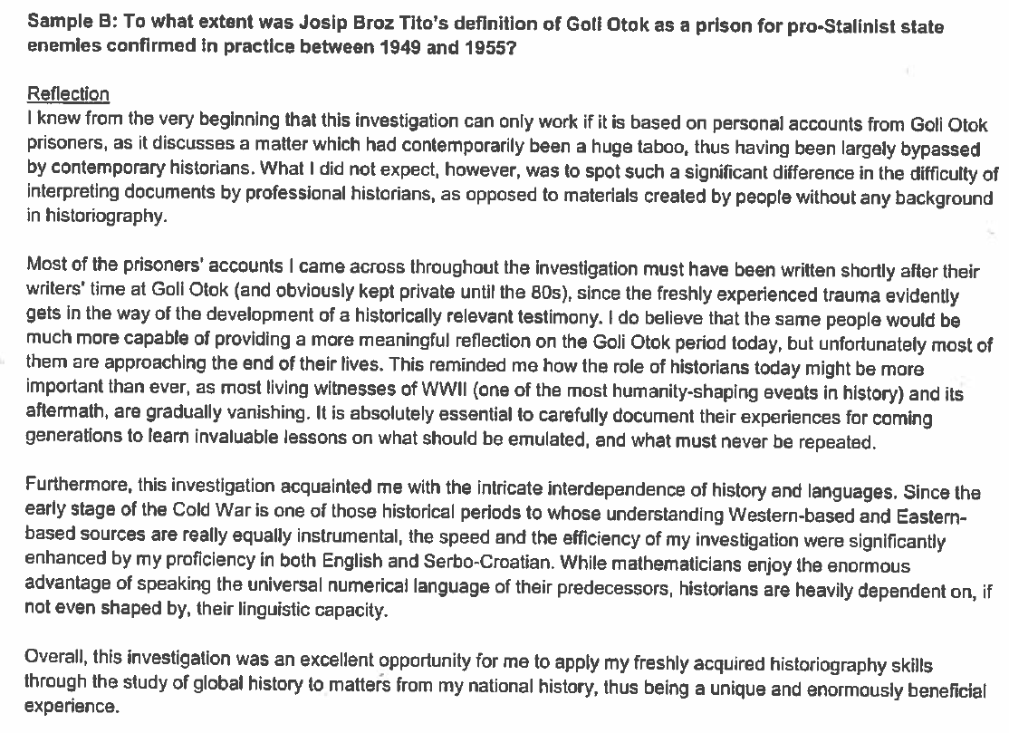

Use the reflection rubric to guide your assessment.
Comment on the methods used by the historian

Comment on the challenges or limitations

Connection between the reflection and the rest of the assignment

Level Awarded:

Bibliography
A bibliography and clear referencing of all sources must be included with every investigation, but these are not included in the overall word count. This is not graded as inaccurate citations are an academic honesty concern and therefore a pass/fail issue.

Word limit
The word limit for the historical investigation is 2,200 words. A bibliography and clear referencing of all sources must be included in the investigation, but are not included in the overall word count. Teachers and Moderators will stop reading after 2,200 words. If the word count is exceeded then most likely the conclusion and reflection will not be marked.
Below are suggested word allocations for each section of the historical investigation. Please note that these word allocations are suggestions only.
Section | Suggested word allocation | Associated assessment criteria | Marks
1. Identification and evaluation of sources | 500 | A. Identification and evaluation of sources | 6 marks
2. Investigation | 1,300 | B. Investigation | 15 marks
3. Reflection | 400 | C. Reflection | 4 marks
Bibliography | Not applicable | Not applicable | Not applicable
Total (maximum word limit) | 2,200 words |  | Total:25 marks

Using assessment criteria for internal assessment
- The same assessment criteria are provided for SL and HL.
- The aim is to find, for each criterion, the descriptor that conveys most accurately the level attained by the student, using the best-fit model. A best-fit approach means that compensation should be made when a piece of work matches different aspects of a criterion at different levels. The mark awarded should be one that most fairly reflects the balance of achievement against the criterion. It is not necessary for every single aspect of a level descriptor to be met for that mark to be awarded.
- When assessing a student’s work, teachers should read the level descriptors for each criterion until they reach a descriptor that most appropriately describes the level of the work being assessed. If a piece of work seems to fall between two descriptors, both descriptors should be read again and the one that more appropriately describes the student’s work should be chosen.
- Where there are two or more marks available within a level, teachers should award the upper marks if the student’s work demonstrates the qualities described to a great extent; the work may be close to achieving marks in the level above. Teachers should award the lower marks if the student’s work demonstrates the qualities described to a lesser extent; the work may be close to achieving marks in the level below.
- The highest level descriptors do not imply faultless performance but should be achievable by a student. Teachers should not hesitate to use the extremes if they are appropriate descriptions of the work being assessed.
- A student who attains a high achievement level in relation to one criterion will not necessarily attain high achievement levels in relation to the other criteria. Similarly, a student who attains a low achievement level for one criterion will not necessarily attain low achievement levels for the other criteria. Teachers should not assume that the overall assessment of the students will produce any particular distribution of marks.
- It is recommended that the assessment criteria be made available to students.

Internal assessment criteria—SL and HL
The historical investigation for both SL and HL is assessed against three criteria.
- Criterion A: Identification and evaluation of sources (6 marks)
- Criterion B: Investigation (15 marks)
- Criterion C: Reflection (4 marks)

Internal assessment criteria (SL and HL)
Criterion A: Identification and evaluation of sources (6 marks)
Marks | Level descriptor
0 | The work does not reach a standard described by the descriptors below.
1–2 | The question for investigation has been stated. The student has identified and selected appropriate sources, but there is little or no explanation of the relevance of the sources to the investigation.  The response describes, but does not analyse or evaluate, two of the sources.
3–4 | An appropriate question for investigation has been stated. The student has identified and selected appropriate sources, and there is some explanation of the relevance of the sources to the investigation.  There is some analysis and evaluation of two sources, but reference to their value and limitations is limited.
5–6 | An appropriate question for investigation has been clearly stated. The student has identified and selected appropriate and relevant sources, and there is a clear explanation of the relevance of the sources to the investigation.  There is a detailed analysis and evaluation of two sources with explicit discussion of the value and limitations of two of the sources for the investigation, with reference to the origins, purpose and content of the two sources.

Criterion B: Investigation (15 marks)
Marks | Level descriptor
0 | The work does not reach a standard described by the descriptors below.
1–3 | The investigation lacks clarity and coherence, and is poorly organized. Where there is a recognizable structure there is minimal focus on the task.  The response contains little or no critical analysis. It may consist mostly of generalizations and poorly substantiated assertions. Reference is made to evidence from sources, but there is no analysis of that evidence.
4–6 | There is an attempt to organize the investigation but this is only partially successful, and the investigation lacks clarity and coherence.  The investigation contains some limited critical analysis but the response is primarily narrative/descriptive in nature, rather than analytical. Evidence from sources is included, but is not integrated into the analysis/argument.
7–9 | The investigation is generally clear and well organized, but there is some repetition or lack of clarity in places.  The response moves beyond description to include some analysis or critical commentary, but this is not sustained. There is an attempt to integrate evidence from sources with the analysis/argument.  There may be awareness of different perspectives, but these perspectives are not evaluated.
10–12 | The investigation is generally clear and well organized, although there may be some repetition or lack of clarity in places.  The investigation contains critical analysis, although this analysis may lack development or clarity. Evidence from a range of sources is used to support the argument.  There is awareness and some evaluation of different perspectives. The investigation argues to a reasoned conclusion.
13–15 | The investigation is clear, coherent and effectively organized.  The investigation contains well-developed critical analysis that is focused clearly on the stated question. Evidence from a range of sources is used effectively to support the argument.  There is evaluation of different perspectives. The investigation argues to a reasoned conclusion that is consistent with the evidence and arguments provided.

Criterion C: Reflection (4 marks)
Marks | Level descriptor
0 | The work does not reach a standard described by the descriptors below.
1–2 | The reflection contains some discussion of what the investigation highlighted to the student about the metods used by the historian.  The reflection demonstrates little awareness of the challenges facing the historian and/or the limitations of the methods used by the historian.  The connection between the reflection and the rest of the investigation is implied, but is not explicit.
3–4 | The reflection is clearly focused on what the investigation highlighted to the student about the methods used by the historian  The reflection demonstrates clear awareness of challenges facing the historian and/or limitations of the methods used by the historian.  There is a clear and explicit connection between the reflection and the rest of the investigation.

Key stages in helping students to prepare for the internal assessment task
- Discuss with students the nature of the internal assessment task, and ensure that they are familiar with the assessment criteria.
- Discuss with students the different types of investigation that they could undertake.
- Discuss with students the importance of academic honesty before they undertake their research, and emphasize the importance of using a single, standard system of referencing.
- Dedicate about 20 hours of class time to the internal assessment task.
- Help students to create an individual timetable for the different stages of the investigation; for example: choosing the topic, finishing the first draft, and the due date for the final version.
- Give students guidance on what constitutes a manageable task. Many internal assessment responses struggle to gain good marks because the question that students have chosen are far too broad for them to address effectively.
- Give students guidance on selecting appropriate sources.
- Give students feedback on a first draft of their internal assessment (this may be done in sections if preferred).
- Check the authenticity of the student's final draft, to confirm that, to the best of your knowledge, it is the student's own work.
- Mark and comment on all internal assessment work, using the assessment criteria stated in the History guide. Do not hesitate to use the full range of marks as appropriate, and remember to adopt a "best-fit" approach to applying the markbands.
- If more than one teacher is involved in the preparation of students, it is vital that internal standardization is undertaken prior to the submission of marks.

Works Cited

Bond, Edward. Proc. of History Category 2 Workshop, Brussels. N.p.: n.p., Nov. 2015. Print.
Chang, Minnie. The zhiqing (educated youth) who were sent down to do farm work with local peasants study Chairman Mao's red book with a local farmer in the field. Digital image. South China Morning Post. South China Morning Post Publishers, 18 Mar. 2013. Web. 30 Jan. 2016.
"History Guide." History Guide. International Baccalaureate Organisation, n.d. Web. 30 Jan. 2016.
"History TSM." History TSM. International Baccalaureate Organisation, n.d. Web. 30 Jan. 2016.
Inside the Berlin-based Stasi Headquarters after Demonstrators Stormed the Premises on January 15, 1990. Digital image. Germany Info. German Missions in the United Statea, n.d. Web. 30 Jan. 2016.
"Plagiarism Scandal Ensnares Prime Minister of Romania." Armenpress. N.p., 20 July 2012. Web. 30 Jan. 2016.
Rodchenko, Alexander. Portrait of Mother. Digital image. Multimedia Art Museum Moscow. N.p., n.d.

