Sourcework: The Sophiatown Removals (1 hour)

Source A
From an address made by Hendrick Verwoerd to the Native Representative
Council, December 1950.
Apartheid policy is as much in the interests of the Bantu as those of the European. If Bantu and European in future develop as intermixed communities, there will be competition and conflict everywhere. The more this intermixing develops, the stronger the conflict will become. The only possible way out is to adopt a development divorced from each other. The Bantu have been made to believe that apartheid means oppression. In reality, however, exactly the opposite is intended. Apartheid takes into consideration the languages, traditions, history and different national communities of the Bantu, so that they may pass through a development of their own. This opportunity arises for them as soon as such a division is brought into being between them and the Europeans so that they need not be the imitators and henchmen of the latter.

Source B
A cartoon published in a British newspaper in 1958 showing Verwoerd.
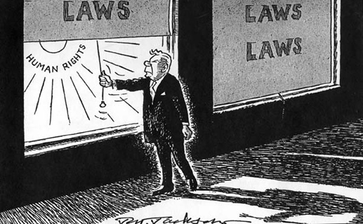

Source C
From South African Info (http://www.southafrica.info)
Sophiatown was not subjected to effective policing. Resettlement in Soweto, surely, would be accompanied by increased levels of policing. It is for this reason that gangsters in Sophiatown were seen to be particularly active in the resistance movement. At this stage several hundreds of match box houses in Meadowlands were nearing completion. Some residents had had the opportunity to view the houses in Meadowlands … Many felt the houses were sub-standard, some felt they were an improvement on the kind of accommodation they had in Sophiatown. It is not clear which of the groups predominated. What is apparent is that if the majority thought the houses sub standard, resistance would have been more intense.

Source D
From South African History Online (http://www.sahistory.org.za)
Apartheid police armed with machine guns and truncheons surrounded the vibrant multi-racial township before homes were bulldozed and people's possessions were loaded onto open trucks as part of the government's policy of racial segregation. Most people were dumped in Soweto township's Meadowlands, about 10km to the south. "We woke up that day to hundreds of police officers, with their trucks and Sten guns," remembered Simon Ramela, who lived here as a teenager. "They took us by complete surprise," he said. Victor Mokhine, another resident, recalls that “We got a notice that we were going to be moved on 12 February 1955, but we were taken by surprise by thousands of policemen and soldiers, who were heavily armed. We were still preparing ourselves to protest the removals, and we had no choice because no one was ready for them - and besides, they were armed”.

Questions
1. a) According to Source C, why was was there so little resistance to the Sophiatown evictions? [3 marks]
1. b) What message is conveyed by Source B? [2 marks]
2. With reference to its origin, purpose and content, analyze the value and limitations of Source A for a historian studying the reasons why the National Party favoured a policy of apartheid. [4 marks]
3. Compare and contrast what Sources C and D reveal about the lack of resistance to the Sophiatown removals. [6 marks]
4. Using the sources and your own knowledge, evaluate the reasons why there was so little effective resistance to the Sophiatown evictions. [9 marks]

