How important was the role of women in the anti-apartheid struggle?

Source A
We are women from every part of South Africa. We are women of every race, we come from the cities and the towns, from the reserves and the villages. We come as women united in our purpose to save the African women from the degradation of passes. For to us an insult to African women is an insult to all women. [Because of passes]:
- homes will be broken up when women are arrested under pass laws
- children will be left uncared for, helpless, and mothers will be torn from their babies
- women and young girls will be exposed to humiliation and degradation at the hands of pass-searching policemen
- women will lose their right to move freely from one place to another.
"The Demand of the Women of South Africa for the Withdrawal of Passes for Women and the Repeal of the Pass Laws," Petition presented to the Prime Minister, Pretoria, 9 August 1956

Source B
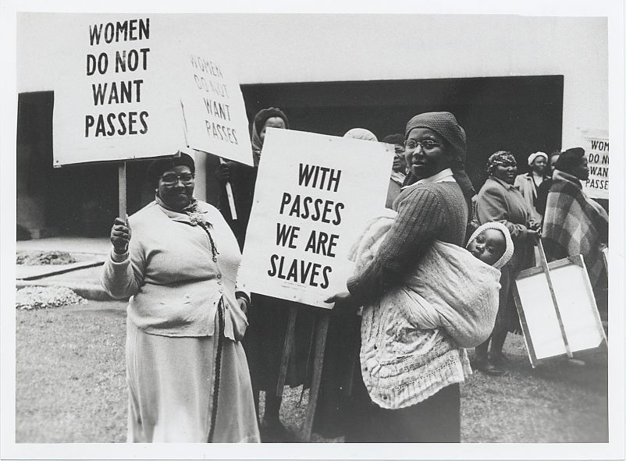
Photograph taken during The 1956 Women's March, Pretoria, 9 August

Source C
Since the middle of June 1959 to date, August 31st, 1959, Natal has been witnessing widespread demonstrations throughout the Province. The demonstrations have been largely by women. Men should take a leaf from the women in this regard. It is not uncommon for women to goad their menfolk to action by deriding them or by taking the initiative in acting. Men should positively and constructively meet this women’s challenge. But more to the point about women is that it is they, especially in African homes, who bear the brunt of facing daily the poverty of the home, since it falls on women to prepare food for the family and to see that children are clothed. Why should Government circles be surprised to find African women in these demonstrations, concerning themselves with such issues as low wages, influx control regulations, increased taxation? Women are hit hard by poverty arising out of these. Men’s silence and inaction to protest against these grievances is shaming us, men. Men are supposed to be the traditional protectors and fenders for their family’s welfare. What about it, African men?
The African Women’s Demonstration in Natal: Report by Albert Luthuli to the Natal People’s Conference: 6 September 1959

Source D
Helen Suzmann was elected to the House of Assembly in 1953 as a member of the United Party for the Houghton constituency in Johannesburg. Dissatisfied with the soft stance of United Party to the apartheid policies of the Government, Suzman and eleven other liberal members of the United Party broke away to form the Progressive Party in 1959. At the 1961 general election all the other Progressive MPs lost their seats, leaving Suzman as the sole parliamentarian opposed to apartheid for thirteen years from 1961 to 1974. For 13 years, she dined alone in Parliament. An eloquent public speaker with a sharp and witty manner, Suzman was once accused by a minister of asking questions in parliament that embarrassed South Africa, to which she replied: "It is not my questions that embarrass South Africa; it is your answers." After the 1961 election Prime Minister Verwoerd announced in Parliament that he had never believed the Progressive Party would be a threat and, turning towards Suzman, said "I have written you off". Suzman replied "And the whole world has written you off".
Wikipedia entry on Helen Suzmann

Source E
At the time of its formation the Black Sash famously draped a black sash over a symbolic replica of the Constitution in a symbolic act of mourning. Not only were they determined to oppose unjust laws but they also wanted to do something practical to help. In 1958 a bail fund was set up to assist those who were arrested in terms of the pass laws. Molly Blackburn was an example of a member like others who were willing to take that risk for the greater good of the people she was serving. Many White South Africans found this fact threatening about the Black Sash organisation because ‘the Black Sash was undoubtedly seen as a group who went against their own self-interest.’(Spink). Blackburn once stated: "White South Africans think that the gap between black and white is too wide to be bridged. I don’t think this is so. If you stretch out a loving hand, somewhere on the other side a loving hand will take it, and that will be the beginning of a bridge".
From South African History online

Questions
1. a) According to Source A, why were women opposed to the Pass Laws? [3 marks]
1. b) What message is conveyed by Source B? [2 marks]
2. With reference to its origin, purpose and content, analyze the value and limitations of Source C for a historian studying the role of women in the anti-apartheid struggle. [4 marks]
3. Compare and contrast what Sources C and D reveal about the motives and methods of women in the anti-apartheid struggle. [6 marks]
4. “The importance of Black and White women in the anti-apartheid struggle was equal but different”. Using the sources and your own knowledge, evaluate the validity of this statement. [9 marks]

