“How successful was Mao as ruler of China, 1949-76?”

Task: Debate
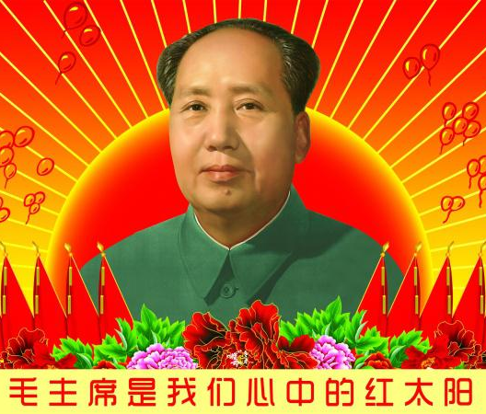
• Members of the class will be required to frame “prosecution” questions on particular policies (summarised as the headings in the six key columns overleaf). These questions should take the format
Is it not true that…which is demonstrated by the following evidence…which is reliable because…

• Each member of the class will then share their question an allocated opponent, who will then be given time to frame a response to it, ideally using fresh evidence from research if appropriate.

• The debate between the first pair of students will then take place and all students should take notes before the audience then attempts to reach a concluding synthesis which both sides are happy to accept. Repeat for the other questions to obtain a thorough analysis of the topic.

Note: An alternative approach is for the teacher to take the role of Mao and answer ALL of the prosecution questions to save time.
Debate Framework

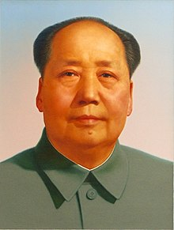 | Politics | Cult of Personality | Social / Cultural | Economic | Minorities | Foreign
Question 1
Answer
Synthesis ( = topic sentence)
Question 2
Answer
Synthesis ( = topic sentence)

Timeline – use this to decide the topic areas around which to frame questions for the debate

 | Politics | Cult of Personality / | Social / Cultural | Economic | Minorities | Foreign
1949 | Organic Law |  | Patriotic Health Movements |  | Force against regions / minorities
1950 |  |  | Marriage Law | Agrarian Reform Law |  | Korean War
1951 |  |  |  | 3-Anti Campaign
1952 |  |  |  | 5-Anti Campaign
1953 |  |  |  | First 5YP
1954 | Constitution |  | Rural Literacy Campaign
1955 |  |  | Snail Fever Campaign
1956 |  | Khrushchev’s Secret Speech | 100 Flowers Campaign |  |  | Sino-Soviet Split
1957 |  |  | Anti-Rightist Campaign
1958 |  |  |  | Great Leap Forward
1959 | Fall of Peng Duhai | Lushan Conference | Great Famine |  | Tibetan rebellion
1960
1961
1962
1963 |  | The Little Red Book |  | Moderate Reforms of  Deng and Liu
1964 | Public retreat of Mao to the “Second Front”
1965 |  | Wu Han Scandal | Barefoot Doctors Campaign
1966 | Fall of Deng and Liu | Return of Mao: the Yangtzee swim | Cultural Revolution
1967
1968 |  | Mao’s Mango Fever
1969 | Lin Biao named Mao’s official successor |  |  |  |  | Sino-Soviet border skirmishes
1970
1971 | Disgrace and death of Lin Biao |  |  |  |  | PRC joins UN Security Council
1972 |  |  |  |  |  | Nixon Visits China
1973 | Return of Deng
1976 | Death of Zhou  Death of Mao

“Mao was supremely successful as a revolutionary but extremely erratic as a nation builder. His great achievements up to 1957 may serve as an inspiration to others, but his major mistakes thereafter must serve as a lesson to all”.
Immanuel C. Y. Hsu, China without Mao (Oxford University Press, 1990)

