Rule of Authoritarian States: Mao

Key Characters

Leftists |  | Centrists | Rightists
Lin Biao | Jiang Qing | Zhou Enlai | Deng Xiaoping | Liu Shoqui

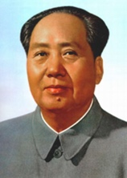 | Mao Zedong (1893-1976)  Chinese communist revolutionary who became the founding father of the People's Republic of China (PRC). His theories, military strategies, and political policies are collectively known as Maoism. He was the son of a wealthy farmer but became a founding member of the Communist Party of China (CPC) whilst at Peking University. During the Chinese Civil War, Mao became head of the CPC after heroically leading his followers to the safety of the Yenan mountains in the legendary 1934 Long March. Although the CPC temporarily allied with their nationalist enemies to defeat the occupying Japanese forces, China's civil war resumed after Japan's surrender and in 1949 Mao's forces defeated the Nationalists forces of Chiang Kai-Shek, who withdrew to the safety of Taiwan.
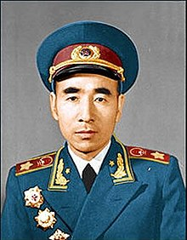 | Lin Biao (1907-1971)  For many years Mao’s closest ally, General Lin Biao was chief of the People’s Liberation Army (PLA) and placed in charge of the Campaign Against the Four Olds (“old ideas, culture, customs and habits”) alongside Mao’s wife, Jiang Qing. This heralded the start of the Cultural Revolution. When the vandalism led by bands of students known as the “Red Guards” threatened to get out of control, he then used the army to crush them. His growing power provoked a rift with Mao, and he was killed in a plane crash attempting to flee into exile after being accused of plotting a coup in 1971.
Jiang Qing (1914–91)
Jiang Qing was Mao’s third wife. A former actress, she had married Mao during the civil war. A close ally of Lin Biao during the Cultural Revolution, Mao called her “the cultural purifier of the nation”. Together with three colleagues, she formed what was disparagingly known as the Gang of Four. She rapidly lost influence after the fall of Lin Biao, and after Mao’s death she was arrested and imprisoned. Jiang blamed Mao for her excesses, claiming, “I was Chairman Mao’s dog. Whomever he told me to bite, I bit”.
Zhou Enlai (1898-1976)
Zhou Enlai was the first Premier of the PRC, serving from October 1949 until his death in January 1976. A pragmatic politician, he navigated the twists and turns of Mao’s policy shifts with great ability and devoted himself to mitigating against extremism on both sides. When the economy needed reviving in the early 1970s, it was Zhou who quietly called Deng Xiaoping back to power; together, they worked on what would later become known as the Four Modernizations. Zhou, suffering from throat cancer, died in January 1976, just months before Mao, and was widely mourned.
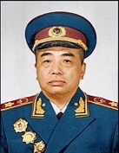 | Peng Dehuai (1898-1974)  Minister of Defence 1954-1959 and highly respected veteran of the Chinese Civil War. He famously attacked Mao’s policies at the 1959 Lushan Conference at the height of the Great Famine which had resulted from the agricultural collectivisation policies of Mao’s Great Leap Forward. He was fired as Minister of Defence and Mao announced that he would mobilise the people against the party if it did not fall in line (it did). He was allowed to retire into obscurity until 1970, when he was arrested during the Cultural Revolution. He died in prison in 1974.
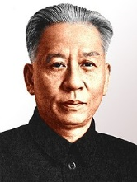 | Liu Shoqui (1898-1969)  For 15 years, President Liu was the third most powerful man in China, behind only Chairman Mao and Premier Zhou Enlai. Originally groomed as Mao's successor, he was given the responsibility (with Deng Xiaoping) of rebuilding the economy after the failures of the Great Leap Forward. However, his moderate (and successful) policies meant he was sent to prison during the Cultural Revolution (where he died after being denied treatment for diabetes). Mao denounced him as "commander of China's bourgeoisie headquarters", China's foremost "capitalist-roader", and a traitor to the revolution.
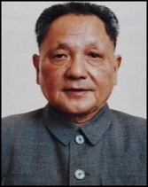 | Deng Xiaoping (1904–97)  Deng Xiaoping was a member of the CPC during the 1920s. He had taken part in the Long March and became General Secretary of the CPC. He was a protégé of Zhou Enlai, who protected him from more severe punishment during the Cultural Revolution. By 1979, Deng had become the paramount leader of China and put in place the economic reforms of the 1980s. He declared that Mao had been “70 per cent right but 30 per cent wrong”. Deng ordered the crackdown on the Tiananmen Square protests of 1989 but was praised for his handling of the reversion of Hong Kong to Chinese control from the British in 1997.

Task
Read through the information provided here carefully. A factual test will follow.

