Case Study: The Sophiatown Removals

Background Information
▪ In 1955, the Apartheid Regime, using the Natives Resettlement Act, evicted the black residents of Sophiatown, a lively multicultural suburb on the edges of Johannesburg. They were rehoused in a sterile estate called Meadowlands. Sophiatown was then bulldozed and rebuilt as a whites-only area called “Triomph”.
▪ This event was the first stage in a policy which became known as ‘separate development’. In 1959, the Promotion of Bantu SeIf-Government Act declared that the reserves which had been created in the 1913 Land Act would become 10 separate ‘countries’ known as homelands or Bantustans.
▪ Each of these would be based on the African language spoken in the area. Every African in South Africa would become a ‘citizen’ of one of these homelands.
▪ By dividing Africans into ten different cultural, political and ethnic groups, the Nationalist government could claim that there was no African majority living in South Africa. Moreover, by highlighting the ethnic identities of Africans, the government hoped to create divisions among them and prevent the growth of a united African nationalism that could threaten the apartheid state.

Task 1: Podcast

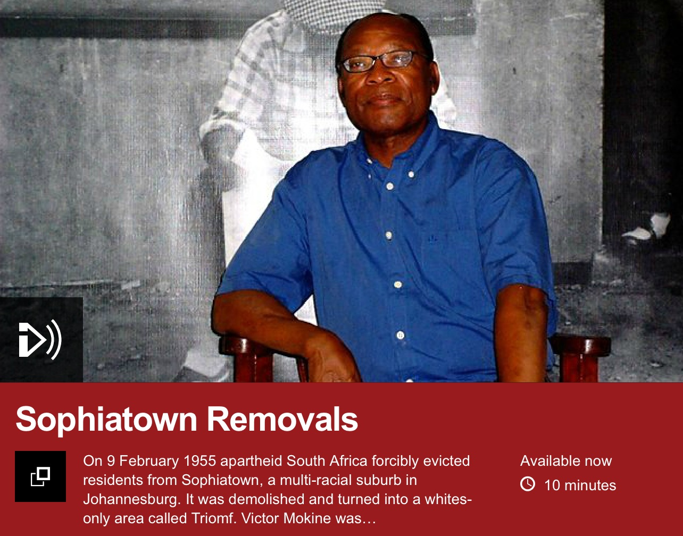
Listen to the BBC “Witness” podcast (9m) and use it to answer the following questions.
Note: the podcast can be easily located by conducting a Google search for ‘BBC Witness Sophiatown’.
▪ Why were the black residents evicted from Sophiatown?
???
▪ How long did the process take, and how many people were affected?
???
▪ How did the Sophiatown get its name?
???
▪ How did this non-white community manage to grow up in this area of Johannesburg, where black residency was usually banned?
???
▪ What examples of multicultural vitality in Sophiatown are provided?
???
▪ Where was the black population moved to?
???
▪ What was the message of the protest song 'Meadowlands'?
???
▪ What was life like in Meadowlands?
???
▪ What do people miss most about Sophiatown?
???
▪ What happened to Sophiatown after the black population was evicted?
???

Task 2: Video
You should now make further notes about how music in particular was used as a form of protest by watching the following video clip:
http://www.activehistory.co.uk/main_area/videoplayer/index.php?id=073702441
???

Note: further information on this theme can be found on this web page: http://www.studentpulse.com/articles/265/3/the-sounds-of-resistance-the-role-of-music-in-south-africas-anti-apartheid-movement

