Student Name:

iGCSE Geography
Course Notes

Tourism

Topic Content Summary
 |  | Happy | Unsure | It’s a Problem
Describe the growth of international tourism
Explain the growth of international tourism
Identify different types of tourism
Identify primary and secondary tourist attractions
Describe and explain the advantages tourism brings to an area / country
Describe and explain the advantages tourism brings to an area / country
Identify management techniques within the tourism industry
Case Study  Describe the attractions, the benefits and disadvantages tourists bring to the area and how tourism is managed | Jamaica

What is tourism?
Key Questions:
- Can you define tourism?
- What types of holidays are there?

Tourism is …

Task
Identify the types of holidays shown below and think of an example location for each type of holiday
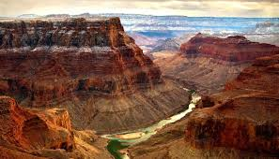
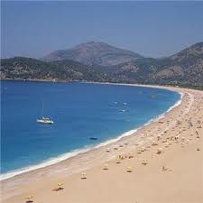
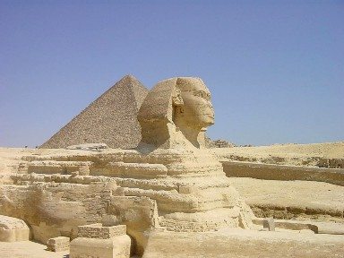
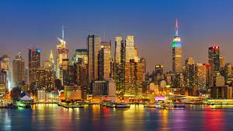
Changing Global Tourism
Key Questions:
- How much has global tourism changed since the 1950s?
- Why has tourism grown so much?
- Why has tourism not grown in all areas of the world?

Stick Growth of Tourism graph here
Describe the changes to global tourism shown on the graph above (4) – include at least one use of data and refer to at least one region.

Why has the number of global tourism risen so much?

Image | Reason | Explanation
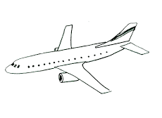

Can you think of any other reasons why people are taking more holidays?

Exam Questions
Applying your new knowledge

Impacts of Tourism
Key Questions:
- How is tourism beneficial to an area?
- Why is tourism not always good for an area?

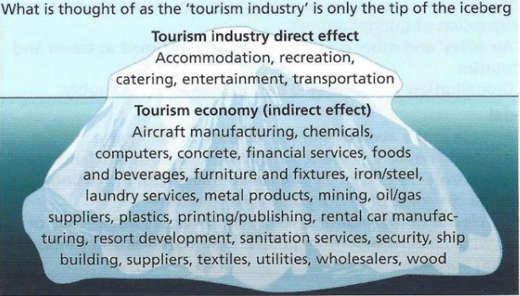
Impacts are …

 | Positive impacts | Negative impacts
Social
Economic
Environmental

Managing Tourism
Key Questions:
- How are the impacts of tourism managed?
- What is sustainable tourism?

Read through the Managing Tourism handout and write down the various techniques used in the three tourist locations and briefly explain what potential impact is being reduced:

Management Technique | Impact being reduced

Tourism Case Study
Key Questions:
- Where is Jamaica?
- Why do people visit Jamaica?
- How does tourism impact upon Jamaica?
- How are these impacts managed?

Use an atlas to locate Jamaica. Describe the location of Jamaica below:

Task 1
Annotate locations that attract people to Jamaica

How does Jamaica’s climate influence tourism?
Task 2
Impacts of Tourism - Benefits to Jamaica
Basic point | Case study detail | Development or link

Impacts of Tourism - Drawbacks to Jamaica
Basic point | Case study detail | Development or link
Task 4
How is tourism being managed and how will it create a sustainable industry?
Technique | Sustainable benefits

